Shenhui Laser

SH-G690 User Guide

Table of Contents

Introduction 5

WARNING 6

SAFETY NOTES 7

Machine Appearance and Accessories 8

Safety 12

Electrical Safety 12

Fire Warning 13

Dos and Donts 14

Installation and Commissioning of the Machine 16

I. 2.1 Installation and Adjusting Steps 16

1. Laser Tube Installation 16

Operation of laser machine 24

I.3.1 Introduction of Main Interface 25

I.3.2 Introduction of key 26

I Chapter 4　Alignment Standards of Optical Path 31

I Chapter 5 Daily Maintenance and Common Faults 35

I.5.1 Daily maintenance 35

I Chapter 6 Warranty Regulations 38

II RDCAM V3.0 User Manual 38

II Chapter 1 Overview 38

II.1.1 Laser engraving cutting system introduction 38

II.1.2 Software supported file formats 39

II.1.3 Environmental requirements 39

II Chapter 2 Software installation 39

II.2.1 Install steps 39

II Chapter 3 Software Basic Operation 42

II.3.1 The main interface operation 42

II.3.2 Language settings and machine information 43

II.3.3 page setting 43

II.3.4 File open and save 44

II.3.5 File import and export 45

II.3.6 Basic graphics creation 48

II.3.7 Object selection 49

II.3.8 Object color 50

II.3.9 Object transformation 50

II.3.10 Object Align 53

II.3.11 Object View 54

II.3.12 Important Tool 54

II Chapter 4 System Settings 67

II.4.1 Laser Export 67

II.4.2 General Setting 69

II.4.3 Machine Para 72

II.4.4 Document 76

II.4.5 System info 77

II.4.6 Password Setting 78

II Chapter 5 Processing 82

II.5.1 Search Device 82

II.5.2 Layer settings 83

II.5.3 Position 87

II.5.4 Go Scale, Cu t Scale 87

II.5.5 Start, pause, stop, saveToUFile, UFileoutput, Download 87

II.5.6 Output select graphics 88

II.5.7 Path optimize 88

II.5.8 Axis move 88

II Chapter 6 FAQ 90

II.6.1 After start processing, the machine does not move or disorder or loss part of graphics 90

II.6.2 Software automatically shut down when import file 90

II.6.3 Machine panel prompt 【Less buffer distance】 90

II.6.4 Processing graphics sis mirror to the actual graphics 90

III User’s Manual of Laser Engraving Cutting Software v3.0 91

III Chapter 1 Introduction of CorelDraw_Laser 91

III.1.1Features of CorelDraw_Laser 91

III.1.2 Environmental requirements 91

III.1.3 Installation and startup 91

III.1.4 Operation instruction of *CorelDraw_Laser* 97

III Introduction of AutoCAD_Laser 138

III.2.1 Features of AutoCAD_Laser 138

III.2.2 Environmental requirements 138

III.2.3 Installation and startup 139

III Attached 142

IV Specification of MC-BOARD Motion Control Mainboard Interface V3.00 147

IV.1 Overview 147

IV.2 Installing Dimensions 148

IV.3 Physical Picture and Interfaces 149

IV.4 Description of Interface Signal 150

V Instruction on the Machine Parts 154

# Introduction

Dear Shenhui valued customer,

Thank you for buying our product.

Our laser device is a professionally-made, high-technology device combined with high-quality optical, mechanical and electrical components.

In this user guide, we have included real object photographs wherever possible in order to more clearly inform about equipment installation & adjustment, maintenance, safety procedures.

The user should read this manual in detail before using the laser device, both for your safety and for the reliable operation and maintenance of the device.

We welcome any comments or suggestions you may have, and appreciate any feedback to [Shenhui@Shenhuilaser.com](mailto:shenhui@shenhuilaser.com)

# WARNING

Liaocheng Shenhui Laser Equipment Co. (Shenhui) cannot be held responsible for any direct or indirect damages, which result from using or working with the products, electric circuits, or software described herein.

The equipment must be used only by suitably-trained and skilled personnel. Before use the manual should be read and understood thoroughly.

Furthermore, Shenhui reserves the right to change or alter any product described herein without prior notice.

©This documentation, with all text and illustrations is the intellectual property of Liaocheng Shenhui Laser Equipment Co.

This document is supplied to the end user for personal use only. This document may not be reproduced or made available to others without our express permission. Any breach of law will be prosecuted.

# SAFETY NOTES

Your laser system uses a high intensity beam of light that can generate extremely high temperatures.

Some materials are extremely flammable and can ignite and burst into flame. This open flame is very dangerous and has the potential to destroy not only the machine, but the building in which it is housed.

Experience has shown that high-powered vector cutting has the most potential to create an open flame. Many materials are susceptible to igniting, but acrylic, in all its different forms, has been shown to be especially flammable when vector cutting with the laser.

Please read the following warnings and recommendations and follow them closely at all times!

* Stay with the laser. Never operate the laser system while unattended.
* Keep the area clear. Clean around the machine and keep the area free of clutter, combustible materials, explosives, or volatile solvents such as acetone, alcohol, paint, or gasoline.
* Be prepared with a fire extinguisher. Always keep a properly maintained and inspected fire extinguisher on hand. Shenhui recommends a multi-purpose dry chemical fire extinguisher.
* Use Air Assist. Always use the system’s Air Assist feature when vector cutting as this will give the greatest protection from combustion.
* Keep your machine clean. A build-up of cutting and engraving residue and debris is dangerous and can create a fire hazard in its own right. Keep your laser system clean and free of debris. Regularly remove any small pieces that have fallen through the grid at the beginning of every shift or work day.
* Do not operate the machine with any open covers or panels. It has been designed to flow air correctly with the covers and panels in place, as well as to be safe for the user.
* Do not process material whose emissions would fail to conform to local environmental laws and regulations
* There are high-voltages and potentially dangerous mechanisms in the machine - non trained technicians should never disassemble or otherwise work on the machine.
* Ensure you have a good ground wire connection
* Keep the machine in a dry place, without smoke, dust, steam or other air pollution, excess electrical flux (such as high-powered AC and DC environments), strong magnetism and where the environmental temperature should be in the range of 5-40
* The laser machine should be kept away from sensitive EMI equipment
* The working voltage is AC220-240V @50Hz. Do not operate at a different voltage.

**Liaocheng Shenhui Laser Equipment Co. bears no responsibility or liability due to improper use and failure to follow the above guidelines.**

# Machine Appearance and Accessories

#### 

Different laser models may have a different appearance, according to their individual specification.

###### Front View

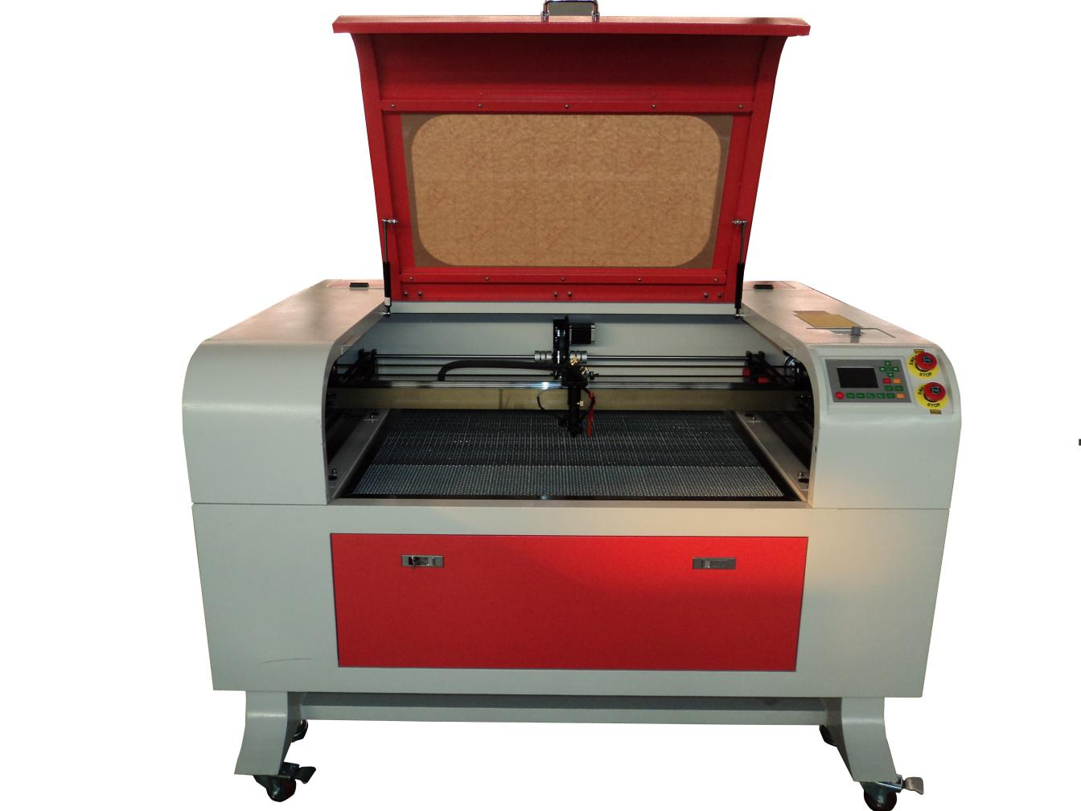

Figure 1 – Front

###### Rear View

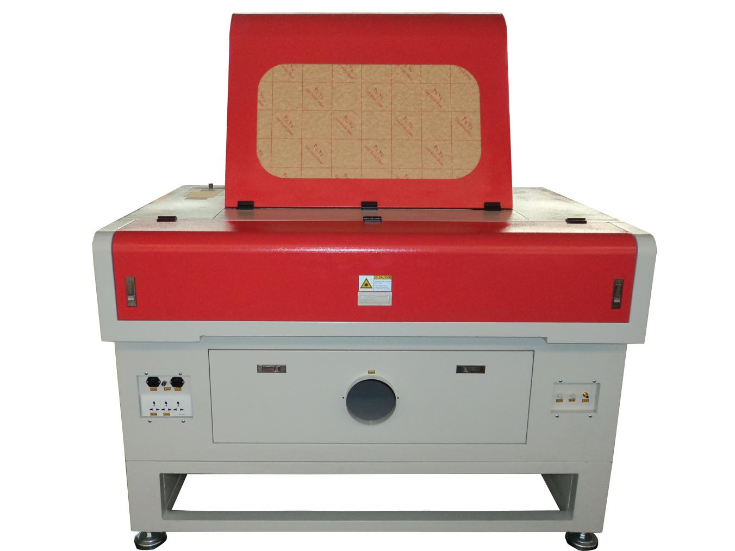

Figure 2 – Rear

###### Accessories set

Water pump, water pipe, air assist pump, air pipe.

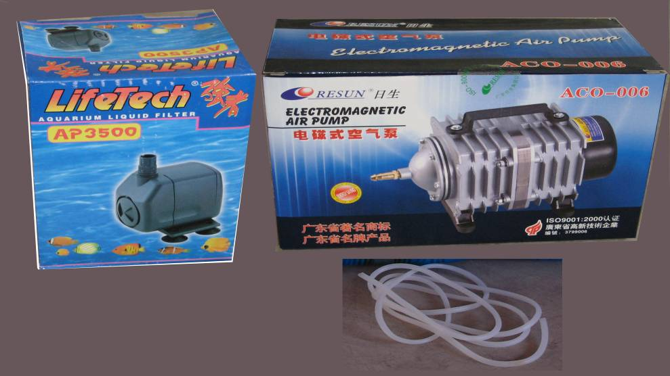

Figure 3

###### Exhaust set

Exhaust pipe, extractor fan



Figure 4

###### Laser Tube

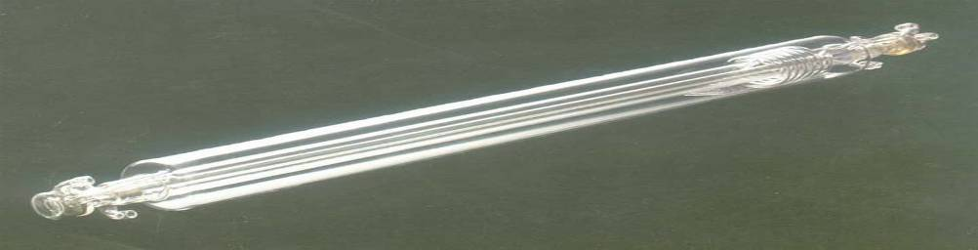

Figure 5

###### Chiller Unit

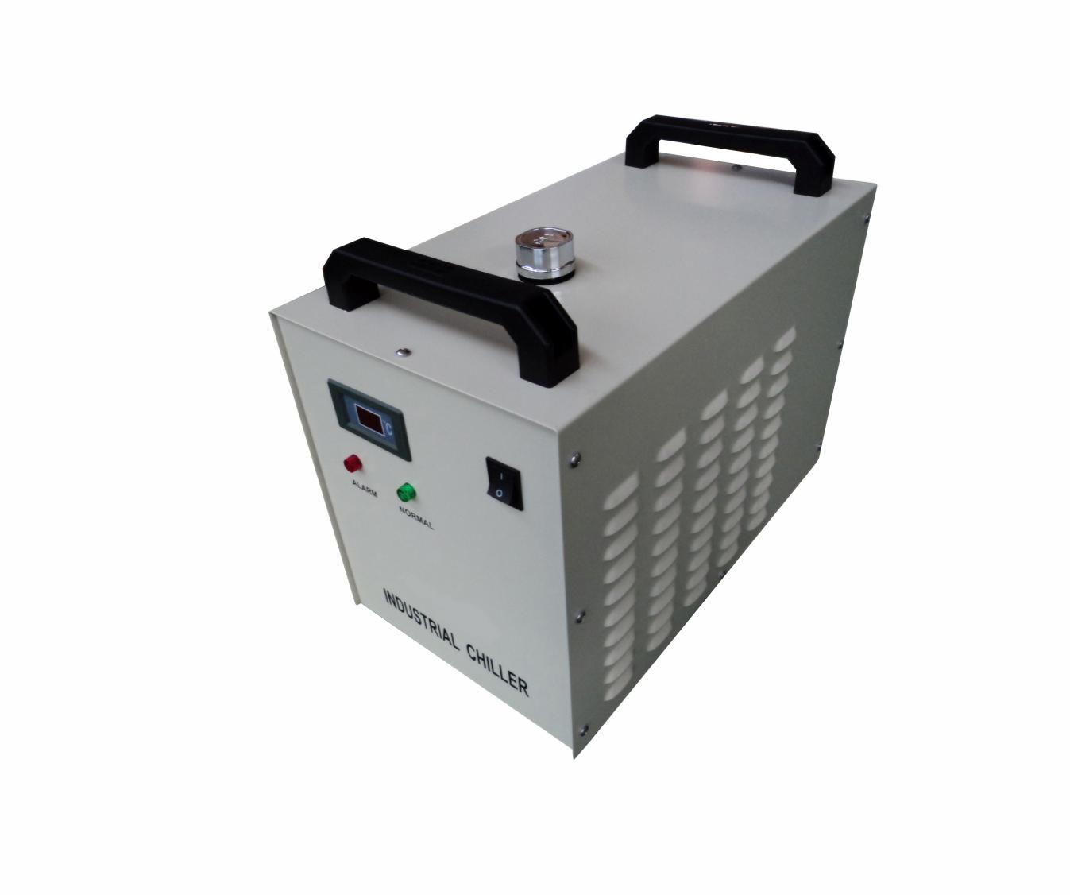

Figure 6

###### Accessory Bag

Manual, cables, software

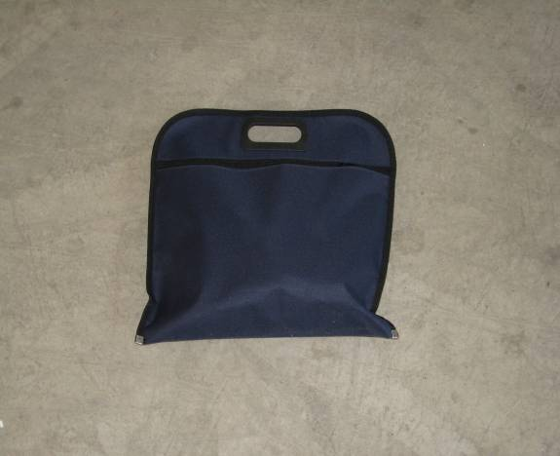

Figure 7

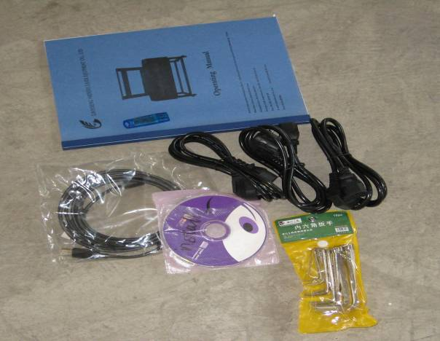

Figure 8

###### Ground Wire

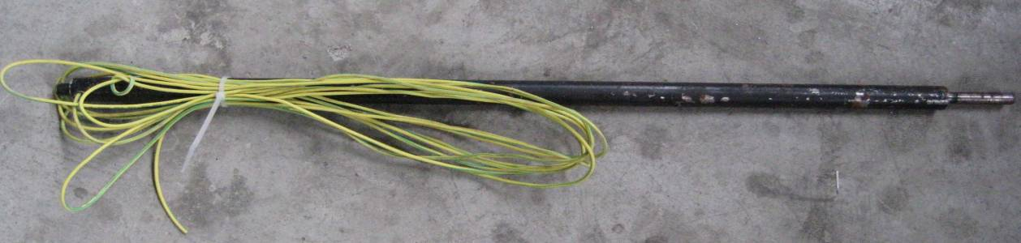

Figure 9

## 

# Safety

The Shenhui Laser System is a Class 4 laser product, as defined in International Standard IEC 60825-1.

The output of the high-power CO2 laser is fully contained within the chassis with the cabinet doors closed. The laser cabinet has safety interlocks that turn the laser off if the access door is opened during operation, and no special precautions are necessary to operate the high-power laser safely.



**The operator of the Shenhui Laser should observe the following general precautions:**

* DO NOT disassemble the machine or remove any of its protective covers while the unit is plugged in.
* DO NOT attempt to defeat the door interlocks.
* DO NOT view directly into the beam of the Laser Diode Pointer (Red Dot Pointer).
* DO NOT operate the Laser Diode Pointer (Red Dot Pointer) without the machine’s focus lens in place. If the unfocused beam strikes a reflective surface, it could be directed out of the cabinet.
* Caution – Use of controls or adjustments or performance of procedures other than those specified herein may result in hazardous radiation exposure.

The standard reference for laser safety is the American Standard for the Safe Use of Lasers, Z136.1-2000, developed by the American National Standards Institute (ANSI). This reference is the basis for many of the federal regulations for laser and laser system manufacturers, and for the Occupational Safety and Health Administration (OSHA) laser safety guidelines. It contains detailed information concerning proper installation and use of laser systems.

## Electrical Safety

The AC input power to the Shenhui Laser is potentially lethal and is fully contained within the cabinet.

* DO NOT open any of the machine’s access panels while the unit is plugged in. Opening a panel may expose the operator to the unit’s AC input power.
* DO NOT make or break any electrical connections to the system while the unit is turned on.

## Fire Warning



Didn’t you see this before?

Yes, you did. That’s how important we think it is for you to read this information!

Your laser system uses a high intensity beam of light that can generate extremely high temperatures.

Some materials are extremely flammable and can ignite and burst into flame. This open flame is very dangerous and has the potential to destroy not only the machine, but the building in which it is housed.

Experience has shown that high-powered vector cutting has the most potential to create an open flame. Many materials are susceptible to igniting, but acrylic, in all its different forms, has been shown to be especially flammable when vector cutting with the laser.

Please read the following warnings and recommendations and follow them closely at all times!

* Stay with the laser. Never operate the laser system while unattended.
* Keep the area clear. Clean around the machine and keep the area free of clutter, combustible materials, explosives, or volatile solvents such as acetone, alcohol, paint, or gasoline.
* Be prepared with a fire extinguisher. Always keep a properly maintained and inspected fire extinguisher on hand. Shenhui recommends a multi-purpose dry chemical fire extinguisher.
* Use Air Assist. Always use the system’s Air Assist feature when vector cutting as this will give the greatest protection from combustion.
* Keep your machine clean. A build-up of cutting and engraving residue and debris is dangerous and can create a fire hazard in its own right. Keep your laser system clean and free of debris. Regularly remove any small pieces that have fallen through the grid at the beginning of every shift or work day.
* Do not operate the machine with any open covers or panels. It has been designed to flow air correctly with the covers and panels in place, as well as to be safe for the user.

## Dos and Donts

###### Donts



**Do Not Run the Laser Unvented**: Never operate the machine without a properly operating vent to the outside or to a filtration unit! Most material will only produce an irritating smoke when engraved. Some materials, including but not limited to paint, varnish, composition board and plastics, produce compounds that can be harmful if concentrated. A properly installed vent is the only way to ensure that problems do not occur.

**Do Not Engrave or Cut PVC: Never engrave or cut any material containing PVC or vinyl**. When engraved, a corrosive agent is produced that will destroy your machine. Your warranty will be void if your machine is damaged by corrosion from engraving or cutting PVC or Vinyl.

**Do Not Operate Machine While Unattended**: Never operate your machine without someone watching the system. There is a significant risk of fire if the machine is set improperly, or if the machine should experience a mechanical or electrical failure while operating.

**Do Not Vector Cut While Machine is Unattended**: Never laser cut any material with the laser without someone watching the system. Because vector cutting moves relatively slowly compared to raster engraving, a tremendous amount of heat is applied to the material being cut. This buildup of heat can cause significant fire risk and the machine should always be monitored. Additionally, the Air Assist should always be turned on when vector cutting to reduce the risk of fire.

**Do Not Operate The System While Doors are Open**: Never operate with any of the covers or enclosures removed, and never modify the enclosure. The laser beam is invisible and is very dangerous!

###### Dos

**Do Clean the System**: Please allow a few minutes a week for cleaning your machine. Just a small amount of effort at the end of the week will pay off with years of trouble free operation of your machine. See the “Section : Cleaning & Maintenance” for specifics.

# Installation and Commissioning of the Machine

A complete working system is composed by laser engraving machine, the exhaust fan, air pump, water pump, water tank, exhaust pipe, data transmission lines and so on. According to the needs, the users can configure the computers, printers, scanners and so on by themselves.

## I. 2.1 Installation and Adjusting Steps

### 1. Laser Tube Installation

As the laser glass is fragile goods, the laser tube should be packed separately in order to ensure its [safety](app:ds:safety) during the transportation. So the users must install the laser tube before machine installation and commissioning.

Laser tube should be mounted on the back of the machine, open the protective cover of laser tube; you can see the two Vee-blocks. As shown in Fig. F2-1:

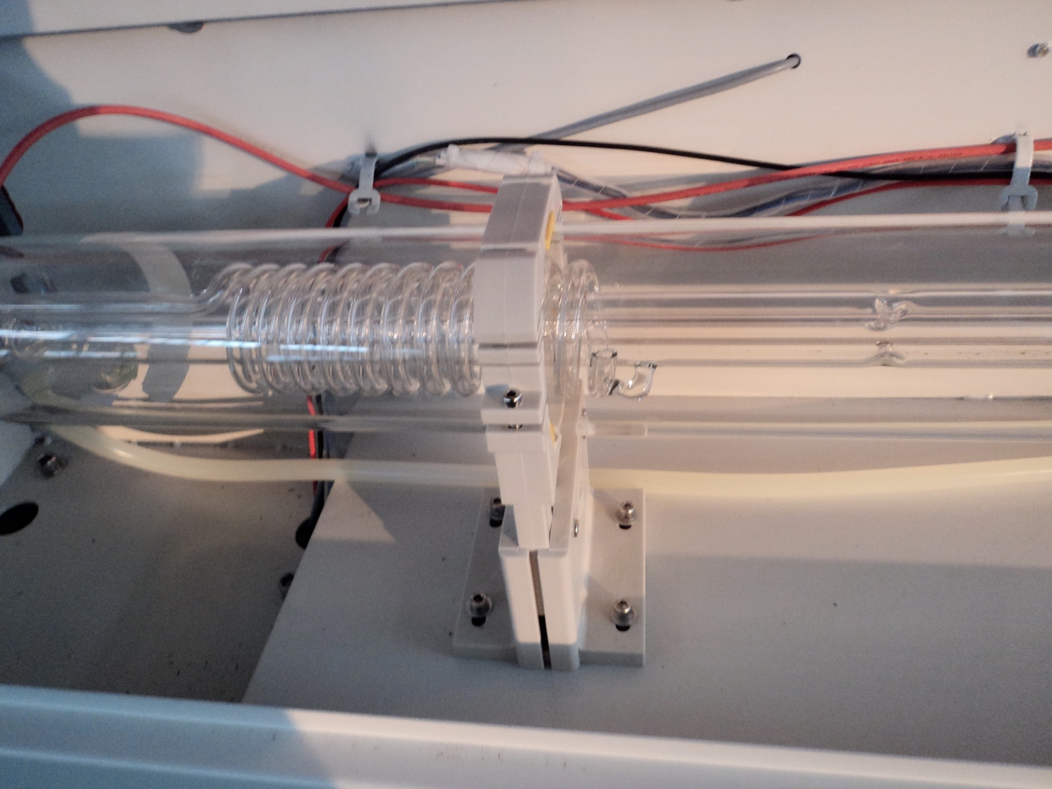

F2-1

Put the light-emitting window (low-voltage end)of laser tube with the same side of No.1 reflector mirror on the Vee-blocks carefully, and then latch on the rubber strip on the Vee-blocks wear of laser tube , fix laser tube well. As shown in Fig. F2-2:

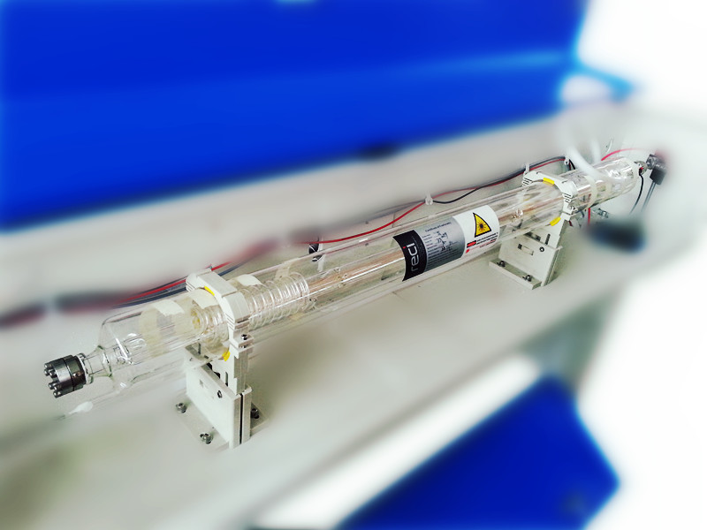

F2-2

**Attention:** ①The laser tube can’t be fixed too tightly to avoid damaging it; ②Be sure to keep the water inlet (laser tube high-voltage side) is located at the bottom of tube to keep the water filling the laser tube fully.

After Fixed the laser tube, the water inlet pipe which connect with water sensor should be connected with the high-voltage side water inlet mouth of the laser tube; the water outlet pipe should connect with the low-voltage water outlet mouth of laser tube (if the weather is cold, ,in case of break the laser tube, we’d better scald the end of the water pipe with boiled water to make it soft. ),As shown in Fig. F2-3, F2-4:

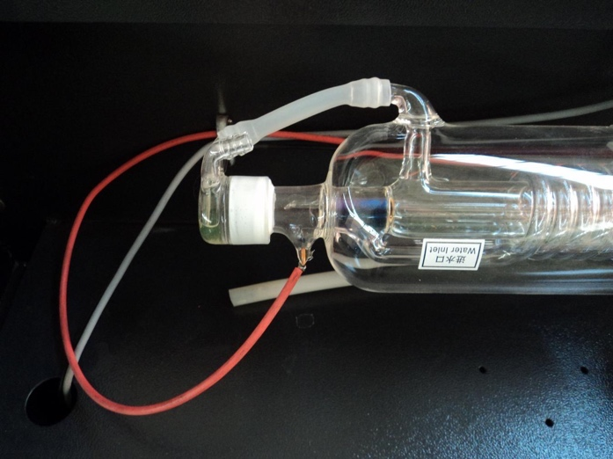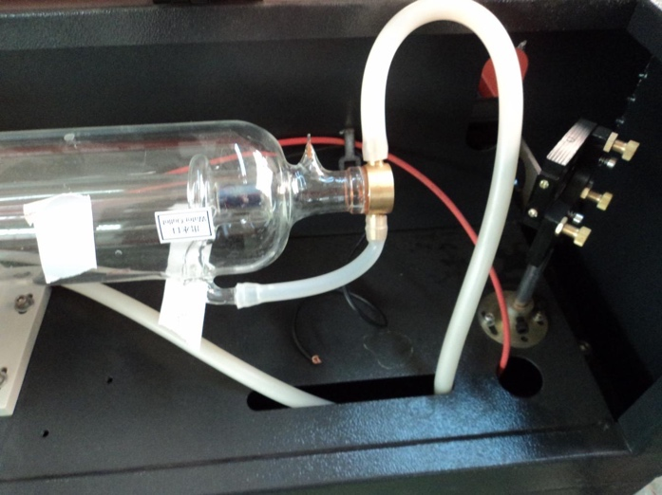

F2-3 F2-4

All the connectors must be butted firmly to prevent water leakage. The rubber pipe must be straight, can not be curled in order to avoid poor water flow.

Finally, let the high-voltage cable of the laser power supply connect to the high-voltage side post head of laser tube, the low-voltage cable of laser power supply connect to low-voltage side post head of the laser tube, as shown in Fig.F2-5 F2-6:

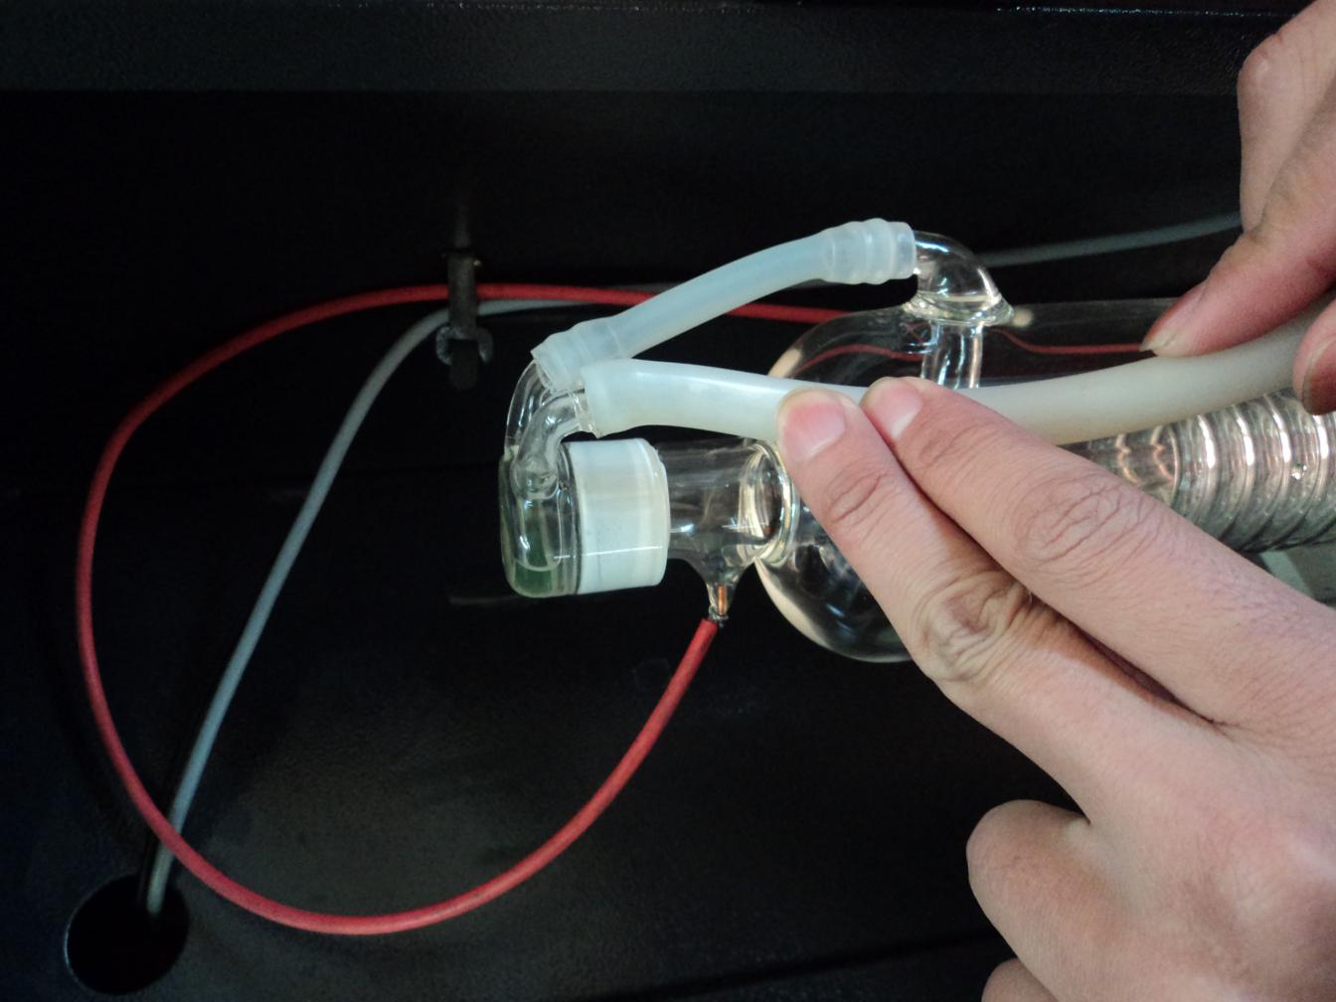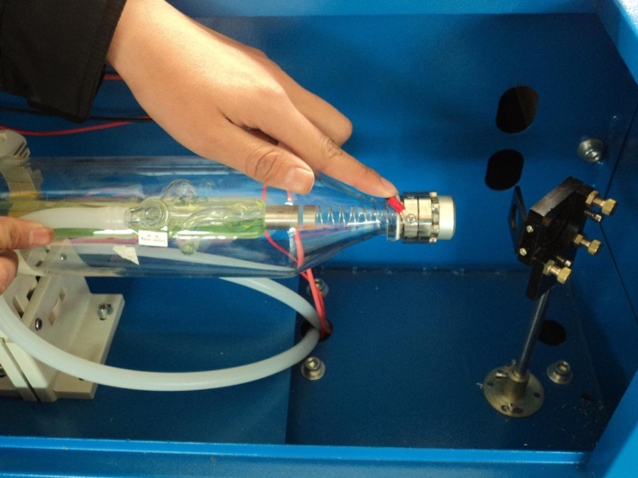

F2-5 F2-6

For security, please seal the post head of the high voltage side and low voltage with silicon gel.

#### 2. Water Pump Installation

Please fill pure water into the water tank (the water level should be higher than the pump at least). Let the water pump outlet connect to water inlet of the machine, using another piece of water pipe connect to the water outlet of the machine ,and put the other side of this water pipe into the water to complete the circulating water piping connection. As shown in Fig.F2-7, F2-8:

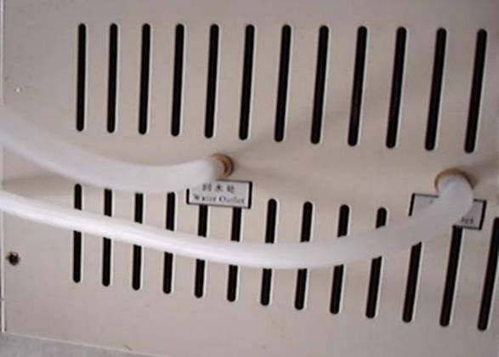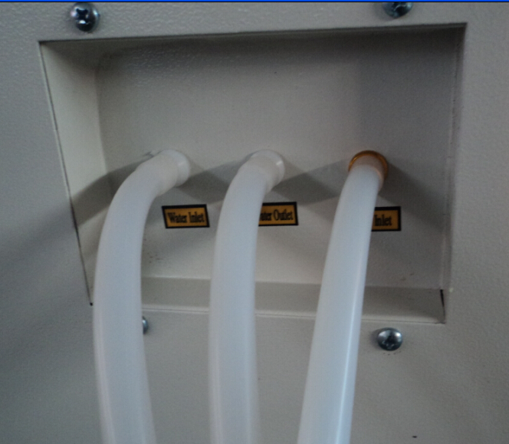

F2-7 F2-8

Connect the water pump power supply, at this time we can see that the laser tube is gradually filled with water. If the water can through the water outlet pipe smoothly, it shows that the pump is working properly.

In order to ensure the cooling water flow of the laser tube normally, a water protection sensor is installed in the water recycling system, when water pumps working poor or abnormal, the laser engraving machine will come into the protection state automatically. Then the laser tube will not emit the laser light. Therefore, in the course of routine maintenance, you should pay attention to the clean water pumps and water pipes.

#### 3. Installation of Air Pump

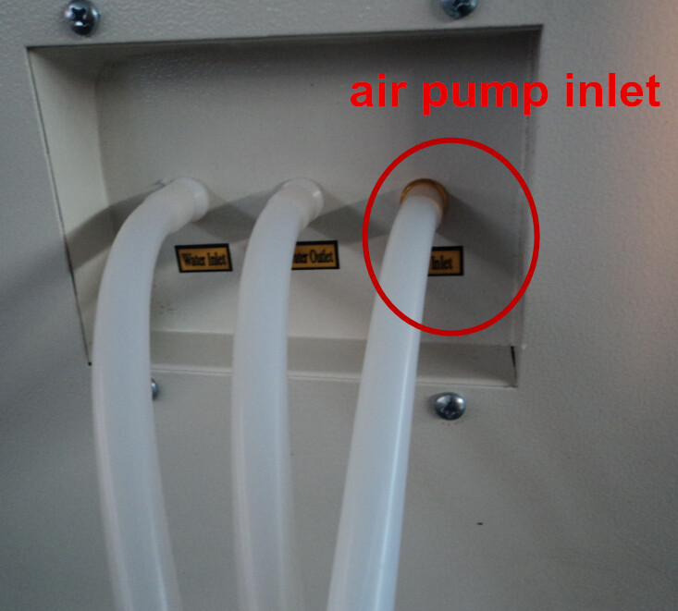Make the air outlet of the pump connected to the air inlet of the engraving machine with air pipe; ensure the outlet can vent air normally after turn on the power. As shown in Fig. F2-9, F2-10:

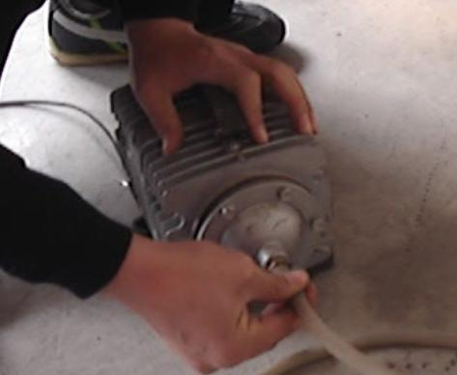

F2-9 F2-10

Air pump is very important in the system. High-pressure air [runs](app:ds:spout) through the air pump and blew out from the laser light-emitting window of the laser head. On the one hand, it can ensure the cleanliness of the focus lens, on the other hand, it can prevent the material inflame by the laser light. Therefore, in the routine maintenance, the user should pay attention to the air pipe, must ensure that it can not be twisty or damaged, otherwise abnormal air may lead to burning materials.

#### 4. Installation of Exhaust Fan

First, let the suction inlet of the exhaust fan connect to the dust suction outlet of the engraving machine by a smoke pipe, and fix them with lock. And then take another smoke pipe connect the outlet of the fan, and put the other end of smoke pipe to outside. At last, connect the power supply wire well. As shown in Fig.F2-11，F2-12:

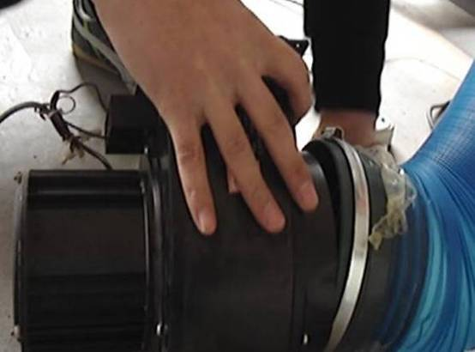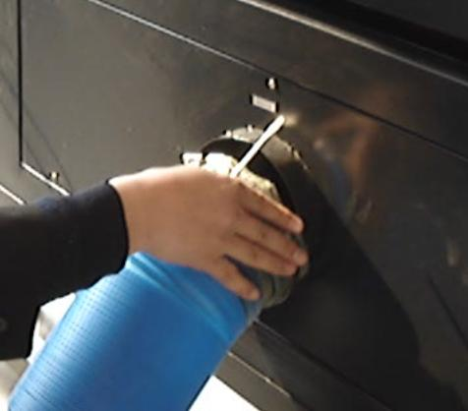

F2-11 F2-12

#### 5. Safety Grounding

Morn laser engraver uses fourth type of laser tube. The type of drive is high-voltage-driven, so during users use the machine, they must comply with the "Safety Note ". On the other hand, it asks stringent requirement about the safety grounding to the users. The safe Line-to-Ground Resistance should be less than 5Ω. Specific connection method are shown in Fig.F2-12, F2-13

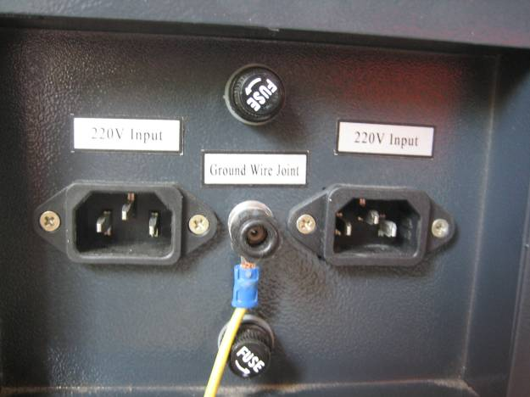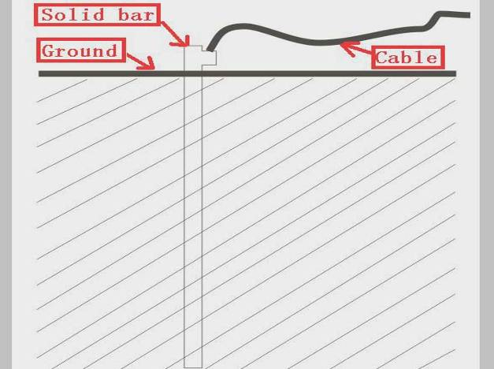

F2-12 F2-13

Attention please, bad grounding can cause high failure rate of equipment and at the same time may cause other safety incidents! ! !

The company won’t assume any responsibility and obligation to the fault and the accident caused by bad grounding!!!

6. Optical Path Adjustment

After let all power cables connect well and electrify, turn on the engraving machine power supply, at this time, the machine starts to reset and return to the last [origin point](app:ds:anchor%20point) . All above shows that the machine is running normally, then turn on the laser power supply, begin to adjust the optical path. As shown in Fig.F1-14:

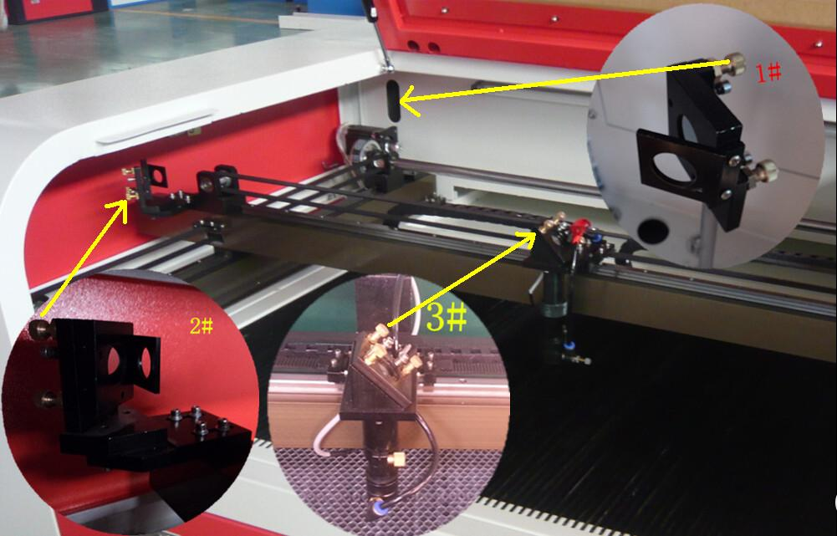

F2-14

Firstly, adjusting the laser position. Make the [multilayer](app:ds:multilayer) adjusting paper stuck on the 1# mirror frame, and then push the "Pulse" key on the control panel. There will be a burned point in the paper, check whether the light spot is in the center of the mirror, if the light spot is not in the center o f the mirror center, we have to make the light spot in the center of the mirror by regulating the location of the laser tube.

Then adjust the 1# reflector mirrors. Move the beams to the nearest place to the 1# reflector; push “Pulse” to get a spot in the paper. And then move the beams to the farthest place from the 1# reflector, get another spot in the paper. We adjust the angle of the mirrors by adjusting the three screws on the back of mirror (clockwise rotation the above screw, the spot will be down; clockwise rotation of the lower left corner of the screw, the spot will move to right; clockwise rotation of the lower right corner of screw, the spot will move to left.), to insure that all the spot are in the same place in

the paper when and where the beam we move.

After adjust the 1# reflector mirror well, the next, adjust the mirror 2# as we do at the first step, move the laser head to the nearest side to 2# reflector , then make a spot in the paper , then move the laser head to the farthest place to 2# , make a spot. We have to adjust the further spot overlap with the first spot by adjust the screws on the 2# reflector frame.

Note: As the best, the location of light spot should be in the center of mirrors. The light spot can not hit the edges of the mirrors. If playing in the edges, please continue to adjust the mirrors until the light spot in the central of them.

At last we have to check whether the light spots are superposition wherever the laser head is. If the spots can not coincide, please re-adjust the optical path by the way we talked above until the spots coincide

After finished the adjustment, we will check whether this laser spot is playing in central of the laser head light hole. If not, turn off the laser power supply, adjust the laser tube position. If it is left and right excursion, which side is biased on, we move the laser tube to this side direction. Such as: if left, we adjust the laser tube to left ; if right , we adjust the laser tube to right .

If the migration is up and down, we have to adjust the laser tube to the [opposite](app:ds:opposite) direction, that is, if up, we will make the laser tube down; if down, we will make the laser tube up.

Note: The above adjustments is just for a low-voltage side of laser tube (light side), if we want to adjust high-voltage side of the laser to achieve the same effect, then the adjusting direction is opposite.

The detailed description of how to adjust optical path, please see Chapter 4 "Alignment Standards of Optical Path".

After adjustment of optical path, please close the laser tube protective cover.

# Operation of laser machine

Besides use the computer to control the function key, we can use the Control Panel. The following is the brief instruction of control panel and main function.

There are 16 function keys and one LCD Panel in the Control Panel:

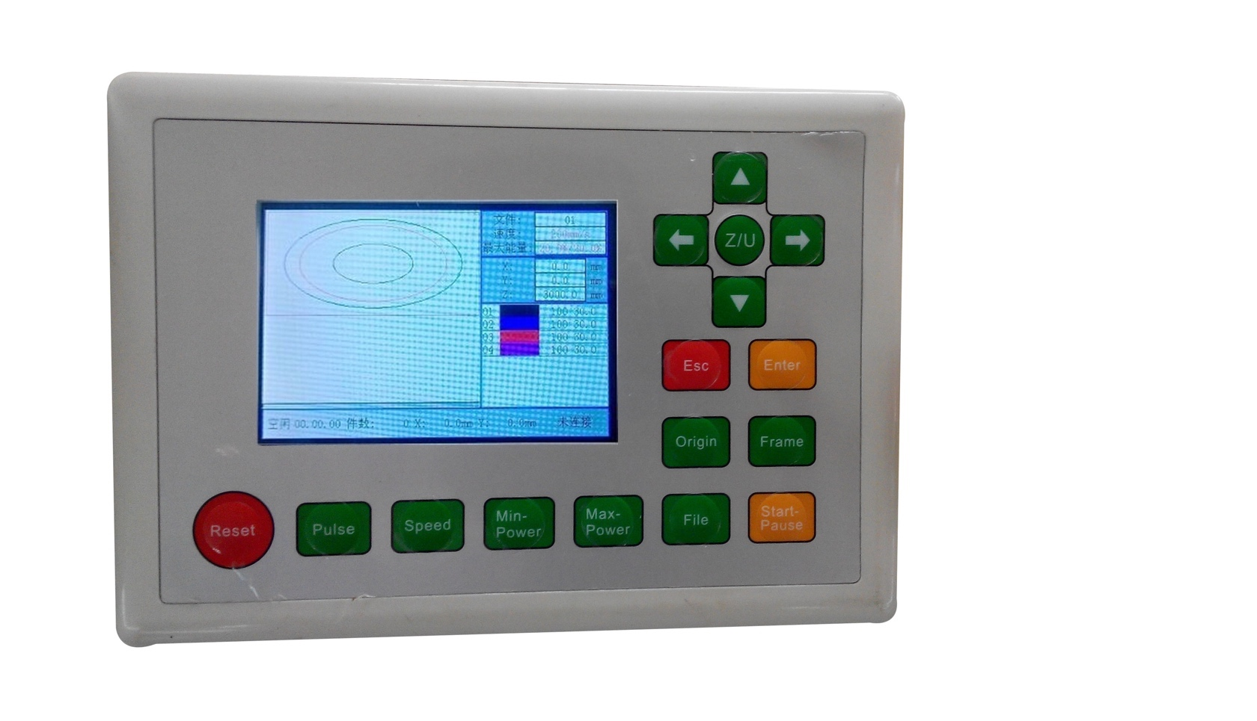

### I.3.1 Introduction of Main Interface

Main Interface1 (Idle)

|  |
| --- |
| File ： XXX  Max Power： XX.X%  Speed ： XXXmm/s  Idle ... |

Main Interface 1

Main Interface2 (Running)

|  |
| --- |
| Files ：XXX  Max Power ：XX.X%  Work Speed：XXXmm/s  Run ：XX：XX：XX |

Main Interface 2

Main Interface3 (Pause)

|  |
| --- |
| File ：XXX  Max Power ：XX.X%  Work Speed：XXXmm/s  Pause ：XX：XX：XX |

Main Interface 3

When the machine does not work, it will appears as “Main Interface1”. The Present file shows”000” (it means not choose Memory File), we can see the Max Power and Engraving Speed” from the LCD panel. The maximum energy expressed as a percentage, accurate to 0.1 percent, the unit of the Speed is mm/s.We can press any key under “Main Interface1”, but some key will not work under “Main Interface 2” and “Main Interface3”.

### I.3.2 Introduction of key

（1）Reset

Reset

Machine will reset(or energized) under all statuses. The main board will reset and the machine will come back to Work Original, and the LCD panel will show”System Reset”. After return Origin successfully, the machine will automatically go to the last Work Origin,

If the last work was finished completely, the LCD will appear the Main Interface 1.If the last work was not finished (the power was off when working), the system will show like this:

|  |
| --- |
| Power Off Rework  OK  Esc |

Interface 4

If we press “Esc” key, the machine will not work successive, and the system will come back to “Main Interface 1”; if we press “Enter”, the machine will continue work, and engrave the picture which is not finished before the power off.

Note, after we press “Enter”, the LCD will appear "Search Power Off Point , Please wait ", the waiting time has relation with last processing data quantity, the more

the data quantity is ,the longer the searching time is. Generally speaking, if the power was off after the graph processed an hour; the searching time is about 1 minute.

（2）Laser

Laser

We can Press this key when the machine under “Idle” and “Pause” status. When we press this key, there has laser emit from the laser tube, the time of light is the time we pressing this key. , when we release it, the laser stop. We can also cut materials by pressing this key and direction key. The laser power is the Max power on the LCD. This key is unusable when under other status.

While the water cooling system does not work, there will be no laser. Also, there will be an error message on the LCD.

（3）Parameters keys

Speed

Max

Power

Min Power

There are three parameters keys: Min Power, Max Power, and Speed. We can adjust the parameters keys under all the three main interfaces (Idle, Run, and Pause). We can see the parameters on the LCD panel when the machine works. When the software is generating the cutting/engraving file, if one of the parameter from Max power ,Min Power and Speed or all the parameters set to 0, it will take the corresponding parameters on the LCD which under the Idle status . Once start work, there will appear the currently processing parameters of the layer on the LCD。

Take “Speed” for example, we can see the following screen when we press Speed key:

|  |
| --- |
| Speed: XXX mm/s  OK Or Esc |

Interface 5

We can pitch onthe parameter which we want to adjust by left or right direction key, and then change it by up and down key. We can save it by pressing “OK” key, and cancel it by pressing “Esc” key.

The Min and Max power with the similar changes. When under Idle status, the power and speed change will affect following operation parameters: track frame on the

keyboard, laser, manual shift axis, etc. Change these three parameters when the machine is working, then just modify the ongoing effect of processing, do not affect layer under the idle status of keyboard parameters and will not affect other layer parameters.

On-line modification of the processing layer parameters, bring great convenience to the users to find a reasonable laser power and speed matching.

（4）File

File

We can see the following screen when we press file key when the machine under the Idle status:

|  |
| --- |
| MemoryFile  UDiskFile  TrackFrame  Del All Memo File |

Interface 6

We can pitch on the file by up or down direction key, then press “Enter” to enter next file. It will show us no “file” if there is no file in “MemoryFile” or “UdiskFile”. If there has file, we can see the name and information of the file on LCD Panel. We can see four files on LCD Panel.

|  |
| --- |
| XXX:XXXXXXXX  XXX:XXXXXXXX  XXX:XXXXXXXX  XXX:XXXXXXXX |

Interface 7

We can choose file by direction keys (up and down used to change the item, left and right key used to change page), and then click “Enter” to enter next interface. It supports the following four functions: “Run”, “Track Frame”, “ToUsb”, “Delete”.

|  |
| --- |
| Run  Track Frame  ToUsb  Delete |

Interface 8

The machine will process the checked file when we choose “Run”, the file will copy to U disk when we choose “ToUsb”, the file will be deleted when we choose “Delete”.

For files in U disk, it supports “copy” and “delete” two functions. If there is any thing wrong, we can press “Enter” or “Esc” key to save or cancel it.

The main board can recognize FAT32 and FAT16 format files. But we have to put these files in U disk root file. More than eight characters files are automatically cut off, the name of the files must be letters or numeral. The files copied from the motherboard to the U disk are placed at the root file.

"TrackFrame" option of Interface 6 means track border for the selected current memory file (latest processed file); "Track Frame" option of Interface 8 means track border for the particular memory file. Any one of these two options is selected, the interface is shown below:

|  |
| --- |
| Blank X.XX mm  CutFrame  TrackFrame  DotCorner |

Interface 9

Get into the interface 9, the cursor is in the first option "Blank" by default (the Blank is the extends outward distance on the basis of the actual size of the graph), at this time, we can set the “Blank” by pressing the arrow keys. Then press the keys “Enter” or “Esc” to set or cancel the setting. After we set the blank distance, the cursor will return to the "Blank", we can select other options by pressing up and down arrow keys. "CutFrame" can make us cut down the finished graph by hands; “TrackFrame” means moving along the border to achieve frame preview; "DotCorner" means the laser will emit at the four corners of the border, through the four spots we can view the graphical size and location intuitively. At these times, the moving speed and the laser power of the machine are the settings which appear on the LCD when the system is idle (the laser power for “DotCorner” is only has relation with the “Max Power”).

Note: If the size of the graph is too large, or the location is very near to the Max/Min coordinates, the border may be exceed the Max /Min coordinates. At this point the interface will show “Exceeding” information, after press Enter key, the system will track or cut down the frame according to the Max/Min coordinates. For “.rd” file generated by older versions software, the interface will

show "No Frame "information when operating frame to “.rd” file. When start border operation successfully, the interface will show "Tracking Frame ",at this time ,the display won’t respond to any other buttons except "Reset".

（5）Start/Pause

Start-Pause

Start/Pause can be pressed in three main interfaces. Press this key when the system is idle, it will process the selected files; Press this key when the machine is working, the work will be paused; Press this key in pause interface, the work will continue.

（6）Origin

Origin

We can press the key when system under Idle status. The main board will take X/Y axis position of current machines as start working point. This key is invalid in other interfaces.

Lan-

Guage

（7）Language

Man-machine interface supports three languages. When the system is idle, press "Language" key, enter the language selection interface, there are three languages: "Simplified Chinese", "Traditional Chinese" and "English", select the language and press the "Enter" key, then the LCD will display the appropriate language. Not modified in the next language, the language selected last time will be effective permanent before changing language next time. (Even restart the machine).

（8）Esc、 Enter

Enter

Esc

Pressing Esc or Enter keys can confirm or cancel the operating in every interface.

（9）Direction key（up and down, left and right）

Direction keys are used to change parameters, move the axis. We can press direction keys to move axis in Idle or Pause system interface. Moving X axis by pressing left and right key, moving Y axis by pressing up and down keys. The Maximum moving speed of pressing key is speed on the LCD when the system under idle status

（10）Z/U key

Z/U

Z/U key is available under the idle status.The interface will show as below after

pressing the key:

|  |
| --- |
| ZAexsMove  UAexsMove  ZAexsReset  ManualSet |

Interface 10

We can change cursor location by pressing up and down arrow keys. When cursor stays in the "ZaexsMove", the axis will move when pressing left and right direction keys.

If the step moving distance is 0,Z-axis will be continuous movement when we pressing left or right keys; If not 0, Z-axis will move a certain distance when we pressing left or right keys. "UaexsMove" is similar as "ZaexsMove". When the cursor selects "ZaexsReset" option, press “Enter”, the system will start to operate Z-axis back to the origin, then the interface shows "Z axis is resetting", when the Z-axis reset finished after finding the origin successfully, the same as X/Y axis, Z axis has Max/Min coordinate protection, Z axis has a automatically acceleration and deceleration when it moves in the Max/Min coordinates of the worktable of. When the cursor selects "step set "option, press Enter, the interface shown as follows:

|  |
| --- |
| Step Moving Distance  XXX.Xmm |

Interface 11

We can set it by pressing the arrows. The set of set moving distance set affects four-axis step distance operation of X/Y/Z/U.

## I Chapter 4　Alignment Standards of Optical Path

During common use, there may appear some deviation with the optical path, resulting in no laser or light path is abnormal, then please refer to the following method to adjust the optical path:

Step one: First to ensure laser beam from laser tube to the center of 1# reflector mirror.

Step two: Affix multi-storey double sticky tape paper on the 2# reflector (Or other objects can be marked on), move laser beam to closest location of laser tube, press pulse(choose suitable power),get a spot on the paper(with special attention: In order to prevent the laser radiation wounding, with a piece of cardboard first to test the approximate location of the spot, and then adjust).

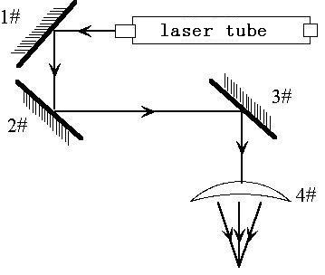

Step three: Move away the beam to the position far from the laser tube, press pulse, get another spot on the paper.

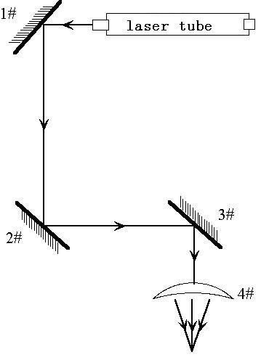

Step four: If the two spots are not superposition, adjust the screws on the back of the 1#mirror to make the laser fire on the same position as the first spot.

Step five: Repeat the second to the fourth steps until the two spots overlap completely. Moreover, the spots should be in the center of the hole.

Step six: Affix multi-storey double sticky tape paper on the 3# reflector ,move laser head to the nearest position from 2# mirror, press pulse(choose suitable power),get a spot on the paper.

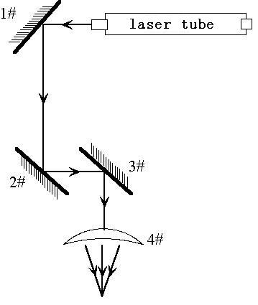

Step seven: Move away the laser head to the position farthest from the 2# mirror, press pulse(first to detect the approximate location of laser with a piece of cardboard to prevent wounding),get another spot .

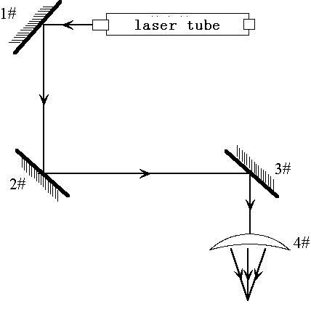

Step eight: If the two spots are not superposition, adjust the screws on the back of the 2# mirror to make the laser fire on the same position as the first spot.

Step nine: Repeat the sixth to eighth steps until the two spots overlap completely. Moreover, the spots should be in the center of the hole.

Step ten: Affix multi-storey double sticky tape paper on the 3# reflector, press pulse, get a spot on the paper. If it is in the center of light hole, then pass.

Step XI: If the laser light is not in the center of light hole, as below figure:

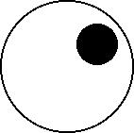

In the left Figure, the spot is upper and right biased.

Top to bottom bias: can only raise or lower the laser tube.

Inside and outside bias: only move the laser tube in or out to adjust.

In this case, it is essential to lower the laser tube(here refers to low-voltage side of the laser tube),and then, from the beginning of all the re-adjustment of the first step.

Note: The operator can’t do the above working until after the professional training. Otherwise, the operator do this working must with the help of the professional .The operator must pay attention to security when adjusting, to prevent the laser radiation wounding.

## I Chapter 5 Daily Maintenance and Common Faults

The stable working of the machine is inseparable with normal daily operation and maintenance. Here are some common daily maintenance and common faults analysis:

### I.5.1 Daily maintenance

1. Replacement of the cooling water (clean water tank and replace recycled water once a week are recommended):

Quality and temperature of the cooling water can affect the lifetime of laser tube directly, suggest use purified water or distilled water, and water temperature should be below than 35 ℃.When higher than 35 ℃,please replace cooling water, or add ice cubes to lower the water temperature,(cooling device is recommended, or use two water tanks).

Note: To ensure that the laser tube full filled with cooling water before machine working.

2. Cleaning of Water Tank

First of all, turn off power, disconnect the water inlet pipe, let the inside water of the laser tube flow into the water tank automatically, open water tank, take out the water pump, clean water pump and water tank, put the pump back to water tank, insert the water pipe which connect water pump to water inlet mouth of the machine, finish all joints, then replace cooling water. Turn on the water pump power supply isolately, let the pump run 2-3 minutes (make laser tube full filled with water).

3. Cleaning of Exhaust Fan

After long time using, inside of fan will accumulate much solid dust, so the exhaust fan will make a great noise, and it is not conducive to the exhaust .When the exhaust effect become poor, we have to clean the fan and smoke pipe .Firstly, turn off the power supply, remove the two pipes from the fan, clean dust inside of the pipes, and then clean the dust inside of the fan.

4. Cleaning of Lens (daily cleaning is recommended before work, equipment must be in shutdown state)

As we have talked before, engraving machine has three reflector mirrors and one

focus lens (1# reflector mirror is near the light outlet mouth of laser tube, the upper left corner of the machine,2# reflector mirror is at left side of the beam,3# reflector mirror is on the top of laser head, the focus lens is located in the bottom part of the laser head),the laser is send out by the mirror reflecting and focus lens focalizing. Mirror is easy to be dirty, resulting in laser loss and mirror damage, you needn’t remove 1#,2# and 3# mirror when cleaning them, Just using a cotton bar to dip some cleaning solution (acetone or alcohol) , swab carefully by rotating from central to edge of the lens.

Take out the focus lens from the laser head, using the same method clean it, after cleaning, put it back.

Note: ① you should wipe the lens carefully, can not damage the surface coating; ② you should do that lightly, to prevent falling; ③keep concave side downward when install the focus lens.

5. Cleaning of Guideway（导轨） (suggest cleaning every two weeks, equipment must be in shutdown state)

First of all, move the laser head to the far right (or left),wipe with a dry cloth until shiny clean, together with a little oil (sewing machine oil is recommended),push the laser head several times slowly along the guide, so that lubricant can be evenly distributed. Clean and lubricate the Y axis two guideways is the same as X axis.

Note: Please prepare for cleaning Guide - dry cotton cloth, lubricating oil.

6. Optical path inspection

Optical path system of the laser engraving machine is completed by the mirror reflection and focus lens focusing, and there is optical path bias with the focus lens, but the three mirrors is fixed by the mechanical part, optical path bias is very possible for them ,although there is no optical bias normally, we still suggest you check optical path before working.

Please get detailed explanation from Chapter 4 "Alignment Standards of Optical Path "I.5.2 [Common](http://www.iciba.com/common/) Faults [Analysis](http://www.iciba.com/analysis/)

|  |  |  |  |
| --- | --- | --- | --- |
| No. | Phenomena of Malfunction | Analysis method | Solution |
| 1 | Open the machine but no movement | Check power supply of machine connects well or not | Make all power supply electrify again |
| Mainboard parameter is right or not | Correct the parameters according to software operating manual |
| 2 | Working with nonstop laser | Mainboard parameter is right or not | Correct the laser parameters according to software operating manual |
| 3 | Desultory light when working | Check water circulation is swimmingly or not | Clean water tank, water pump and water pipe |
| Voltage is stable or not | Add regulator for the laser machine |
| 4 | Self-test abnormal when starting | Mainboard parameter is right or not | Correct the X and Y axis direction ,limit position parameters according to software operating manual |
| 5 | After output data ,machine no action | Check whether the data port choice is correct. | Choose correct port |
| Check whether turn on the machine | Turn on the machine |
| Check whether connected ground wire for the machine | Connect ground wire |
| check whether installed the USB driver | install the USB driver |
| 6 | No laser when working | Check whether optical path is bias | Adjust the optical path |
| Check whether the cooling water is running | Ensure the water is running |
| 7 | Can’t detect the laser equipment | TThe computer or USB communication problem | Change computer or USB line |

## I Chapter 6 Warranty Regulations

I 6.1 Warranty Periods

From the date of purchase, whole year warranty (except consumables). Optical lenses and the laser tube are consumables, three months warranty.

I 6.2 Warranty Clauses

This warranty is for products of our company.

During the warranty period and under the correct use, malfunction can be based on this warranty terms, show the warranty card or invoice, enjoy our free maintenance service.

The following cases, can’t enjoy the free service, a fee will be charged according to the concrete condition.

1) Maintenance services not caused by the machine quality;

2) Overstep the warranty period;

3) Can’t show or alter warranty card;

4) Didn’t fulfill the contractual obligation;

5) Without the company agrees, privately to tear open outfit, modification, maintenance of product;

6) Equipment failure due to human or force majeure factors.

The company only assume the legal obligation for the product itself, but don't assume other responsibilities which caused by the using of the products.

# II RDCAM V3.0 User Manual

## II Chapter 1 Overview

### II.1.1 Laser engraving cutting system introduction

Laser engraving cutting system achieves effective control through a computer numerical, according to the user’s different requirements of the completion of processing tasks. The system including control board and control panel, and supporting software. This manual describes how to use the software to complete the task of laser processing. (Motherboard wiring and control panel operations see the accompanying manual and control panel wiring board operating instructions)

### II.1.2 Software supported file formats

Vector format：dxf, ai, plt, dst, dsb…etc.

Bitmap format：bmp,jpg,gif,png,mng…etc.

### II.1.3 Environmental requirements

⑴ Windows 2K/XP/Vista、win7,XP recommended.

⑵ Above CPU586, above PIII or PV recommended.

⑶ Memory, above 1G recommended.

## II Chapter 2 Software installation

### II.2.1 Install steps

1. Double-click the Setup.exe under the installation directory, the following dialog box appears:

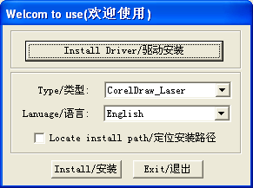

1. Click【Install Driver/驱动安装】to install USB drive:

If there are hardware installation prompts, choose continue until the installation is complete.

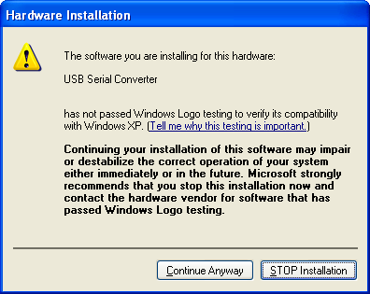

After installation, the following dialog box appears, indicating the successful installation of USB drivers.

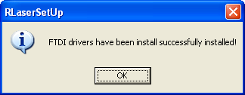

1. Select the software version of the type and language, as shown below:

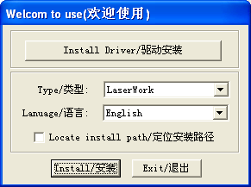

Select install language

1. Click【Install/安装】.After installation, following dialog box appears, indicating the software has been installed successfully.

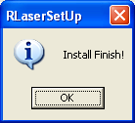

## II Chapter 3 Software Basic Operation

### II.3.1 The main interface operation

After start the software, you can see the interface shown in the following figure.

Menu Bar

Cutting Property Bar

System Bar

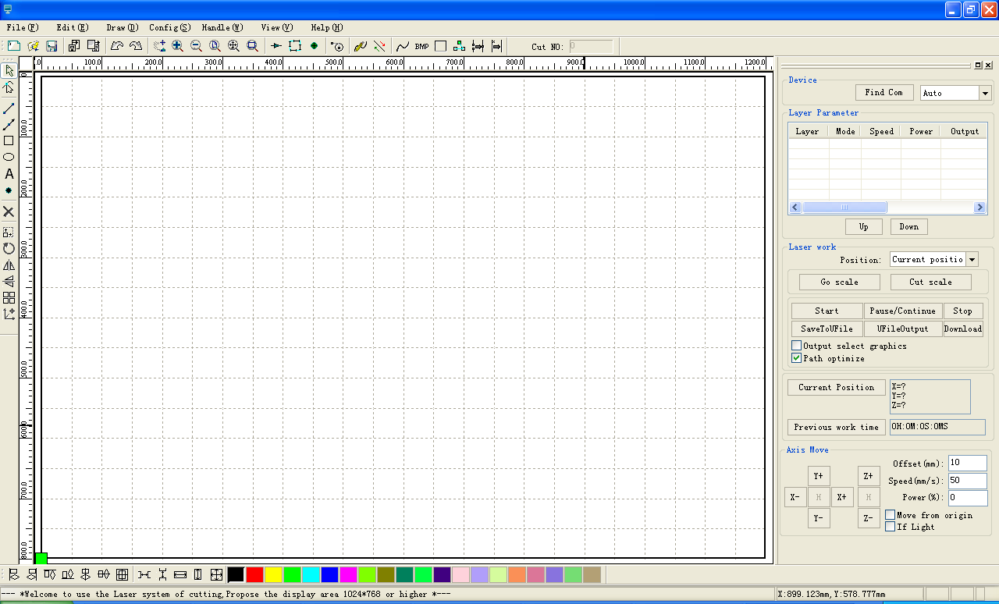

Control Panel

Layer Bar

Align Bar

Edit Bar

**Menu Bar**：The main function of this software is available through the implementation of the Menu Bar. Menu bar including: Document, Edit, Draw, Setting, Processing, View and Help.

**System Bar**: On the System Bar, placed some most commonly command buttons which is chosen from the menu.

**Edit Bar**：The Edit Bar default on the left of the work area. In the Edit Bar placed frequently used tools to make the operation more flexible and convenient.

**Align Bar**：Alignment of the selected objects.

**Layer Ba**r：Change the layer of the selected objects.

**Control Panel**：Using the Control Panel to complete laser processing of multiple tasks,

Layer parameter settings, axis control, processing etc.

### II.3.2 Language settings and machine information

In addition to installation process can set the software language type, you can easily switch in different language.

Click Menu Bar【**Help**】->【**语言/Language**】expand menu，select the required language types.

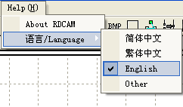

To obtain manufacturers information, so that we can provide you with better service. Click Menu Bar【**Help**】->【**About RDCAM**】

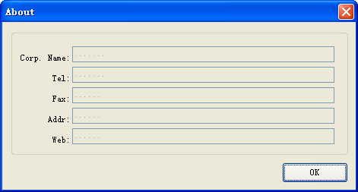

### II.3.3 page setting

Click Menu Bar【**Config**】->【**Page setting**】the following dialog box appears：

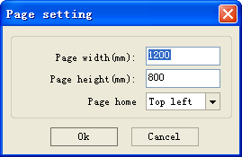

【**Page width**】：Software page width, usually associated with machine X breadth.

【**Page height**】：Software page height，usually associated with machine Y breadth.

【**Page home**】：Software page zero point, usually associated withmachine home position**.**

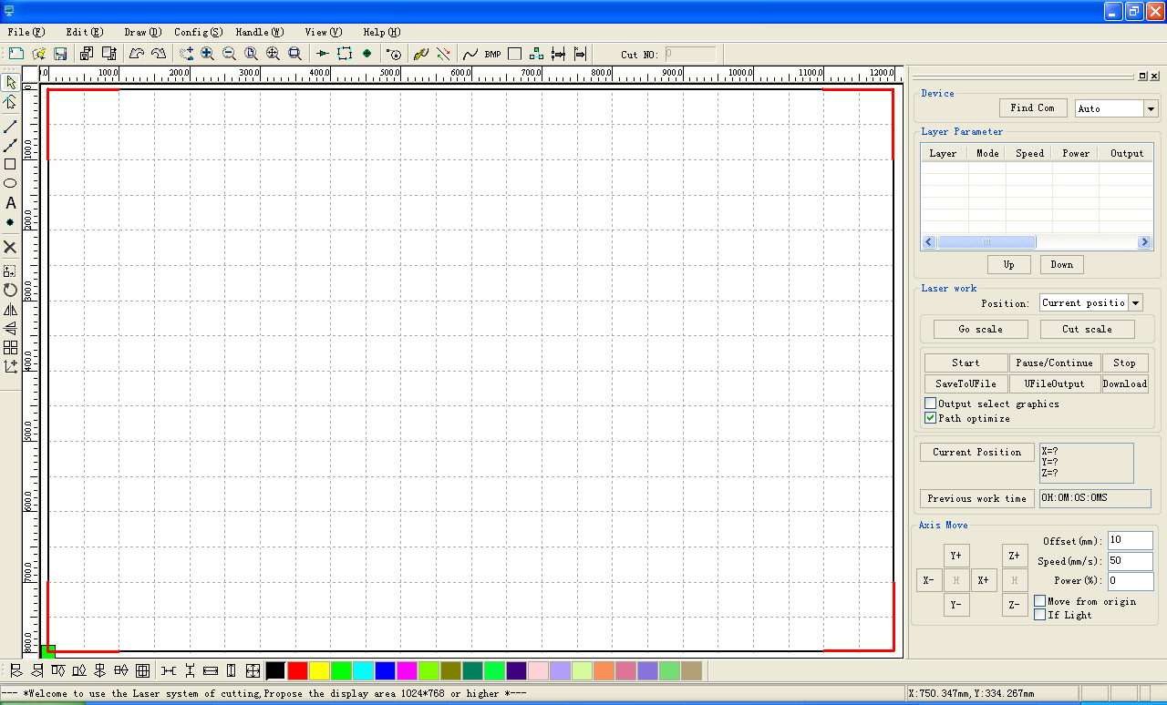

Bottom right

Bottom left

Top right

Top left

### II.3.4 File open and save

The software uses rld file format to save graphic information、layer parameters of various layers and processing sequence of the graphic elements.

II.3.4.1 Open File

Click menu【**File**】->【**Open**】,or click icon, the following dialog box appears：

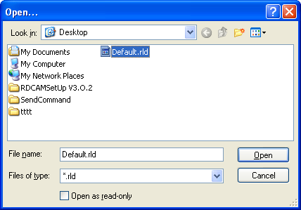

Select file

选中【预览图形】可以显示当前选择的文件

（2）Select file (e.g. Default.rld), click【**Open**】

II.3.4.2 Save File

Click menu【**File**】->【**Save**】,or click icon,the following dialog box appears：



Input file name

（2）Enter the file name in the edit box，then click【**Save**】.

### II.3.5 File import and export

Supported file format for import: dxf, ai, plt, dst, dsb...etc

Supported file format for export plt

II.3.5.1 File import

Click menu【**File**】->【**Import**】，or click icon. The following dialog box appears.

Select file, and click【**Open**】.

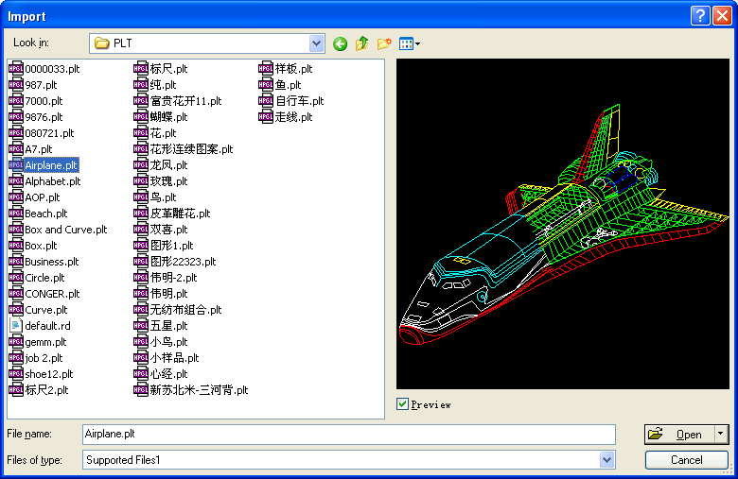

Select【**Preview**】，the selected file can be shown.

For most vector file, data automatically imported into the corresponding layer of RDCAM software according to the layer description.

For some special documents such as DST/DSB, data will be imported into the current layer.

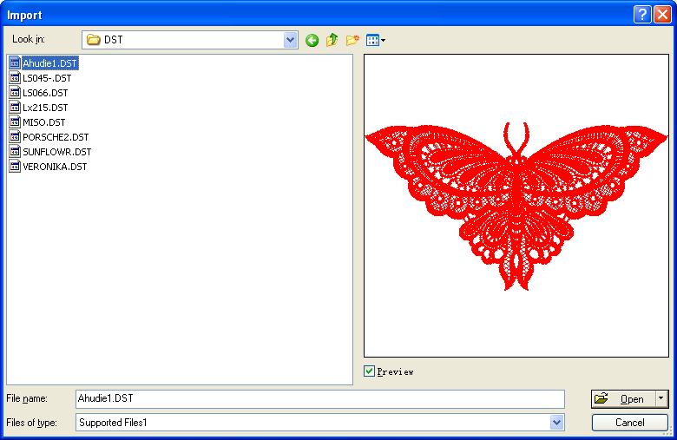

Current layer



II.3.5.2 File export

Click menu【**File**】->【**Export**】or click icon. The Export dialog box appears.

Input file name, and click button【**Save**】.

II.3.5.3 File parameters setting

**PLT Precision**: According to the accuracy of the original plt file to select the appropriate import unit.

**Smooth curves**: When import vector file，automatically smoothing the original curves. For the original graphic is smooth or need to repeatedly adjust the beset smoothing effect, you can uncheck this button. Do not do smoothing curves may reduce time of import processing.

**Auto close curves**：According to close tolerance automatic check and closed curve

**Auto delete repeat lines**: Automatically remove the completely overlapped curves.

**Combine lines**：According to merger tolerance, auto-connecting curves.

**Export precision**: The accuracy of export plt file or output file.

**Velocity uni**t: Software supported two types of speed unit: mm/s、m/min.

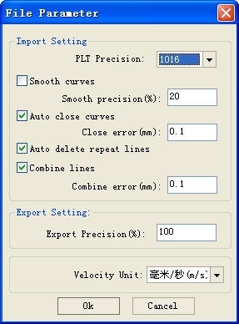

### II.3.6 Basic graphics creation

◆ Line

Click menu【**Draw**】->【**Line**】，or click Edit Bar ,drag the mouse on the screen you can draw an arbitrary line. Press the “Ctrl” key while dragging the mouse to draw horizontal or vertical line.

◆ Polyline

Click menu【**Draw**】->【**Polyline**】，or click Edit Bar . Drag the mouse on the screen you can draw an arbitrary polyline.

◆ Rectangle

Click menu【**Draw**】->【**Rectangle**】，or click Edit Bar . Drag the mouse on the screen you can draw an arbitrary size rectangle.

Press the “Ctrl” key while dragging the mouse to draw square.

◆ Ellipse

Click menu【**Draw**】->【**Ellipse**】，or click Edit Bar . Drag the mouse on the screen you can draw an arbitrary size ellipse.

Press the “Ctrl” key while dragging the mouse to draw round.

◆ Text

Click menu【**Draw**】->【**Text**】，or click Edit Bar .

Software supported two type of font to create text: TrueType and SHX.

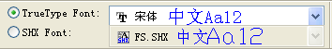

Double-click on the screen, the following dialog box appears.

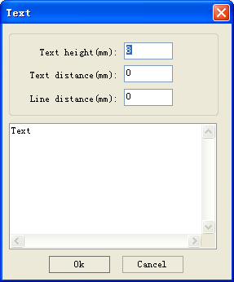

Input text and text setting, click button【**OK**】.

### II.3.7 Object selection

In the process of drawing and edit graphics, first of all is to select the object.

When the object is being selected, in the center of this object will have a shaped mark“ × ”，and surrounded by eight control points.

Click menu【**Draw**】->【**Select**】，or click Edit Bar，switch to status “Select”. Under this status, you can select object. The following are five kinds of method of selecting：

◆ Click menu【**Edit**】->【**Select All**】（Shortcuts **Ctrl+A**）, select all objects.

◆ Click mouse on the screen to select single object

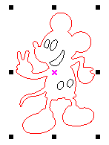

◆ Select object using select box

Press the mouse and drag, as long as the box come into contact with the object will be selected.

◆ Increased select object/minus select object

Increase select：Press “Shift” key, click or box select to increase select object.

Minus select：Press “Shift” key, click or box selects the selected object.

◆ Select object according to layer

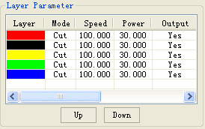

Right-click the selected layer, then the part of all objects in the layer will be selected.

### II.3.8 Object color

The color of object that is the color of the object contour. You can click the color button on the Layer Bar to change the color of the object has been selected. The color of the pressed button is the color of current layer.



### II.3.9 Object transformation

Transformation of object mainly include: object location, orientation and size, but does not change the basic shape of the object and its characteristics.

II.3.9.1 Object Image

Object image is flip the selected object in the horizontal or vertical direction.

Click Edit Bar，flip the selected object horizontal.

Click Edit Bar ，flip the selected object vertical.

II.3.9.2 Object Rotate

Click Edit Bar，will pop up the dialog of rotate angel setting.

Set rotate angle and click the button【**OK**】.

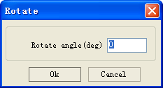

If you want to drag rotation, set rotate angle 0, and determine.

Dragging the mouse to adjust the rotate angle, in the dragging process, there will be followed by rotating wire-frame outline.

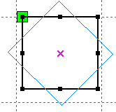

II.3.9.3 Object Size

Select objects，click Edit Bar， will pop up the dialog of size setting.

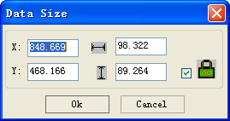

You can set size and center position of the selected object.

You can lock ratio of the selected object by check.

II.3.9.4 Object Array Replication

Click Edit Bar，select object wants to copy. Then click ， the following dialog box appears：

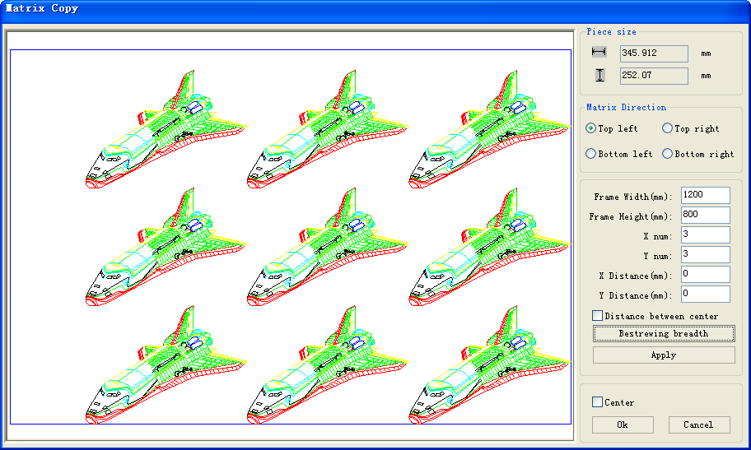

 Width of a single graphic (mm) Height of a single graphic (mm)

You can array replication object along different directions. The direction of copy is based on the original graphics. Such as choose the array direction lower right, and then the original graphic will appear on the upper left corner wheras if it is to the upper left array, then the original graph appears in the lower right.

After setting the array number and array spacing，click button【**Apply**】,you can see the actual graphics array.

There are two forms of array spacing：center spacing and edge spacing.

Choose center spacing，then【**X Distance(mm)**】、【**Y Distance(mm)**】representing the distance of the two graphic center.

If not choose center spacing, then 【**X Distance(mm)**】、【**Y Distance(mm)**】representing the distance of the graphic edge.

Center distance X= Edge distance X + width of object

Center distance Y= Edge distance Y + height of object

Switch between the two kinds of calculate method, 【**X Distance(mm)**】、【**Y Distance(mm)**】will be calculated automatically.

Click【**Bestrewing breadth**】，The software will automatically calculate the array number

according to the workpiece size、width、height、X distance and Y distance.

Adjust spacing can be directly input values, and click 【**Apply**】

Can also press the direction keys to adjust objects spacing.

Check【**Center**】,then after object array replication, graphics will be centered on the work area.

Scroll the mouse wheel to zoom view of the graphics.

Drag the mouse to pan view of the graphics.

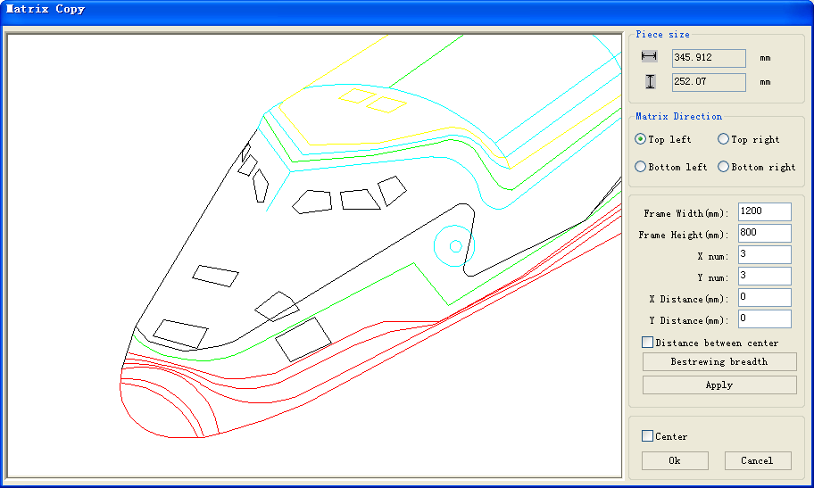

II.3.9.5 Place Object to the Origin

Click，select objects need to place to origin then click.

### II.3.10 Object Align

Select objects，click tools on the Align Bar.

Whick include:

Left alignment、Right alignment、Top alignment、Bottom alignment

Vertical center alignment、Horizontal center alignment、center alignment

Horizontal equidistance、Vertical equidistance

Same width、Same height、Same size.

Benchmark object：

If you press “Shift” key and select object one by one, Zhen the benchmark object is the last object.

If you select object by select box, then the benchmark object is the object which curve number in the final.

### II.3.11 Object View

Move：Click menu【**Edit**】->【**Move**】，or click .Then hold down the left mouse button in the drawing area，and drag pan.

Zoom Out：Click menu【**Edit**】->【**ZoomOut**】，or click .Each click it，the drawing area zoom out once. Move mouse to the drawing area and click, each click, mouse position as center drawing area zoom out once.

Zoom In：Click menu【**Edit**】->【**ZoomIn**】，or click .Each click it，the drawing area zoom in once. Move mouse to the drawing area and click, each click, mouse position as center drawing area zoom in once .

View Select：Click menu【**Edit**】->【**View Select**】，or click .Move the mouse to the drawing area, hold down the left mouse button and drag，a dash border box will show in the drawing area, release mouse button，then the region in the dash border box will display in the drawing area with the largest proportion.

View Page Frame：Click menu【**Edit**】->【**View Page Frame**】，or click .The page frame will full display.

View Data Frame：Click menu【**Edit**】->【**View Data Frame**】，or click .The selected objects will full display

### II.3.12 Important Tool

Here are some frequently used tools. Using these important tools, can make the current document in the graphics more orderly, and make the processing of output faster.

II.3.12.1 Manually Set the Cut Order

Users can set cut number of each object manually.

Click menu【**Edit**】->【**Show direction**】and【**Edit**】->【**Show path**】，or click System Bar，

Work area will display the path and direction of cutting.

Dash lines means that the laser is off.

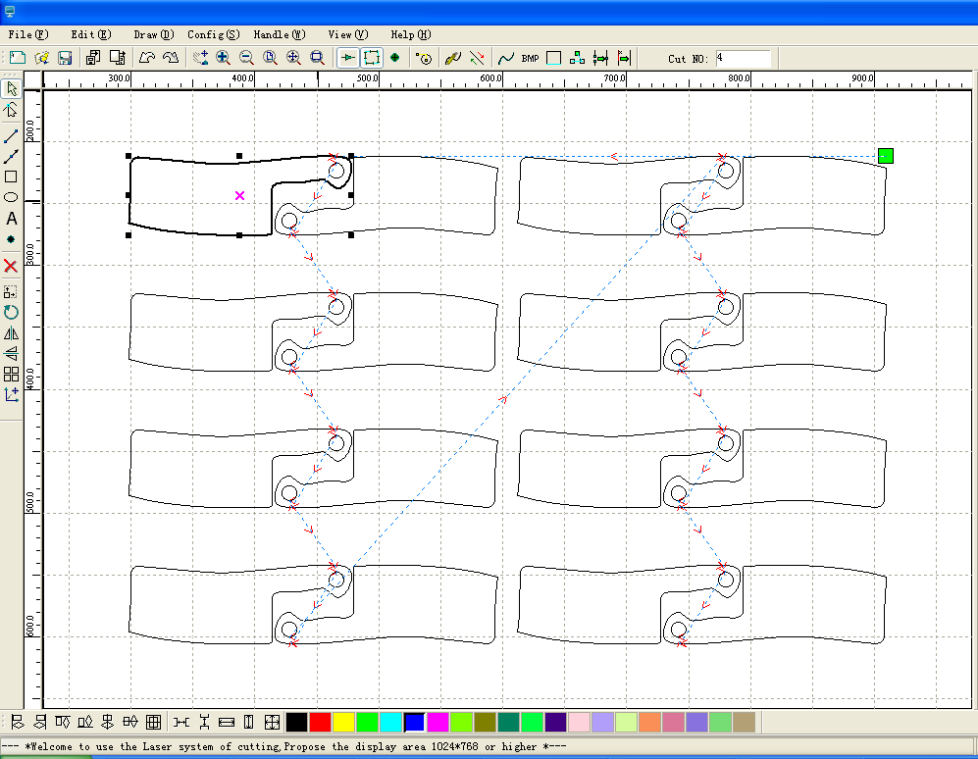

Cutting number

Path

Direction

Graphics processing sequence is along the dash lines.

Cutting Property Bar shows the cutting serial number of the current selected object, modify the serial number, cutting sequence will change also.

II.3.12.2 Manually Set the Cutting Direction and the Starting Point

Click menu【**Edit**】->【**Show Direction**】，or click System Bar，shows the cutting direction.

Click menu【**Edit**】->【**Show Point**】，or click System Bar ，shows all the points of the selected graphics.

Click menu【**Edit**】->【**Set Cut Point**】or click System Bar ，enter the mode for edit cutting point

As shown in following figure, the node where the arrow is located is a cutting point.

Double-click any point on the curve, will located the cutting point at the point.

Click menu【**Edit**】->【**Set Cut Direction**】or click System Bar ，enter the mode of edit cutting direction.

Double-click the node where the arrow is located, the cutting direction of the object will reverse.

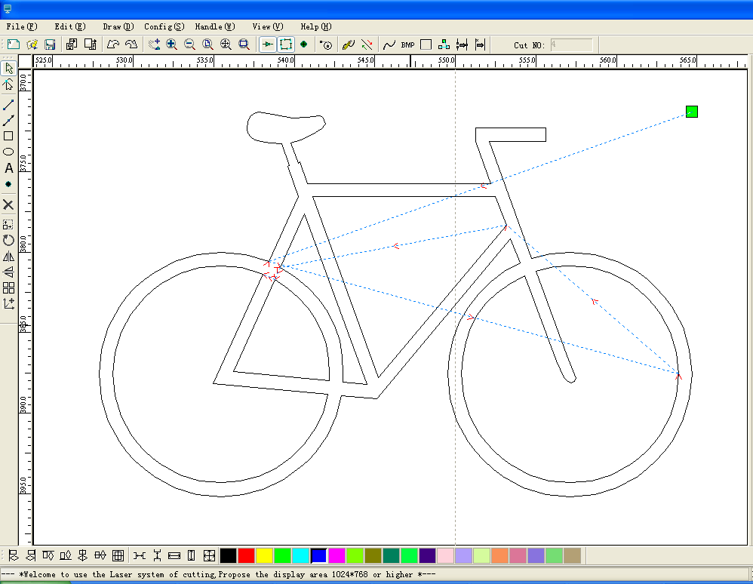

Cutting direction

Cutting point

II.3.12.3 Setting and Editing the Cut In/Cut out Lines

Drawing or importing curves, the curve is default not having any cut in/cut out lines.

If want to add cut in/cut out lines, select the objects，then click【**Edit**】->【**Edit cut in property**】，or click.The following dialog box is appear.

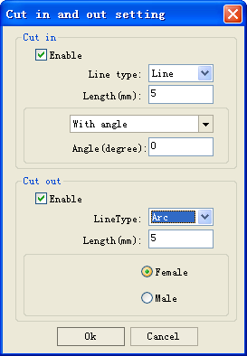

To make cut in/cut out lines, first of all need to enable the cut-in/cut out function.

There are two types of the cut in/cut out lines: straight line and arc

Straight line cut in achieve through three ways:

Cut in with angle: cut in line and starting segment into a certain angle，counterclockwise angle is positive

Cut in at center，the starting point of the cut in line is at center.

Cut in from center，the direction of the cut in line is from center to starting point, and length is as setting.

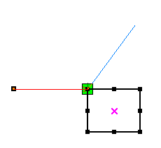

Cut in line

Cut out line

The arc length of cut in arc is as setting.

There are two types of cut in/cut out arc，as shown in the following figure



Female

Male

The processing of setting cut out lines is same as cut in lines.

II.3.12.4 Path Optimization

Path optimization if primarily to re-order the vector graphics.

Click menu【**Handle**】->【**Cut optimize**】，or click,the following dialog box is appears.

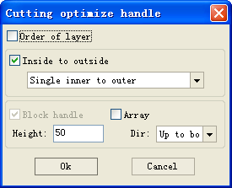

Click menu【**Edit**】->【**Show Path**】，or click ，can see the cutting path before and after processing.

Laser head

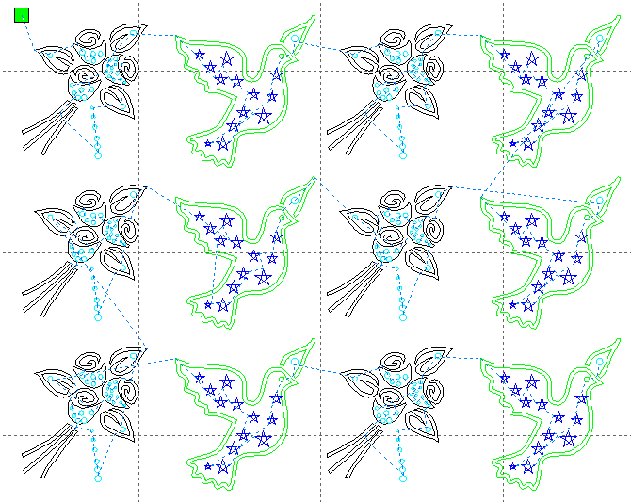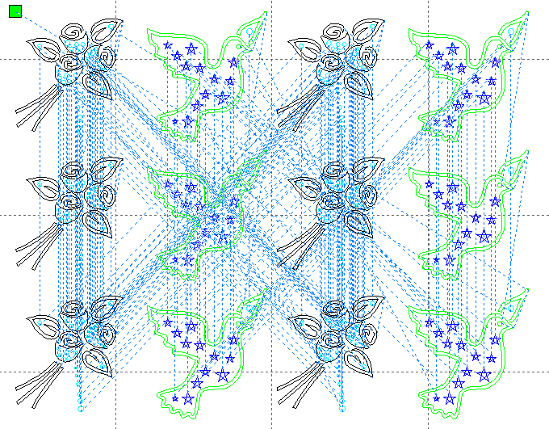

Before processing After processing

Graphics cutting path is always starting from the laser head.

II.3.12.5 Curve Smooth

For some less accuracy curves, this function can make curves more smoothness, and processing smoother.

Click menu【Handle】->【Curve Smooth】，or click ，the following dialog box appears.

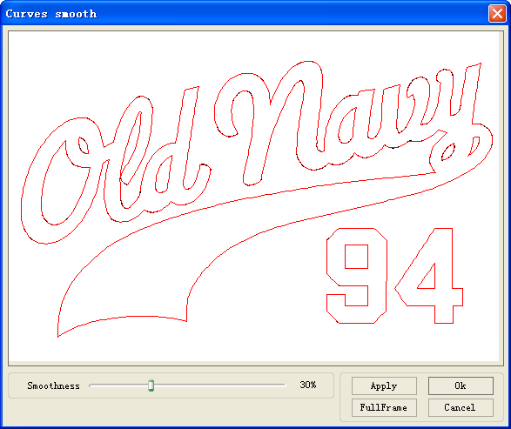

Drag the smooth slider, and click button【**Apply**】，before smooth and after smooth curves will all show in the dialog.

The black curves represent the original curves, and the red curves represent after smooth curves.

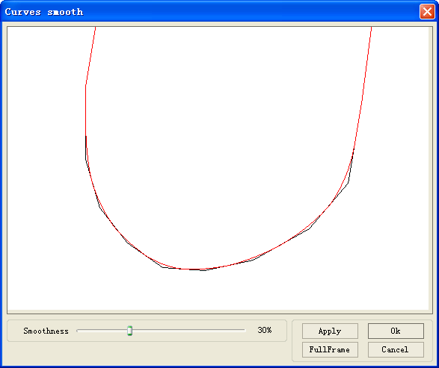

You can view the graphics with drag mouse.

You can zoom in/zoom out the graphics with scroll wheel.

Click button【**FullFrame**】，graphics will shown in the dialog box for largest.

After get satisfied smoothing effect，click button【**Apply**】，curves will processing smooth according to smoothness settings.

II.3.12.6 Check Closure

Click menu【**Handle**】->【**Curve auto close**】，or click System Bar,the following dialog box appears.

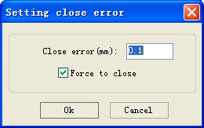

**Close error**: When distance from the starting point to ending point less than close tolerance, automatic closing of the curve.

**Force to close**: Mandatory closure of all selected curves.

II.3.12.7 Remove the Overlap

Click menu【**Handle**】->【**Delete overlap**】,or click，the software will automatically remove the ovlapped curves within the selected curves.

There are two parts of the function of remove overlap：

Broken the curve into numbers of parts, when a single curve overlapping within itself.

Automatically checks the completely overlapped curves, and prompted to remove them.

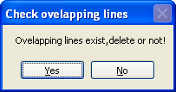

II.3.12.8 Combine Curve

Click menu【**Handle**】 /【**Combine Curve**】，or click,the following dialog box appears.

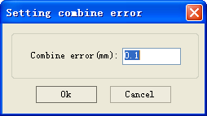

The software automatically merges curves in the selected curves, when these curves merge toleracnce is less than the setting of combine error.

II.3.12.9 Bitmap Handle

Click ，and select a bitmap, then click menu【**Handle**】->【**Bitmap handle**】，or click System

Bar.

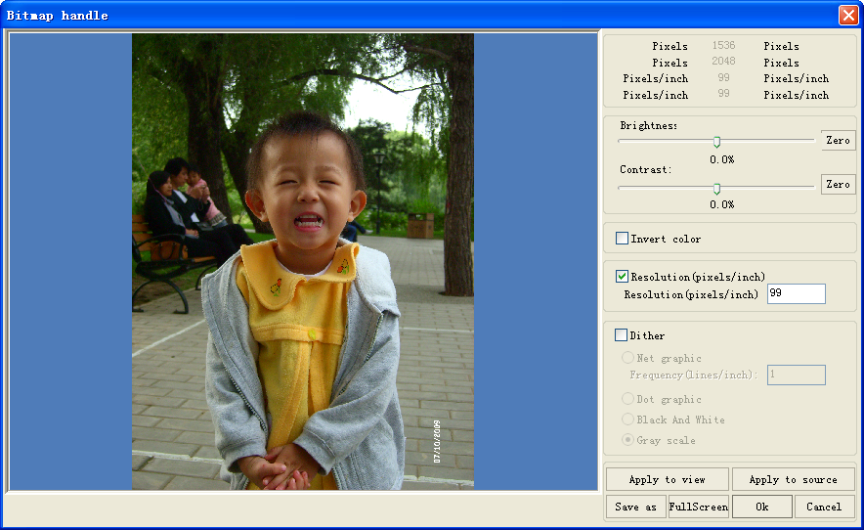

In the top right of the dialog box displays the information of the current image.

Be noted that，the horizontal resolution and vertical resolution is changing with drag scaling.

【**Apply to view**】：Current settings is only used for preview, without affecting to the original bitmap，press button【**Cancel**】，bitmap will returned to the state of original image.

Therefore, only use for adjust effect. However, this approach requires more time and memory space.

【**Apply to source**】：Current settings is use for original bitmap directly，so even finally click button【**Cancel**】，image will also unable to return to the original image.

Therefore, it mainly used in multi-step operation，and the current operation of this

step is necessary to do, such as general pictures must be transformed into grayscale.

This can save the computing time of the follow-up operation.

【**Save as**】：Retain the results of the previous operation, In addition to using【**Apply to view**】can also be exported. On this basis, to facilitate subsequent processing.

【**Gray scale**】Generally, other image processing’s is based on the grayscale，so before handling, you can do a grayscale processing, then click button【**Apply to source**】.For the grayscale than the color image occupied smaller memory，for large image step by step handle, to a certain extent to avoid the lack of memory.

For color image, adjust contrast and brightness, have some auxiliary effect to following dither processing.

Adjust contrast:



Before processing After processing

Invert:



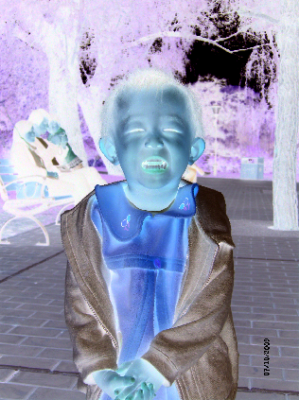

Before processing After processing

There are three method for dither processing: Net graphic、Dot graphic、Black and white

Net graphic

Net graphic need adjust net size，better suited to material which is not high resolution，or the laser is relatively slow to respond.

To get the appropriate net size, you can adjust resolution and net frequency of the image.

The higher resolution, the more delicate.

The higher net frequency, the smaller net size. The lower net frequency, the bigger net size.

Generally, resolution of image is 1000, and net frequency is 30-40lines.

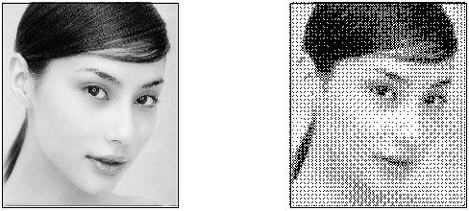

Dot graphic

Dot graphic performance of good grayscale，better suited to material which is high resolution, and the laser responds fast.

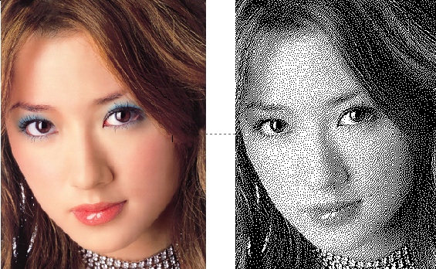

Black and white

In most cases, the effects of color image into black and white image is poor,，however, for some clear

outline image, is very easy to use.

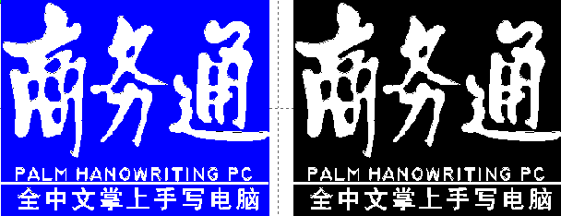

## II Chapter 4 System Settings

Before output graphics，required to determine whether the system settings are correct. Click menu【Config】->【System Setting】

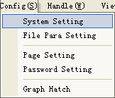

### II.4.1 Laser Export

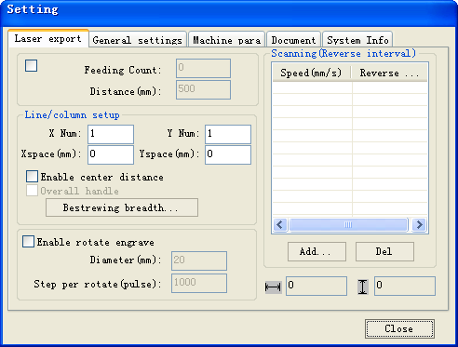

Enable feed

Feed Setting

To use the feed, must first enable the feed.

After set feeding parameters，the shaft will be feeding a feeding length, and repeat the process, until the times of processing reach to number of feeding.

2> Array Setting

Array processing setting is facilitating used to treatment array processing of graphics.

**X Num** and **Y Num**，correspond to the rows and columns of the array

**X Space** and **Y Space**，correspond to the rows spacing and column spacing of the array.

If not check“**Enable center distance**”，the **X space** and **Y space** means edge spacing，otherwise means center spacing.

3> Bestrewing Breadth Setting:

According to the size of frame and current array settings, to determine the maximum number of columns(**X Num**) and rows(**Y Num**).

Click button **Bestrewing breadth**, the following dialog box appears:

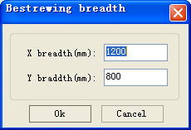

Click **OK**，software can automatically calculate the appropriate numbers of rows and columns.

4>Rotate Engraving

【**Enable rotate engrave**】：After enable engraving，the actual precision of Y-axis will be based on diameter and step per rotate to auto match the setting of pulse precision of Y-axis. In addition, the work area in the main interface will also change.

【**Diameter**】：The diameter size of the parts.

【**Step per rotate**】：The number of pulse corresponds to the workpiece rotate one week.

5>Reverse interval

While bi-directional scanning, for the tension of belt, may cause the edge of graphic irregularity. So provide backlash setting to amendment it. A specific speed corresponding specific backlash.

Generally, the faster the speed, the greater the backlash.

①Add backlash setting

Click button **Add**，pop up the following dialog box

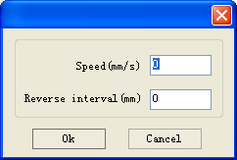

After setting **Spped** and **Reverse interval**，then click **OK**，the backlash value be inserted into the backlash list

②Modify backlash setting

Double click the item in the backlash list, pop up the following dialog box.

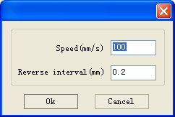

③Remove backlash setting

Click to select item which want to delete, then click button **Delete**.

### II.4.2 General Setting

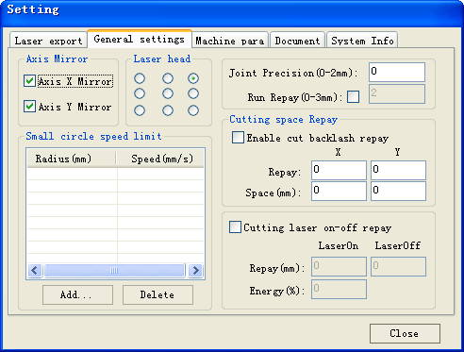

1>Axis Mirror

Generally, Axis direction of mirror is based on the actual location of the limit or home of machine.

The default coordinate system if Descartes coordinate system, and zero in the bottom left.

If the zero point of the machine is top left, Zhen X-Axis do not need to mirror, but Y-Axis need to mirror.

If the zero point of the machine is top right, Zhen both X-Axis and Y-Axis are all need to mirror.

In addition, this function can also use to other application for mirror.

2>Laser head

Position of Laser head means the location laser head relative to the graphic.

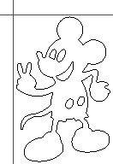  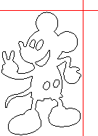

Top Left

Top Middle

Top Right

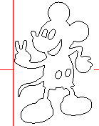  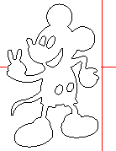

Middle Left

Center

Middle Right

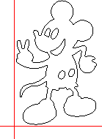 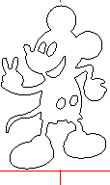 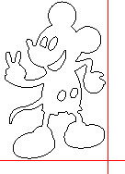

Bottom Left

Bottom Middle

Bottom Right

3>Joint precision (0-2mm)

When the distance between the end point of one line and the end point of another line is less than the joint precision, the software automatically connect these two lines.

Note: This value is usually set to 0.1mm,for very large amouts of data graphics,in order to reduce the waiting time before processing can be set to 0mm.

4>Run Repay

For the jump motion moving faster,may occurs position error.Using run repay can compensation this.

5>Small Circle Speed Limit

On processing work，the software automatically determine whether the current round need to limit speed ,then according to the diameter size of the circle to determine the speed.

If parameter configuration appropriate, will greatly enhance the quality of small round.

Click button【**Add**】，【**Delete**】 to configuration.

The software can automatically calculate the speed of the round, according to the round speed limit list.

6>Cutting laser on-off repay

【Cutting laser on-off repay】：

After enable ，the software auto compensation the cutting processing according to the cutting laser on-off repay settings.

【**Repay**】：The processing of laser-on，laser energy from start energy for a gradual change to the normal energy ,while the machine from the start point moves a laser-on repay length.

The processing of laser-off, the machine from the end point moves a laser-off repay length.

【**Energy**】：The energy of the start point of graphics.

### II.4.3 Machine Para

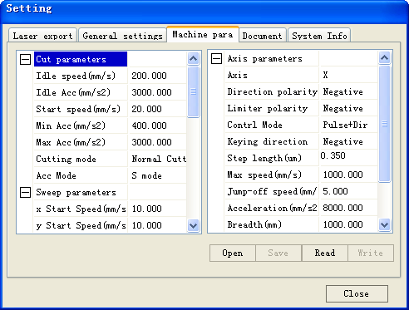

⑴ Machine parameters are described as follows:

#### A. Laser parameters

*Laser mode*: there are currently three types of Laser devices: home-made glass tube, RF Laser (pre-ignition pulse not required) and RF Laser (pre-ignition pulse required), the glass tubes adopt analog quantity for control and RF tubes adopt digital quantity for control. If the machine adopts home-made glass tube, the laser type should be “Analog quantity”, while if it adopts RF tube, the duty ratio (pre-ignition pulse required/ not required) should be selected correspondingly. After modification of Laser type options, the system should be reset, and the modifications should take effect after the reset.

*Laser freq*: the pulse frequency of the control signal used by the laser installed on the machine.

*Max. power (%), Min. power (%):* you can set the limit power values for the laser, namely, during the operation, the max. power set by the user cannot be higher that the max. power set here and the min. power set by the user cannot be lower than the min. power set here.

*On-delay, off-delay*: if the on/off delay parameter is not 0, when the laser is turned on/off, the laser will be turned on in advance and turned off behind schedule at the time delay set in advance. The range for the time delay may be 0us ~ 0.1s.

#### B. Other parameters

*reset speed*: this parameter decides the speed of the machine to return to the origin when startup, if the breadth of the machine is too large, you can set a comparatively large value of reset speed, but do not set it too large, the controller will control this parameter within 50mm/s, namely, any reset speed value set by the user exceeding 50mm/s should be deeded invalid.

*Idle speed*: this parameter decides the max. speed of all lines not emitting beams during the operation of the machine. This parameter should not be lower than the lower of the jump-off speed of the X-axis and that of the Y-axis and not exceed the higher of the max. speed of the X-axis and that of the Y-axis, if the setting is illegal, the controller will automatically set this parameter within the range above; a comparatively high idling speed can shorten the operation time of the entire figure while excessively high idling speed may cause dithering of the tracks, therefore, you should take all relevant factors into consideration when setting.

*Line shift speed of scanning*: this parameter is specially used to control the max. speed of the scanning to shift vertically from one line to the next line below it. If during the scanning, the line space is too large or the block space is too large when scanning block figures while precise positioning for each line or block is required, you can set the line shirt speed of scanning to a comparatively low value. This parameter cannot be less than the jump-off speed of the corresponding axis during the line shift and cannot be higher than the max. speed of the corresponding axis during the line shift, if the setting is illegal, the controller will automatically set this parameter within the range above.

*Acce. mode*: this parameter decides the acceleration and deceleration mode (S mode or T mode) of the motor during operation, the motor accelerates and decelerates slowly and smoothly in the S mode and fast and relatively unsmooth in the T mode; the default mode is the S mode.

*Scan mode*: There are two modes for your selection: the general mode and the special mode, in the general mode, there’s no any treatment during the scan, in the special mode, light spots will be treated. If the special mode is activated, the power of the laser should be increased and correspondingly, the light spot percentage will be lower and the laser power attenuation will be higher, to achieve the same depth of scanning, the laser power should be higher. The purpose to select the special mode is to make the laser to emit beams at high power and in short period, during deep scanning, the effect of flat bottom can be achieved, however, if the light spots are improperly adjusted, this effect may not be achieved and the working mode of high power and short period may influence the service life of the laser. The default mode is the general mode.

*Facula size*: this parameter is invalid in the general mode of scanning and is only valid in the special mode. The controller will control this parameter at 50%~99%.

*Array mode*: you can choose the swing mode and the one-way mode. The Swing mode: cutting the array back and forth in order; the One-way mode: always cutting the array from one direction to another. If One-way mode is selected, all array units have the same movement modes and the same liquidity of movements; however, this mode will take more time than the swing mode. The default mode is the Swing mode.

*Return position*: You can select the locating point and the machine origin. This parameter decides the position, the locating point or the machine origin, where the laser head stops upon completion of each operation.

*If Protection on*: If the machine is provided with any additional protection signals besides water protection, you should make corresponding selections in this option. The protection signal is inputted from universal input port 2 port (please refer to the User’s Manual of the main board). When this protection signal is enabled, the controller will carry out real-time inspection on the protection signal, if the input is at high level, the machine will be protected and the operation in progress will be suspended and the laser will be turned off.

#### C. Axis parameters

*Direction polarity*: if a the X or Y axis move against the machine origin when the electrical system of the machine is reset, that means that the direction signal polarity of this axis is incorrect, at this time, you should disconnect the axis from the motor driver (otherwise, the inspection of the main board will be insufficient, which may cause collision of this axis), after D16 on the main board flashes (which means that the reset has been completed, D16 will go out first each time the machine is reset and start flashing after reset completion, do not read or write all parameters on the PC before D16 starts flashing, please refer to the User’s Manual of the main board interface for the position of D16), modify the direction signal polarity of this axis on the PC, upon completion, press the Reset button to reset the main board.

*Limiter polarity*: If when the axis of movement reaches the limit position, a low level signal is triggered to turn on the LEDs corresponding to various limit positions and when the axis of movement departs from the limit position, a high level signal is triggered to turn out the LEDs corresponding to various limit positions, the limit polarity is negative; contrariwise, if when the axis of movement departs from the limit position, the LEDs corresponding to various limit positions are out and when the axis of movement reaches the limit position, the LEDs corresponding to various limit positions are on, the limit polarity is positive. Incorrect limit polarity setting may cause insufficient inspection of the system when resetting, which may lead to collision of the axes.

*Control mode*: There are two modes for your selection: the double-pulse mode and the pulse + direction mode, which should be deiced according to the type of the motor drive installed on the machine, in general, the pulse + direction mode is selected. After any modification of the control mode option, the main board should be reset to make the modification take effect.

*Keying direction*: After correct setting of the direction polarity of the machine, if the X-axis moves to the Right when you press the Left button and the X-axis moves to the Left when you press the Right button, that means the keying direction settings are incorrect and modifications should be made correspondingly; the Up and Down keys are corresponding to the movement of the Y-axis, if the Y-axis moves upwards when you press the Down button and the Y-axis moves downwards when you press the Up button, the keying directions of the Y-axis should be modified.

*Step length*: Or the pulse equivalent of the motor, it means the absolute distance covered by the corresponding axis when a pulse is sent to the motor. Before correct setting of this value, you can make the machine to cut a large rectangle (the larger figure, the less error) and the motor pace length can be calculated automatically with the length of the figure and the measured length.

*Max. speed*: The driving force of the motor and the inertia of the axis of movement decides the max. speed of polarity of the axis. During the scan, the scanning speed should not exceed the max. speed corresponding to the axis of the scanning; in the cutting mode, the resultant velocity during the cutting cannot exceed the lower of the max. speed of the X-axis and that of the Y-axis. If the speed is set too high, the controller will automatically protect the speed under the max. speed.

*Jump-off speed*: the speed of the axis of movement to be started directly from the static status, if it is set too large, the motor may lose synchronism, dither or even produce whistle, if it is set too low, the operation speed of the entire figure will be reduced. According to the inertia of the axis of movement, this value can normally be set at 8~15mm/s. If the inertia of the axis of movement is too high (the axis is heavy), you can set a lower jump-off speed, while if the inertia of the axis of movement is too low (the axis is light), you can set a higher jump-off speed.

*Acceleration*: The acceleration of the axis of movement when accelerating or decelerating, too high acceleration will also result in loss of synchronism, dithering or even whistle of the motor, while too low acceleration will result in slow acceleration which will reduce the operation speed of the entire figure. A typical range of 800 ~ 3000mm/s2 can be set for an axis with high inertia, Y-axis corresponding to the crossbeam, for instance, and a typical range of 10000 ~ 20000mm/s2 can be set for an axis with low inertia, X-axis corresponding to the dolly, for instance.

*Breadth*: the max. distance that the axis of movement can cover, which should be decided according to the actual situation of the machine.

### II.4.4 Document

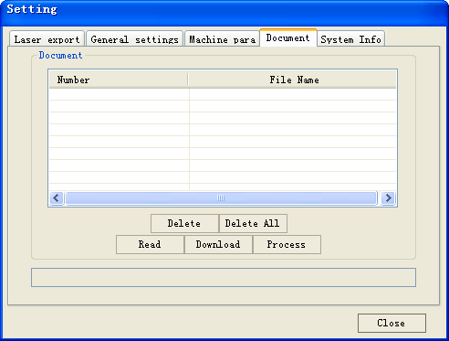

Document list

Read

Click button **Read**，the software will communications with the controller，read the list of files on the controller.

After read controller successful ,file information will be displayed in the document list.

Download

Click button **Download**，will pop up the file dialog , select *.rd downloaded file, then the file will be downloaded to the controller.

If the download is successful, the document list will update.

Process

Select the file to be processed from the document list ,and click button **Process**

The controller will start the specified document.

Delete

Select the file you want to delete from the document list，and click button **Delete**

The controller will delete the specified document.

If the deletion is successful, the document list will be updated.

Delete All

Automatically remove all file in the controller, and update the document list.

### II.4.5 System info

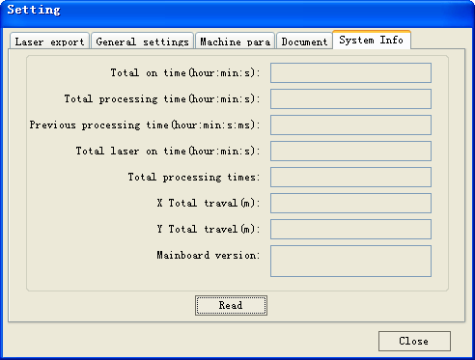

**Total on time**: The total time of motherboard working

**Total processing time**: The total time of processing, including the time of jump moving.

**Previous processing time**: The time of the last processing

**Total laser on time**: The time of the laser processing

**Total processing times**: The number of completed processing, not include the processing forcing to end.

**X total travel**: The total travel of motor X.

**Y total travel**: The total travel of motor Y.

**Motherboard version**: The version of the current controller.

### II.4.6 Password Setting

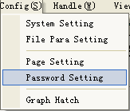

The manufactory can use the function of password setting to set manufacture password or user’s period password.

Click **Password Setting**，if has connected with the controller , pop up the following dialog.

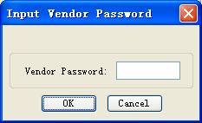

After input the correct manufactory password，pop up the following dialog.

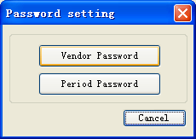

Vendor Password Setting

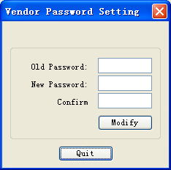

1. Input old password

2. Input new password

3. Confirm new password

4. Modify password

As figure shown, input the **Old Password**、**New Password** and **Confirm Password** , then click Modify.

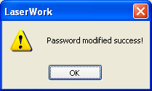

2> Period Password

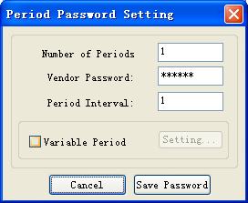

1. Number s of Period

2. Input Vendor Password

3. Input Period Interval

4. Set Variable Period

5. Save Password

After setting Period、the number of day each period and vendor Password.

Click **Save Password**，then pop up the file dialog to save the password file.

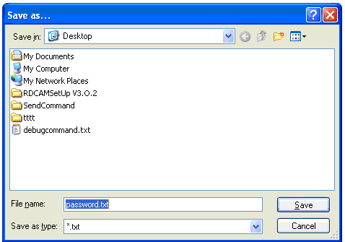

After save password successful，pop up the prompt dialog.

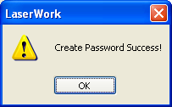

Information of the password file.

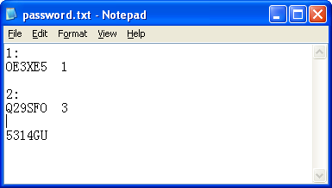

First Period

The number of day of Period 1

Password of Period 1

Password for Cancel

If the software be locked, you can input the corresponding password for the current period, or input the password for cancel.

After input the password for cancel, then the controller will no longer limit.

3> Variable Period

If you need setting variable day for each period, can check **Variable Period.**

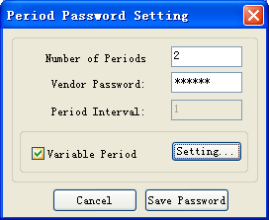

Check Variable Period, and click Setting

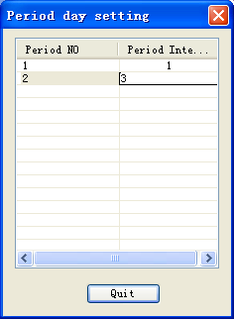

After setting successfully, quit this dialog, and save password

## II Chapter 5 Processing

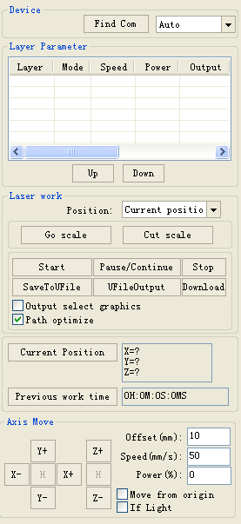

Axis control

Processing control

Layer settings

Search device

### II.5.1 Search Device

If the computer only connected one device，you can set to Auto. The software will automatically search the device.

If the computer connected many devices, then first of all you need to click【**Find com**】.

After search, the connected devices will all add to the drop-down list.

What you need to do is select the specified device.

### II.5.2 Layer settings

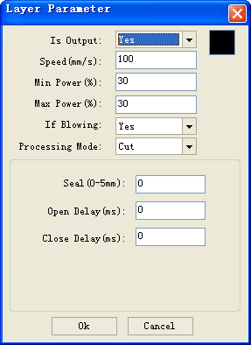

There are two options: *Yes* and *No*.Select *Yes*, the corresponding layer will be exported for processing; Select *No*, it will not be exported

Processing mode, meaning the mode to process corresponding layer; If you select vector layer (color layer) currently, there are three options: Laser scanning, Laser cutting and Laser dotting; If you select bitmap layer (BMP layer) currently, there is only one option: Laser scanning.

The range of power value is 0~100, it means the intensity of laser during the process; the higher the value is, the stronger the laser is, and the lower the value is, the weaker the laser is. If the value is zero, means the default power is used (i.e., the power set on the panel of the machine).

The speed of laser processing; speed will influence the processing effect: the slower the speed is, the better the processing effect is and the smoother the track is; the faster the speed is, the worse the processing effect is; if the speed value is zero, it means the default power is used (the speed set on the panel of the machine). Please input suitable speed value!

⑴ How to set proper *Min power* and *Max power*

If the laser is too strong during the whole process, you should set the minimum and maximal power lower, otherwise, set them higher;

If the laser is too weak in some places during the process, you should set the maximal power higher;

If the laser is too strong in some places during the process, you should set the minimum power lower.

⑵ Setup of processing parameters under different *Processing modes*

*Processing modes* include *Laser scan, Laser cut and Laser dot*. The bitmap layer (BMP layer) can be only processed by *Laser scan*.

① Setup of processing parameters in the *Laser scan* mode

As shown in the following figure, if you select processing mode of *Laser scan*, the menu is as shown in the following figure.

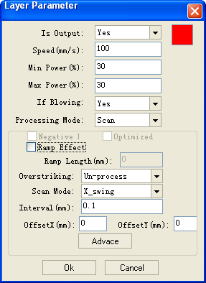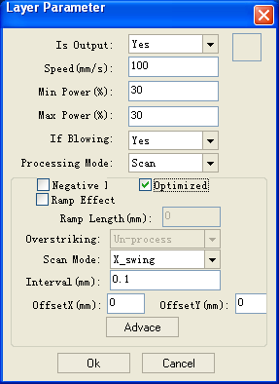

The Vector layer (color layer) doesn’t support *Negative engraving* and O*ptimized scan*.

Negative engraving*:* If you do not select *Negative engraving,* the black dots which run across the bitmap will emit laser and the white dots which run across the bitmap will not. If you select Negative engraving*,* the white dots which run across the bitmap will emit laser and the black dots which run across the bitmap will not.

O*ptimized scan:* If you select O*ptimized scan,* it will adjust users’ setup of *Scanning interval* automatically to the best values and optimize the scanning effect. Otherwise, we should select *Scanning interval* as set by the user for scanning. **We generally select the *Optimized scanning***.

*Ramp effect*: If you select *Ramp effect*, it can make the track edges of scanned figures presented as ramp in order to attain solid effect.

The *Minimum power* set currently corresponds with the power of the top ramp, the *Maximum power* corresponds with the power of the bottom ramp. You should set the same value for the maximum power and the minimum power if you do not select ramp effect.

*Ramp length:* the length of the ramp

Overstriking: Includes Un-process, Intaglio and Rilievi

*No processing:* does not adopt overstriking.

*Intaglio:* when selecting the intaglio font (please refer to the attachment below for what is font intaglio), the font will receive overstriking processing.

Note: if you select R*ilievi* for *Overstriking* when selecting intaglio font, the font strokes will be thinner instead of thicker.

R*ilievi:* when selecting rilievi font (please refer to below attachment for what is font rilievi), the font will receive overstriking processing.

Note: if you select Intagliofor *Overstriking* when rilievi font, the font strokes will be thinner instead of thicker.

Additional note: What are font intaglio and rilievi?

Font intaglio: the text does not have the outline border. It is the text itself that is to be scanned, please see the figure below:

Font rilievi: The text has the outline border, it is the figural base to be scanned, please see the figure below: 

Scan modes: including X_unilateralism, X_swing, Y_unilateralism and Y_swing.

*X_unilateralism:* The laser head scans figures back and forth at the level direction, but only emit laser toward one direction. For example, the laser head emits laser when scanning from right to left, but not emits laser when scanning from left to right.

*X_swing:* The laser head emits laser and scans figures back and forth horizontally.

*Y_unilateralism:* The laser head scans figures back and forth vertically, but only emit laser toward one direction. For example, the laser head emits laser when scanning from the top down, but not emits laser when scanning from the bottom up.

*Y_swing:* The laser head emits laser and scans figures back and forth vertically.

Note: We generally adopt the scanning mode of *X_swing*.

*Interval:* The interval between the current line and the next line to be scanned by the laser head. The smaller the interval is, the darker the scanned figures is; if reverse, the weaker.

Recommendation: ① the scanning interval is set below 0.1mm for vector layer (color layer) in general. ② the scanning interval is set above 0.1mm for bitmap layer (BMP layer) in general, and then the *Minimum power* and *Maximum power* should be changed to attain the perfect effect of the scanned figures.

② Setup of processing parameters of *Laser cut*

The processing mode is *Laser cut* as shown in figure

*Seal (mm):* it means the length of the extended line at the closed figure interface. We set it at zero in general; If the value is set above zero (0-2mm), it is usually used in the craft of cutting polymath methacrylate to eliminate the obvious heave effect.

③ Setup of processing parameters of *Laser dot*

*Laser dot:* drawing dots along the track of the figures.

As shown in figure, select *Laser dot* as the processing mode, the menu will be showed as figure

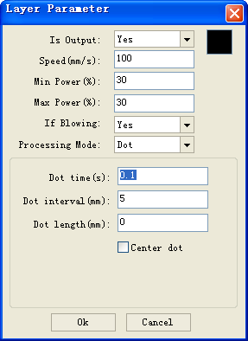

Only dot at center

Dot length, for cutting dash line

The interval between the dots

The time for emitting laser on one dot during the process. The higher the value is, the darker the dot is; if reverse, the weaker.

Layer reorder:

Click button ***UP,* Down** can change the order of layers, the above layer processing first.

### II.5.3 Position

Setting the laser head back location after processing completed.(Current position、Original anchor、Machine Zero.

**Current Position**: Laser head back to the position before processing.

**Original ancho**r: Laser head back to the last anchor, the anchor may set at panel.

**Machine zero:** Laser head back to the zero of the machine.

### II.5.4 Go Scale, Cu t Scale

For Example **Go Scale, as** the following figure shown, the actual graphic is round, and the red rectangle outside the circle is the smallest rectangle, click button **Go Scale,** laser head will run once along the rectangular path.



For Example **Cut Scale**, As the following figure shown, the actual graphic is round, and the red rectangle outside the circle is the smallest rectangle, click button **Cut Scale**, laser head will be cut along the rectangle.

### II.5.5 Start, pause, stop, saveToUFile, UFileoutput, Download

**Start**：Output the current graphic to the machine for processing.

**Pause\Continue**：Click **Pause**，will stop the processing work, click the button again to **Continue**

**Stop**：Stop the current processing work

SaveToUFile：

Save current file as RD format，using for offline processing（Can be copied to other memory board for full offline operation）.

For example：Save the round

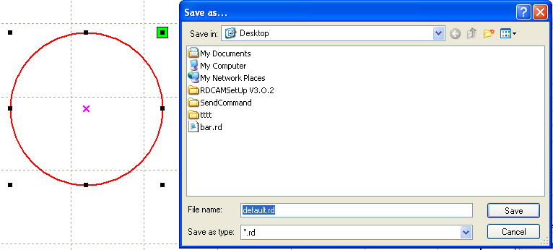

UFileOutput：

Output the offline file (RD format)

After save offline file, click **UfileOutput** to select rd file to processing.

Download：

Download the file to the memory of the controller , then user can start the file through the machine panel.

### II.5.6 Output select graphics

After check **Output select graphics**，then only output the selected part, rather than not output the part not selected

### II.5.7 Path optimize

After check **Path Optimize**，then automatically perform the path optimize before the output.

If has done the Path optimize or not need optimize, then not check Path Optimize can reduce waiting time.

### II.5.8 Axis move

Axis control can only control one axis each time.

You can set the information for axis move, including move length、speed、laser on-off and laser power.

If you check move from origin, then the offset you set means the offset to machine zero.

If you not check move from origin, then the offset means the offset to the current position.

Note: According to the provisions of the controller, the absolute position is no negative in the whole breadth. If you check the Move from Origin, and set the offset value negative, then the machine will hit limiter.

## II Chapter 6 FAQ

### II.6.1 After start processing, the machine does not move or disorder or loss part of graphics

◆ Check whether the graphic data is out if frame. The data beyond of the frame will not be cut.

◆ Check the setting of Laser head position.

### II.6.2 Software automatically shut down when import file

If the operating system is XP, please check if the patch is installed.

### II.6.3 Machine panel prompt 【Less buffer distance】

◆ Check the engraving speed in the machine parameter，generally, the engrave speed no 8000

◆ Ensure that graphics are not close to the border of the machine frame.

### II.6.4 Processing graphics sis mirror to the actual graphics

Check “Axis Mirror” in the General settings dialog（See：*4.2 General settings* ）

# III User’s Manual of Laser Engraving Cutting Software v3.0

Preface

There are two kinds of laser engraving cutting software. One is based on the direct output software of CorelDraw (hereinafter referred to as CorelDraw Laser); the other is based on the direct output software of AutoCAD (hereinafter referred to as AutoCAD Laser). Now we are going to introduce them in turn:

## III Chapter 1 Introduction of CorelDraw_Laser

### III.1.1Features of CorelDraw_Laser

Mainly used in movement control, it is an important part of laser movement control and is. It realizes effective control to laser numerical control machine tool by computer and accomplishes processing tasks according to user’s different requests. There are its functions and features below:

1. CorelDraw_Laser is a plug-in module stalled in CorelDraw, utilizing indirectly powerful functions of plotting and edit such as zooming and circumrotating.
2. It supports almost all the file formats supported by CorelDraw, including vector formats (such as Plt and AI) and bitmap formats (such as BMP).
3. It is able to support the file formats of DST and DSB (not supported by CorelDraw itself) by the import function of CorelDraw_Laser module itself.
4. It supports the function of files synthesizing by utilizing the import function of CorelDraw, allowing many files to be exported and processed once and for all.

### III.1.2 Environmental requirements

1. Above CPU586, above PIII or PⅣ recommended
2. Memory, above 1G recommended
3. Windows2000/XP、Vista、WIN7, XP recommended
4. Support the software of CoreDraw11 and CorelDraw12. CorelDraw13. CorelDraw14.

### III.1.3 Installation and startup

III.1.3.1 Installation

1. You should have installed CoreDraw11 or CorelDraw12 before you install CorelDraw_Laser.

If you don’t, please install CoreDraw11 or CorelDraw12 on your computer first.

1. Open CoreDraw11 or CorelDraw12、CoreDraw13、CoreDraw14, complete the configuration before installation.

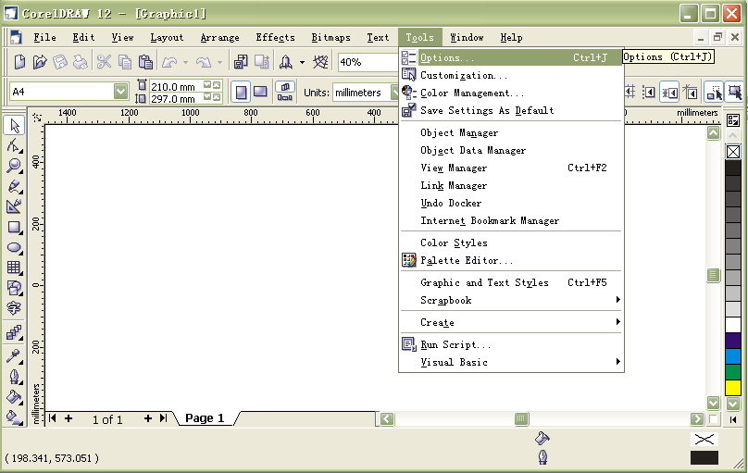

Figure 1-1

⑴ As shown in figure 1-1, enter the main menu of CorelDraw, choose CorelDraw menu, tools->options, a menu as shown in figure 1-2 will pop up:

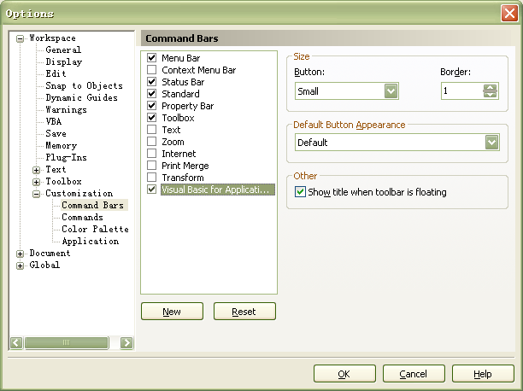

Select Visual Basic

for applications

Figure 1-2

⑵As shown in figure 1-2, select *Visual Basic for applications*, and then click on *Ok button*. Now the main menu of CorelDraw is shown in figure 1-3:

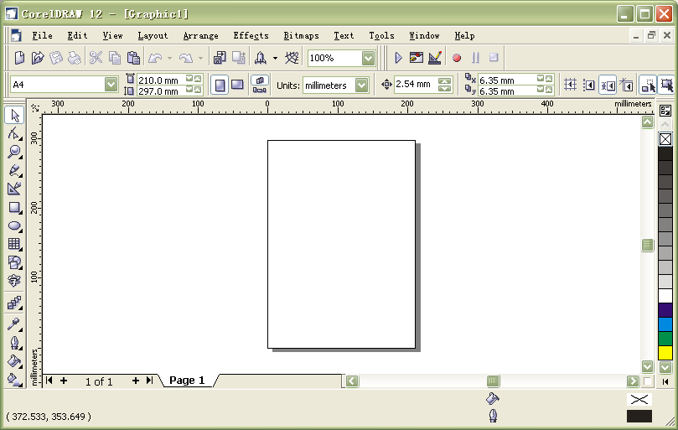

Visual Basic for applications tool bar

Figure 1-3

⑶The CorelDraw configuration is now completed, close CorelDraw.

1. In order to ensure smooth installation, we suggest you to close the Anti-Virus Software first.
2. Double click on , the software installation menu as shown in figure 1-4 will pop up:

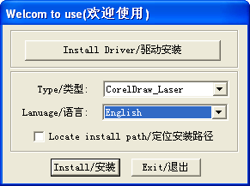

2. Includes three options: *Simplified Chinese, Traditional Chinese, English.* Please select the software language you need.

install USB drive

1. Includes two options: CorelDraw_Laser and AutoCAD_Laser. Select CorelDraw_Laser

3. Click on this button to install.

Figure 1-4 software installation menus

1. Click【Install Driver/驱动安装】to install USB drive：

If there are hardware installation prompts, choose continue until the installation is complete.



After installation ,the following dialog box appears, indicating the successful installation of USB drivers.



As shown in figure 1-4, select *CorelDraw_Laser*, select software language, then click on the *Install* button, a prompt menu as shown in figure 1-5 will pop up to show successful installation.



Figure 1-5 the prompt for installation completion

1. Installation completion.

III.1.3.2 Startup

1. Open CorelDraw11 or CorelDraw12, will pop up the main menu of CorelDraw as shown in figure 1-6:

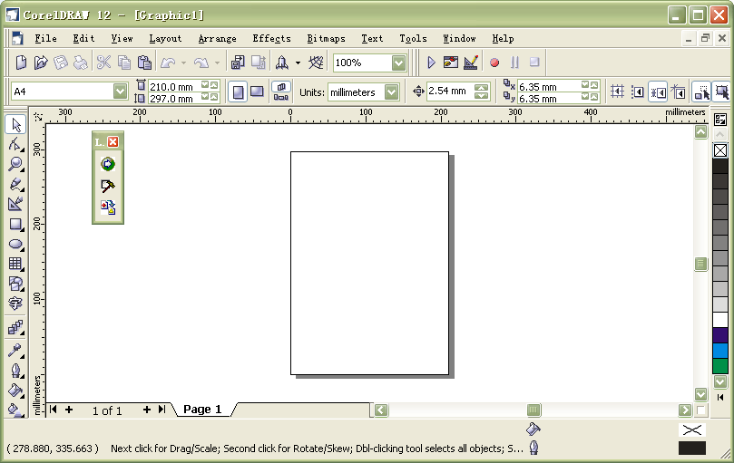

Import DST/DSB data button

Settings button

Laser Processing button

*LaserUsing* tool bar

Figure1-6 CorelDraw main menu

You can drag *LaserUsing* toolbar freely to the position you accustomed to, for example, as shown in figure 1-7:

LaserUsing tool bar

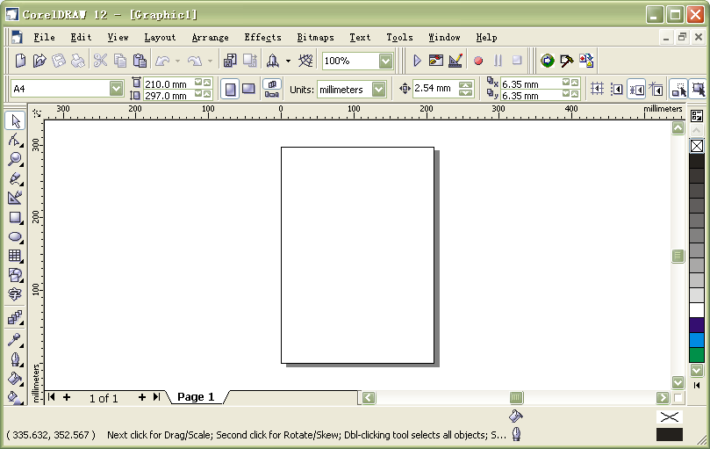

Import DST/DSB data button

Settings button

Laser Processing button

Figure1-7

### III.1.4 Operation instruction of *CorelDraw_Laser*

#### III.1.4.1 Settings of the *settings* dialog box

Settings button

LaserUsing tool bar



Figure1-8

As shown in figure 1-8, click on the button *Settings* in the *LaserUsing* toolbar, the *Settings* dialog box as shown in figure 1-9 will pop up:

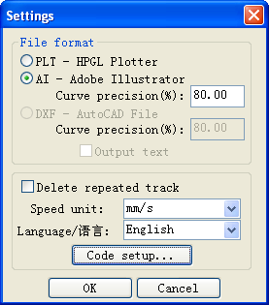

Figure1-9 *Settings* dialog box

1. Selection of *file format*

(1) *Settings* of CorelDraw_Laser (CorelDraw direct output software)

Supporting two formats, PLT-HPGL Plotter and AI-Adobe Illustrator

* 1. Generally, we should select “AI-Adobe Illustrator” and set the “Curve Precision” between 80 and 100. The higher the precision is, the smoother the curve is, and the relevant cutting speed is faster.

Note: If the precision is set too high, it may lead to the phenomena that the laser head is dithering when processing, in this case, we should adjust the precision value lower accordingly.

If it is set too low, the exported curve may be unsmooth (or even turned into a straight line), in this case, we should adjust it higher accordingly.

* 1. Select “AI-Adobe Illustrator”, if you find the graph is abnormal during the output processing (for example, there is one more line segment when outputting the graph), you can select “PLT-HPGL Plotter”.)

(2) *Settings* of AutoCAD_Laser (AutoCAD direct output software)

It only supports the file format of “DXF-AutoCAD File”.

a. Curve precision

It is generally set between 80 and100. The higher the precision value is, the smoother the curve is, and the relevant cutting speed is faster.

Note: If the precision is set too high, it may lead to the phenomena that the laser head is dithering when processing, in this case, we should adjust the precision value lower accordingly. If it is set too low, the exported curve may be unsmooth (even turn to a straight line), in this case, we should adjust it higher accordingly.

b. Whether to *Output text*

If you need to output text, select it, if not, don’t select it.

2. Whether to Delete repeated track.

If this feature is selected, the software will delete repeated tracks automatically. It will only cut once for outputting and for several times for the contrary.

For example, draw two overlapped rectangle in CorelDraw (as shown in figure 1-10), if you select D*elete repeated track,* the rectangle will only be cut once when output cutting. If you don’t select it, the rectangle will be cut twice.

D (d)

A (a)

B (b)

C (c)

Figure 1-10. Two overlapped rectangles

Note: if you select *Delete repeated track*, it will influence the speed for opening the software. So normally, we don’t select it (especially for figures with too much data).

3. Selection of the *Speed unit*

It is very convenient for users to set the speed when using the software. Users can select the speed

units of meter/minute or millimeter/second according to their own habits. All the speed values used in the software interface to be set by users should adopt the selected unit.

4. Selection of *Language.*

Users can select the language shown in the menu according to their own requirements, such as Simplified Chinese, Traditional Chinese or English.

5. Code setup

Manufacturers use this function to set manufacture code and users’ time limit code.

The steps of setting code are as follows:

(1) Click on the Code setup button, the dialog box Input manufacturer code as shown in figure 1-11 will pop up:



1. Input 6 bit manufacturer code

Figure1-11

(2) Click on the *Ok button*, the dialog box *Code setup* as shown in figure 1-12 will pop up:

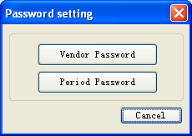

Figure 1-12

a) Setup of the *Manufacturer Code*

Click on the *Manufacture code* button shown in figure 1-12, the dialog box *Setup Manufacturer Code* as shown in figure 1-13 will pop up:

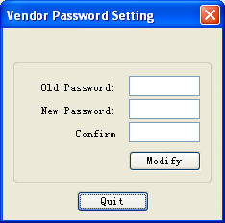

1. Input the old manufacturer code

2. Input the new manufacturer code

3. Repeat the new manufacturer code

4. Modify password

Figure1-13

After inputting the *old code,* the *new code, confirmed code*, click on the *Modify* button as shown in figure 1-13. When the modification is successful, a menu as shown in figure 1-14 will pop up to show that the manufacture code has been modified.



Figure 1-14

Setup of the Time Limit Code

Click on the *Time Limit Code* button in figure 1-12, a dialog box *Setup Time Limit Code* as shown in figure 1-15 will pop up:



1. Number s of Period

2. Input Vendor Password

3. Input Period Interval

4. Set Variable Period

5. Save Password

Figure 1-15

After inputting the *Encrypt period,* the *Encrypt time*, the *Manufacture code* and select *USB port* in turn, click on the *Save Code* button, a menu as shown in figure 1-16 will pop up:

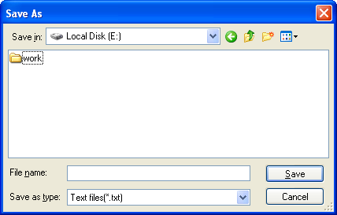

1. Input the file name of the code file

Figure 1-16

2. Save to file

Input File Name and then click on the Save button as shown in figure 1-16, a menu as shown in figure 1-17 will pop up to show that has been saved successfully.



Figure 1-17

Additional note:

① Introduction of code file formats. For example, suppose there is a code file 1.txt as shown in

Figure 1-18:

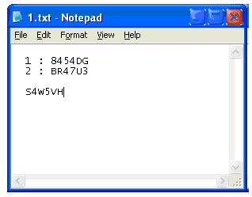

Figure 1-18

Where, “1: 8454DG” indicates that the code of the first period is 8454DG; “2: BR47U3” indicates that the code of the second period is BR47U3; “N: XXXXXX” (N is an integer, X represents any digit or letter) indicates that the code of the Nth period is XXXXXX. At last, “S4W5VH” (the text at the last line) indicates that the code for releasing the limitation is S4W5VH.

If you need setting variable day for each period, can check **Variable Period.**



Check Variable Period, and click Setting

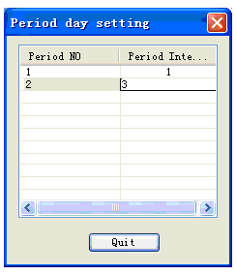

After setting successfully, quit this dialog, and save password

② How to release the code limitation when the manufacture code expires?

When the expiration date of the limitation code set by the manufacture arrives, a menu as shown in figure 1-19 will pop up once you open CorelDraw and click on any button in the *Laser Using* tool bar in figure 1-7:

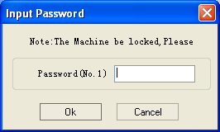

1. Input the code

2. Confirm

Figure 1-19

As shown in figure 1-19, press the *Ok* button, a menu as shown in figure 1-20 will pop up:



1. Input the code of the first period

“NO.1” indicates that the code of the first period is requested.

Figure 1-20

Instruction: Figure 1-20 shows that the code of the first period is required, now the user can input the code of the first period or the code for releasing the period. If you input the code for releasing the period, the machine would not be locked any more in the future.

Input the C*ode* and select the right *USB port*, then press the *Ok button* as shown in figure 1-20;

#### III.1.4.2 Importing Dst/Dsb files data

Import Dst/Dsb data button

*LaserUsing* tool bar

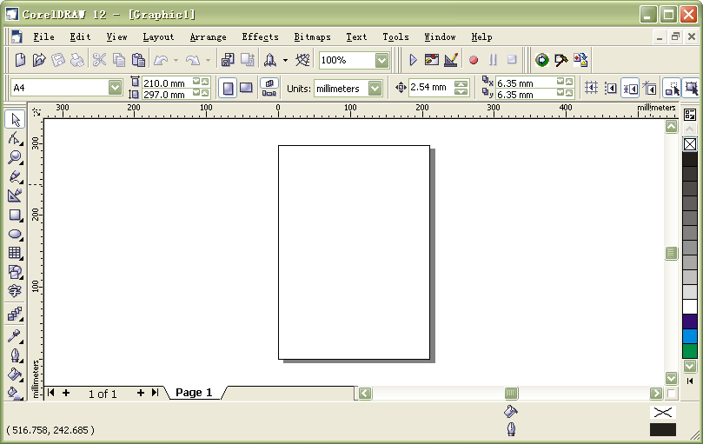

Figure 1-21

As shown in figure 1-21, click on the *Import Dst/Dsb file data* button in the *Laser Using* tool bar, a menu as shown in figure 1-22 will pop up:

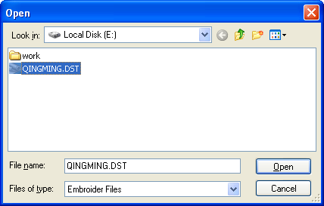

2. Click on the “Open” button

Figure 1-22

1. Select one DST/DSB file you need to import

Select one DST (or DSB) file you need to import (e.g.: QINGMING.DST in the dialog box as shown in figure 1-22. Then click on the *Open* button, the imported DST (or DSB) file will be showed in CorelDraw, just as shown in figure 1-23:

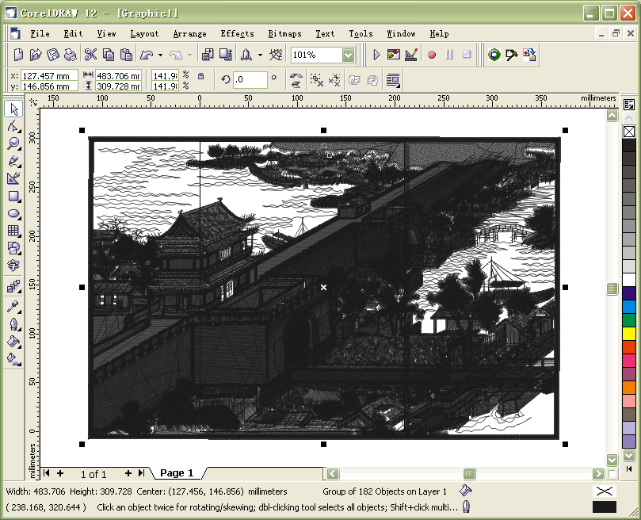

Figure 1-23

#### III.1.4.3 Laser processing

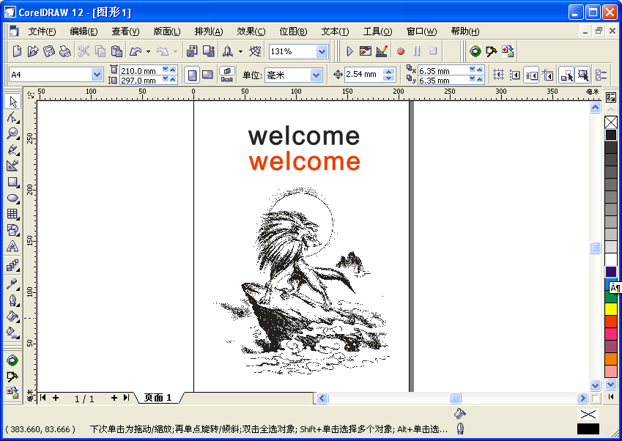

LaserUsing tool bar

“Laser processing” button

Figure 1-24 (CorelDraw shows 2 figures and one picture of “wild wolf”.)

As shown in figure 1-24, click on the “Laser processing” button in the Laser Using tool bar, a menu as shown in figure 1-25 will pop:

Label 6: show the figure to be processed

Label 5

Label 4

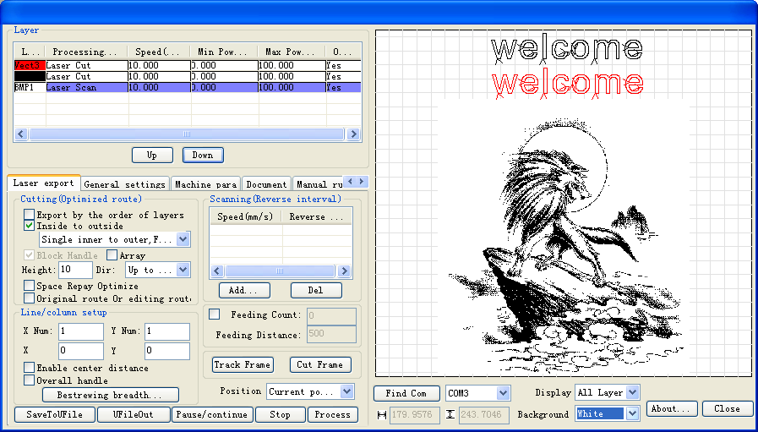

Label 3

Label 2

Label 1

Figure 1-25 Main menu of “*Laser processing*”

Label 1: Each layer corresponds to one item, every item includes: color of this layer (if the layer is bitmap, it will be labeled BMP) and the parameters of laser processing (e.g.: processing mode, speed, minimum power etc.);

Label 2, Label 3: The array order of layers in Label 1 can be changed by clicking on the *Up* and the *Down* buttons.

Label 4: shows how to display figures, there are three options (*all layers, chosen layer, hide).* Note: When the figure you want to display is very complicated and causes the display speed to be too slow, you can select *hide*;

Label 5: There are two options (white and black) for the background color. In general, we select *White* in CorelDraw_Laser and *Black* in AutoCAD_Laser.

Label 6: Display figures according to the selection of Label 4 and Label 5.

#### III.1.4.3.1 The setup of layer parameters

Double click on corresponding option of the layer by the left key of the mouse



Figure1-26

As shown in figure 1-26, double click on corresponding option of the layer requiring modification of parameters with the left key of the mouse, a menu as shown in figure 1-27 will pop up:

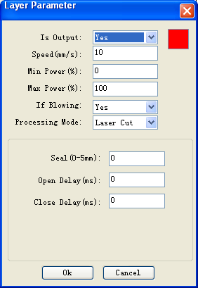

There are two options: *Yes* and *No*.Select *Yes*, the corresponding layer will be exported for processing; Select *No*, it will not be exported.

The speed of laser processing; speed will influence the processing effect: the slower the speed is, the better the processing effect is and the smoother the track is; the faster the speed is, the worse the processing effect is; if the speed value is zero, it means the default power is used (the speed set on the panel of the machine). Please input suitable speed value!

The range of power value is 0~100, it means the intensity of laser during the process; the higher the value is, the stronger the laser is, and the lower the value is, the weaker the laser is. If the value is zero, means the default power is used (i.e., the power set on the panel of the machine).

Processing mode, meaning the mode to process corresponding layer; If you select vector layer (color layer) currently, there are three options: Laser scanning, Laser cutting and Laser dotting; If you select bitmap layer (BMP layer) currently, there is only one option: Laser scanning.

(You can see that the vector layer is selected in the figure)

Figure1-27

⑴ How to set proper *Min power* and *Max power*

If the laser is too strong during the whole process, you should set the minimum and maximal power lower, otherwise, set them higher;

If the laser is too weak in some places during the process, you should set the maximal power higher;

If the laser is too strong in some places during the process, you should set the minimum power lower.

⑵ Setup of processing parameters under different *Processing modes*

*Processing modes* include *Laser scan, Laser cut and Laser dot*. The bitmap layer (BMP layer) can be only processed by *Laser scan*.

① Setup of processing parameters in the *Laser scan* mode

As shown in figure 1-27, if you select processing mode of *Laser scan*, the menu is as shown in figure 1-28 (or figure 1-29).

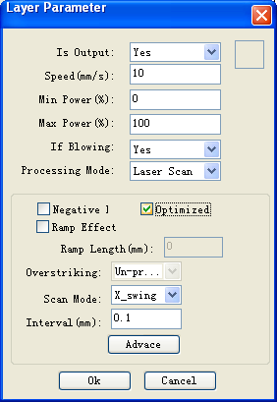 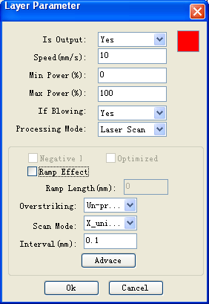

Figure 1-29 Laser scanning parameters of the bitmap layer (BMP layer)

Figure1-28 Laser scanning parameters of the vector layer (color layer)

The Vector layer (color layer) doesn’t support *Negative engraving* and O*ptimized scan*.

Negative engraving*:* If you do not select *Negative engraving,* the black dots which run across the bitmap will emit laser and the white dots which run across the bitmap will not. If you select Negative engraving*,* the white dots which run across the bitmap will emit laser and the black dots which run across the bitmap will not.

O*ptimized scan:* If you select O*ptimized scan,* it will adjust users’ setup of *Scanning interval* automatically to the best values and optimize the scanning effect. Otherwise, we should select *Scanning interval* as set by the user for scanning. **We generally select the *Optimized scanning***.

*Ramp effect*: If you select *Ramp effect*, it can make the track edges of scanned figures presented as ramp in order to attain solid effect.

The *Minimum power* set currently corresponds with the power of the top ramp, the *Maximum power* corresponds with the power of the bottom ramp. You should set the same value for the maximum power and the minimum power if you do not select ramp effect.

*Ramp length:* the length of the ramp

Overstriking: Includes Un-process, Intaglio and Rilievi

*No processing:* does not adopt overstriking.

*Intaglio:* when selecting the intaglio font (please refer to the attachment below for what is font intaglio), the font will receive overstriking processing.

Note: if you select R*ilievi* for *Overstriking* when selecting intaglio font, the font strokes will be thinner instead of thicker.

R*ilievi:* when selecting rilievi font (please refer to below attachment for what is font rilievi), the font will receive overstriking processing.

Note: if you select Intagliofor *Overstriking* when rilievi font, the font strokes will be thinner instead of thicker.

Additional note: What are font intaglio and rilievi?

Font intaglio: the text does not have the outline border. It is the text itself that is to be scanned, please see the figure below:

Font rilievi: The text has the outline border, it is the figure base to be scanned, please see the figure below: 

Scan modes: including X_unilateralism, X_swing, Y_unilateralism and Y_swing.

*X_unilateralism:* The laser head scans figures back and forth at the level direction, but only emit laser toward one direction. For example, the laser head emits laser when scanning from right to left, but not emits laser when scanning from left to right.

*X_swing:* The laser head emits laser and scans figures back and forth horizontally.

*Y_unilateralism:* The laser head scans figures back and forth vertically, but only emit laser toward one direction. For example, the laser head emits laser when scanning from the top down, but not emits laser when scanning from the bottom up.

*Y_swing:* The laser head emits laser and scans figures back and forth vertically.

Note: We generally adopt the scanning mode of *X_swing*.

*Interval:* The interval between the current line and the next line to be scanned by the laser head. The smaller the interval is, the darker the scanned figures is; If reverse, the weaker.

Recommendation: ① The scanning interval is set below 0.1mm for vector layer (color layer) in general. ② The scanning interval is set above 0.1mm for bitmap layer (BMP layer) in general, and then the *Minimum power* and *Maximum power* should be

changed to attain the perfect effect of the scanned figures.

② Setup of processing parameters of *Laser cut*

The processing mode is *Laser cut* as shown in figure 1-27.

*Seal (mm):* it means the length of the extended line at the closed figure interface. We set it at zero in general; if the value is set above zero (0-2mm), it is usually used in the craft of cutting polymethyl methacrylate to eliminate the obvious heave effect.

③ Setup of processing parameters of *Laser dot*

*Laser dot:* drawing dots along the track of the figures.

As shown in figure 1-27, select *Laser dot* as the processing mode, the menu will be showed as figure 1-30:

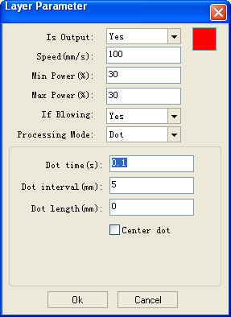

The time for emitting laser on one dot during the process. The higher the value is, the darker the dot is; if reverse, the weaker.

The interval between the dots

Only dot at center

Dot length, for cutting dash line

Figure 1-30

#### III.1.4.3.2 Laser export,introduces Setup of related parameters and how to export the figures to the machine for processing.

Label 2

Label 4

Label 6

Label 11

Label 5

Label 1

Label 3

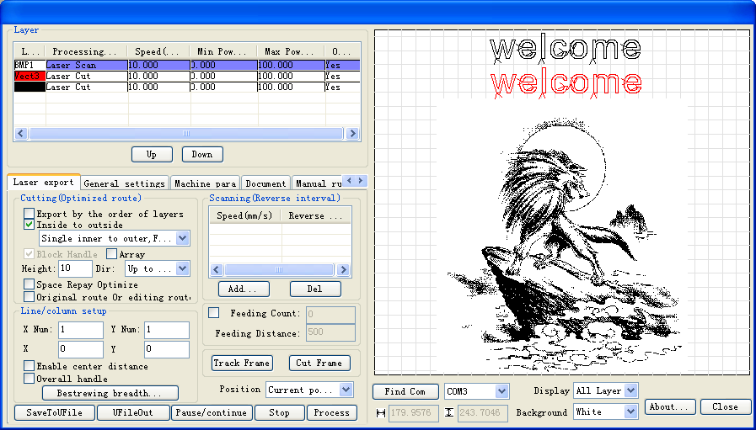

Label 9

Label 10

Label 8

Label 7

Figure 1-31

⑴ Setup of *Cutting (optimized route)* (as Label 1 in figure 1-31)

It is used to optimize the cutting route during laser cutting.

① Export by the order of layers

Export layers to the machine for processing in turn according to the order of layers from the top down as shown in Label 11. For example, the black layer is above the red layer in figure 1-31, then we have to cut the black “Welcome to use” before cutting the red “Welcome to use”.

We do not select (check) *Export by the order of layers* in general.

② Partial optimization

Search the point which is the nearest to with the laser head and then cut the rest part of the figure every time. **We select Partial optimization in generally.**

③inside to outside and start point

If there are other figures in the closed figure, we should cut all the internal figures first and then cut the closed figure.

If you select *inside to outside first*, then select *start point,* it will find a perfect point in the closed figure and start to cut.

When select *inside to outside* and *start point* for special techniques such aspolymath methacrylate, while in normal cases, we do not select *inside to outside*.

④ Block process

The system will *select Block process* automatically.

1*.*Setup of *Height and dir*. Different figures require different *Height* values. The height is always set between 10 and 20mm for figures not well-regulated. For *Dir,* you can select *Top to bottom, From the bottom up, Left to right* or *Right to left* according to the requriemets of processing.

Note: For well-regulated figures, you must set appropriate height value to achieve perfect cutting order. For example:

a. Cutting **Text**, set the *Height* value the same to the height of the text font.

b. Processing **Light blocking board formed with short line segments,** set the *Height* value less than the space between two lines.

2*.*  Setup of *Array*

**Usually, we do not select (check) *Array,*** but for cutting array figures, we can select the feature.

For example: you can select *Array* when cutting array circles, set the *height* value less than the diameter of the circle.

⑤ Original route

Once you select Original route, export according to the order of layers, the route optimization of Part optimization, From the inside to outside and Block processing will be invalid. It shows that it will be exported to the machine for processing according to the drawing order of layers in CorelDraw.

We do not select (check) this feature in general; special route optimizing arithmetic processing is not needed inside the software itself, so it does not need any waiting time when exporting figures to process. So you can select this feature and need not wait for the software arithmetic processing when exporting the figure with a large amount of data.

⑵ Setup of *Scanning* (*Reverse interval*) (as Label 2 in picture1-31)

The edges of figure may be unsmooth because of the extending of machine strap when the laser bilaterally scanning the picture. So we increase the reverse interval to for the amendment. There is certain reverse interval under certain speed; Generally speaking, the faster the speed is, the bigger the reverse interval is.

① add reverse interval

Left click on the *add* button in Label 2 block of figure 1-31, a menu as figure 1-32 will pop up:

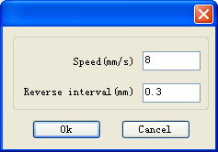

Input laser scanning speed

Input reverse interval

Figure 1-32

Input Speed (e.g.: 8) and Reverse interval (e.g.: 0.3) as shown in figure 1-32, then click on the *OK* button, a menu as figure 1-3 will pop up 3:

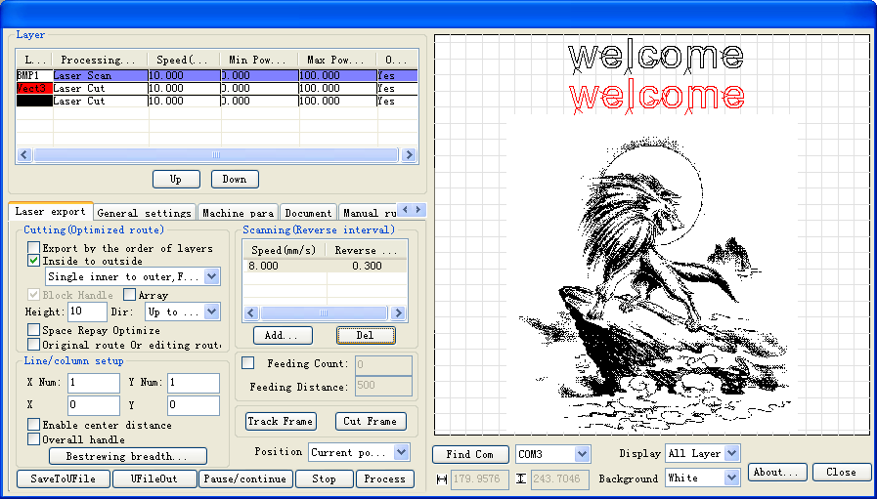

One item “8.00 | 0.30” added

Figure 1-33

We can see in figure 1-33 that one item “8.00 | 0.30” has been added in the block of *Scanning (Reverse scanning).*This shows that the laser scanning speed is 8m/min and the reverse interval is 0.30mm.

Following the same operation, we can add one more item “10.00 | 0.40” as shown in figure1-34 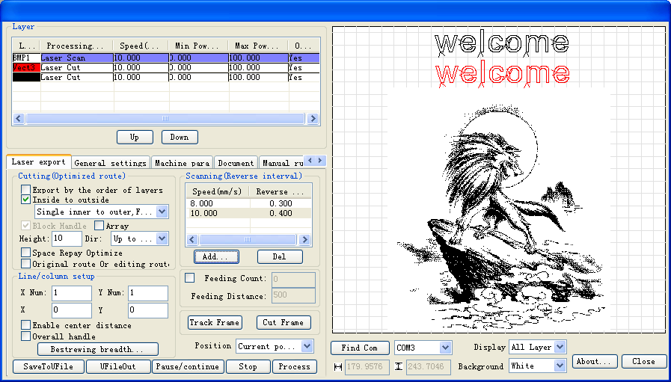

There are two items in the reverse interval list now: “8.00 | 0.30” and “10.00 |0.40”

Figure 1-34

At this time, the reverse interval is 0.30mm when the laser scanning speed is 8m/min;

the reverse interval is 0.40mm when the laser scanning speed is 10m/min.

Thus, if we scan the figure with laser at the speed of 9m/min, the reverse interval will be 0.3+(9-8) / (10-8) × (0.4-0.3)=0.35mm; If we scan the figure with laser at the speed of more than 10m/min, the reverse interval equals the reverse interval of 0.40mm at the speed of 10m/min. If we scan the figure with laser at the speed of less than 8m/min (e.g.: 6m/min), the reverse interval will be 6/8×0.30=0.225mm; **so we don’t need to add a reverse interval for every speed value.**

② Modifying reverse interval

Double click on the reverse interval item to be modified in the *Scanning (reverse internal)* block with the left key of the mouse, such as “10.00 |0.40”, a menu as figure 1-35 will pop up:

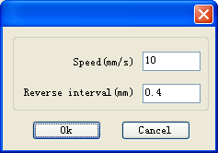

Input reverse interval value

Figure 1-35

As shown in 1-35, input proper *Reverse interval* (e.g.: 0.45), then click on the *ok* button, now the reverse interval corresponding to the scanning speed of 10m/min has been modified to 0.45mm.

③ Deleting reverse interval

Click on the reverse interval item to be deleted in the *Scanning (reverse inter)* block with the left key of

the mouse, and then click on the *Delete* button.

⑶ Settings of the *line&column setup* (as Label 3 in picture1-31)

One figure is copied to multiple lines and columns to be exported to the machine for processing.

Suppose we need to export a circle as shown in figure 1-36:

This means that the current figure (a circle here) is copied into 2*3=6 copies, which are exported to machine for processing as 2 lines and 3 columns.

The width of current figure (here is a circle)

The interval between two adjacent circles in the direction of the Y-axis

The height of the current figure (a circle here).

The interval between two adjacent circles in the direction of the X-axis

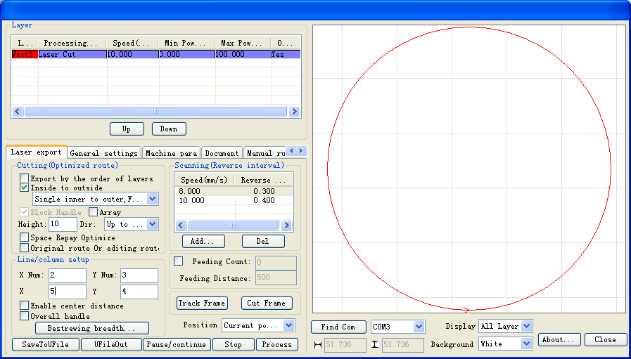

Figure 1-36 exporting a in multiple lines and columns

Introduction of parameters in Line&column setup is shown in figure 1-36.

If we adopt export and processing according to the Line & column setup in figure 1-36, then the actual figure exported is as figure 1-37:



Instruction:

The line space is the distance between the centers of the adjacent upper and lower circles, 51.736+4=55.736mm.

The column space is the distance between the centers of the adjacent left and right circles, 51.736+5=56.736mm.

Figure 1-37

Bestrewing breadth setup:

This allows us to decide how many lines (Y) and columns (X) can be exported at the most according to the breadth and the range interval set by user.

Operation procedure:

① Click on the *Bestrewing breadth* *button*, a menu as figure 1-38 will pop up:

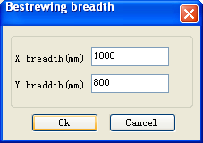

Figure 1-38

② As shown in figure 1-38, input the actual *X breadth* (e.g.: 1000mm) and the *Y breadth* (e.g.: 800mm), click on the *OK* button.

A menu as figure 1-39 will pop up:

The Y interval is 51.736+4=55.736mm according to the Y breadth of 800mm, and the Y number is 14.

The X interval is 51.736+5=56.736mm according to the X breadth of 1000mm, and the obtained X number is 17.

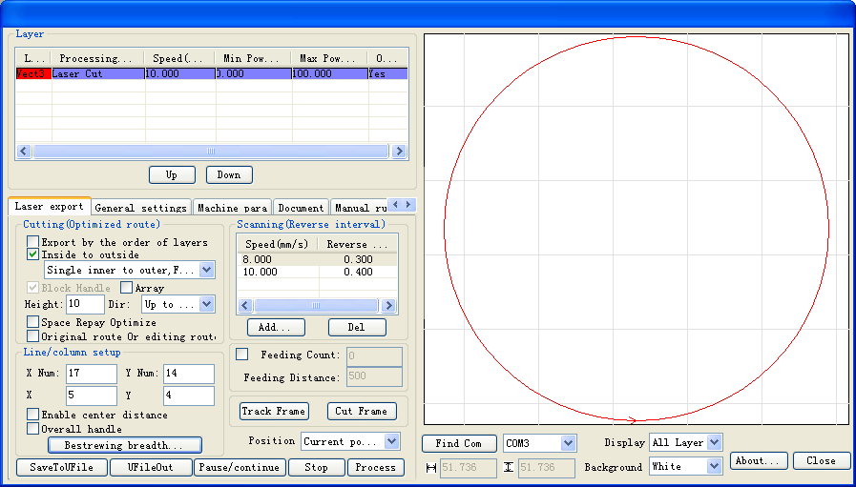

Figure 1-39

⑷ Setup of *track frame* (as Label 4 in figure 1-31)

Cut along the side of the minimum circumscribed rectangular which contains the current graph.

Operation procedure: set the laser *Power* and cutting *Speed*, select correct *USB port*, then click on the *Run* button.

Let’s illustrate the meaning of *track frame* with an example, as shown in figure 1-40:

Figure 1-40

The circle is an actual graph, the red rectangular is the minimum circumscribed rectangular of this circle. The laser head will cut along the rectangular after you click on the *Run* button.

⑸*Port* selection (as Label 5 in figure 1-31)

Select correct port according to the USB port which connects the computer with the machine.

⑹Selection of *Origin* (as Label 6 in figure 1-31)

Origin includes three options: Current position, Original anchor point and Machine zero.

Show the position to which the laser head will return when the figure processing is finished.

*Current position*: the laser head returns to its position before the processing.

*Original anchor point*: the laser head returns to the previous anchor point. The anchor point can be set by the keys on the machine panel.

*Machine zero*: the laser head returns to the limit point of the machine.

⑺ *Export (*as Label 7 in figure 1-31)

It saves the figure processing data processed by the software to file.

The saved file can be downloaded to the machine. We can start the file directly for export and processing by the keys on the machine panel.

Operation procedure: Click on the *Export* button, then input the name of file to be saved in the dialog box and click on the *Save* button.

⑻ *Import* (as Label 8 in figure 1-31)

Open the saved file and export it to the machine for processing.

Operation procedure: Click on the Import button, then select the file you need to process in the dialog box and click on the Open button.

⑼ *Process* (as Label 9 in figure 1-31)

Export the current figure to the machine for processing.

Operation procedure: Click on the *Process* button directly.

(10) Display of the current operation status (as Label 10 in figure 1-31)

It is used to show information on the status of the user’s current operation. For example, if you select an incorrect *USB port*, it will show “Transfers failure, the serial port can’t be opened” when you click on the *Process* button.

#### III.1.4.3.3 General Settings

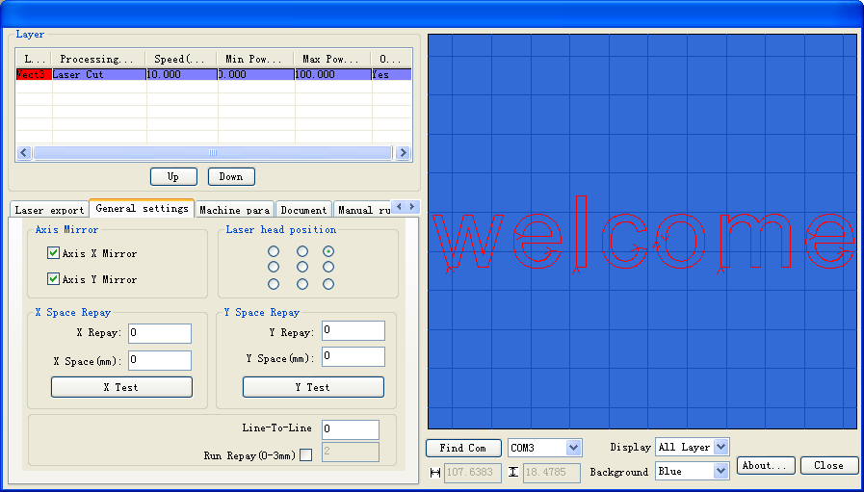

Click on the *General settings* button to switch from any other menu to this menu

Label 3

Label 2

Label 1

Figure 1-41

⑴ Axis Mirror (as shown in Label 1 in Figure 1-41)

Generally, Axis direction of mirror is based on the actual location of the limit or home of machine. The default coordinate system if Descartes coordinate system, and zero in the bottom left. If the zero point of the machine is top left, then X-Axis does not need to mirror, but Y-Axis need to mirror. If the zero point of the machine is top right, then both X-Axis and Y-Axis are all need to mirror. In addition, this function can also use to other application for mirror.

Note: If the settings are inccorrest, the exported figures may be reverse or upside down..

⑵ Laser head(as shown in Label 2 in Figure 1-41)

Position of Laser head means the location laser head relative to the graphic.

  

Top Left

Top Middle

Top Right

  

Middle Left

Center

Middle Right

  

Bottom Left

Bottom Middle

Bottom Right

Note: You must ensure correct *limit position* settings(as shown in Label 1 in Figure 1-41).

⑶ *Line-to-line precision* *(0-2mm)* (as shown in Label 3 in Figure 1-41) settings

If the distance between one end of a line segment and one end of another is smaller than or equal to this value, the software will internally consider the two segments to be connected.

For example, please see Figure 1-46:

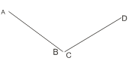

Note:

In the two line segments AB and CD, the distance between B and C: |BC|=0.05mm

Figure 1-46

If the *Line-to-line precision* value is set to 0.1mm, as |BC|=0.05mm<0.1mm, AB and CD are deemed to be connected (namely, B and C overlap), as shown in Figure 1-47:

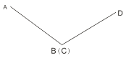

Figure 1-47

Note: Points B and C are considered overlapped now

Note: This value is normally set to 0.1mm, for figures with large quantity of data, it can be set to 0mm to reduce the waiting time before the processing.

#### III.1.4.3.4 Machine Para. (Machine parameters)

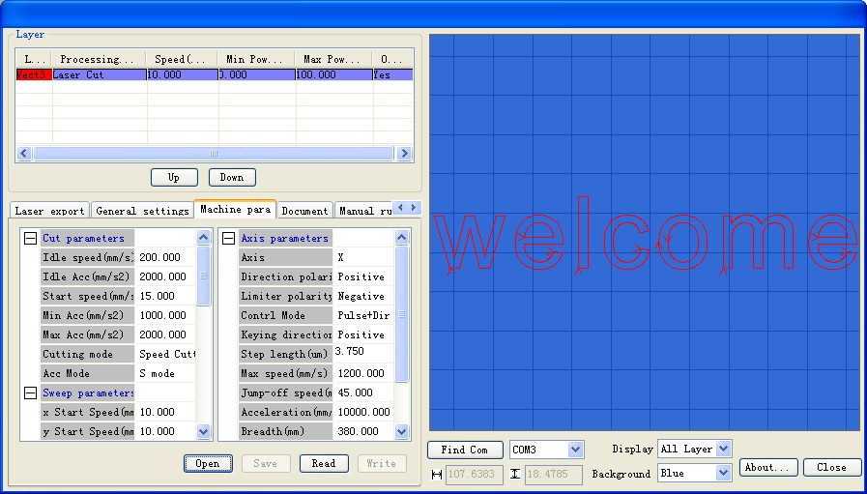

Click on the *machine Para.* Button to switch from any other menu to this menu

Figure 1-48

⑴ Machine parameters are described as follows:

A. Laser parameters

*Laser mode*: there are currently three types of Laser devices: home-made glass tube, RF Laser (pre-ignition pulse not required) and RF Laser (pre-ignition pulse required), the glass tubes adopt analog quantity for control and RF tubes adopt digital quantity for control. If the machine adopts home-made glass tube, the laser type should be “Analog quantity”, while if it adopts RF tube, the duty ratio (pre-ignition pulse required/ not required) should be selected correspondingly. After modification of Laser type options, the system should be reset, and the modifications should take effect after the reset.

*Laser freq*: the pulse frequency of the control signal used by the laser installed on the machine.

*Max. power (%), Min. power (%):* you can set the limit power values for the laser, namely, during the operation, the max. power set by the user cannot be higher that the max. power set here and the min. power set by the user cannot be lower than the min. power set here.

*On-delay, off-delay*: if the on/off delay parameter is not 0, when the laser is turned on/off, the laser will be turned on in advance and turned off behind schedule at the time delay set in advance. The range for the time delay may be 0us ~ 0.1s.

B. Other parameters

*reset speed*: this parameter decides the speed of the machine to return to the origin when startup, if the breadth of the machine is too large, you can set a comparatively large value of reset speed,

but do not set it too large, the controller will control this parameter within 50mm/s, namely, any reset speed value set by the user exceeding 50mm/s should be deeded invalid.

*Idle speed*: this parameter decides the max. Speed of all lines not emitting beams during the operation of the machine. This parameter should not be lower than the lower of the jump-off speed of the X-axis and that of the Y-axis and not exceed the higher of the max. speed of the X-axis and that of the Y-axis, if the setting is illegal, the controller will automatically set this parameter within the range above; a comparatively high idling speed can shorten the operation time of the entire figure while excessively high idling speed may cause dithering of the tracks, therefore, you should take all relevant factors into consideration when setting.

*Line shift speed of scanning*: this parameter is specially used to control the max. Speed of the scanning to shift vertically from one line to the next line below it. If during the scanning, the line space is too large or the block space is too large when scanning block figures while precise positioning for each line or block is required, you can set the line shirt speed of scanning to a comparatively low value. This parameter cannot be less than the jump-off speed of the corresponding axis during the line shift and cannot be higher than the max. Speed of the corresponding axis during the line shift, if the setting is illegal, the controller will automatically set this parameter within the range above.

*Accelerated mode*: this parameter decides the acceleration and deceleration mode (S mode or T mode) of the motor during operation, the motor accelerates and decelerates slowly and smoothly in the S mode and fast and relatively unsmooth in the T mode; the default mode is the S mode.

*Scan mode*: There are two modes for your selection: the general mode and the special mode, in the general mode, there’s no any treatment during the scan, in the special mode, light spots will be treated. If the special mode is activated, the power of the laser should be increased and correspondingly, the light spot percentage will be lower and the laser power attenuation will be higher, to achieve the same depth of scanning, the laser power should be higher. The purpose to select the special mode is to make the laser to emit beams at high power and in short period, during deep scanning, the effect of flat bottom can be achieved, however, if the light spots are improperly adjusted, this effect may not be achieved and the working mode of high power and short period may influence the service life of the laser. The default mode is the general mode.

*Facula size*: this parameter is invalid in the general mode of scanning and is only valid in the special mode. The controller will control this parameter at 50%~99%.

*Array mode*: you can choose the swing mode and the one-way mode. The Swing mode: cutting the array back and forth in order; the One-way mode: always cutting the array from one direction to another. If One-way mode is selected, all array units have the same movement modes and the same liquidity of movements; however, this mode will take more time than the swing mode. The default mode is the Swing mode.

*Return position*: You can select the locating point and the machine origin. This parameter decides the position, the locating point or the machine origin, where the laser head stops upon completion of each operation.

*If Protection on*: If the machine is provided with any additional protection signals besides water protection, you should make corresponding selections in this option. The protection signal is inputted from universal input port 2 port (please refer to the User’s Manual of the main board). When this protection signal is enabled, the controller will carry out real-time inspection on the protection signal, if the input is at high level, the machine will be protected and the operation in progress will be suspended and the laser will be turned off.

C. Axis parameters

*Direction polarity*: if a the X or Y axis move against the machine origin when the electrical system of the machine is reset, that means that the direction signal polarity of this axis is incorrect, at this time, you should disconnect the axis from the motor driver (otherwise, the inspection of the main board will be insufficient, which may cause collision of this axis), after D16 on the main board flashes (which means that the reset has been completed, D16 will go out first each time the machine is reset and start flashing after reset completion, do not read or write all parameters on the PC before D16 starts flashing, please refer to the User’s Manual of the main board interface for the position of D16), modify the direction signal polarity of this axis on the PC, upon completion, press the Reset button to reset the main board.

*Limiter polarity*: If when the axis of movement reaches the limit position, a low level signal is triggered to turn on the LED corresponding to various limit positions and when the axis of movement departs from the limit position, a high level signal is triggered to turn out the LED corresponding to various limit positions, the limit polarity is negative; contrariwise, if when the axis of movement departs from the limit position, the LED corresponding to various limit positions are out and when the axis of movement reaches the limit position, the LED corresponding to various limit positions are on, the limit polarity is positive. Incorrect limit polarity setting may cause insufficient inspection of the system when resetting, which may lead to collision of the axes.

*Control mode*: There are two modes for your selection: the double-pulse mode and the pulse + direction mode, which should be deiced according to the type of the motor drive installed on the machine, in general, the pulse + direction mode is selected. After any modification of the control mode option, the main board should be reset to make the modification take effect.

*Keying direction*: After correct setting of the direction polarity of the machine, if the X-axis moves to the Right when you press the Left button and the X-axis moves to the Left when you press the Right button, that means the keying direction settings are incorrect and modifications should be made correspondingly; the Up and Down keys are corresponding to the movement of the Y-axis, if the Y-axis moves upwards when you press the Down button and the Y-axis moves downwards when you press the Up button, the keying directions of the Y-axis should be modified.

*Step length*: Or the pulse equivalent of the motor, it means the absolute distance covered by the corresponding axis when a pulse is sent to the motor. Before correct setting of this value, you can make the machine to cut a large rectangle (the larger figure, the less error) and the motor pace length can be calculated automatically with the length of the figure and the measured length.

*Max. speed*: The driving force of the motor and the inertia of the axis of movement decide the max. Speed of polarity of the axis. During the scan, the scanning speed should not exceed the max. Speed corresponding to the axis of the scanning; in the cutting mode, the resultant velocity during the cutting cannot exceed the lower of the max. Speed of the X-axis and that of the Y-axis. If the speed is set too high, the controller will automatically protect the speed under the max speed.

*Jump-off speed*: the speed of the axis of movement to be started directly from the static status, if it is set too large, the motor may lose synchronism, dither or even produce whistle, if it is set too low, the operation speed of the entire figure will be reduced. According to the inertia of the axis of movement, this value can normally be set at 8~15mm/s. If the inertia of the axis of movement is too high (the axis is heavy), you can set a lower jump-off speed, while if the inertia of the axis of movement is too low (the axis is light), and you can set a higher jump-off speed.

*Acceleration*: The acceleration of the axis of movement when accelerating or decelerating, too high acceleration will also result in loss of synchronism, dithering or even whistle of the motor, while too low acceleration will result in slow acceleration which will reduce the operation speed of the entire figure. A typical range of 800 ~ 3000mm/s2 can be set for an axis with high inertia, Y-axis corresponding to the crossbeam, for instance, and a typical range of 10000 ~ 20000mm/s2 can be set for an axis with low inertia, X-axis corresponding to the dolly, for instance.

*Breadth*: the max. Distance that the axis of movement can cover, which should be decided according to the actual situation of the machine.

⑵ How to input a certain machine parameter?

For example, to modify the *reset speed*, please see Figure 1-49:

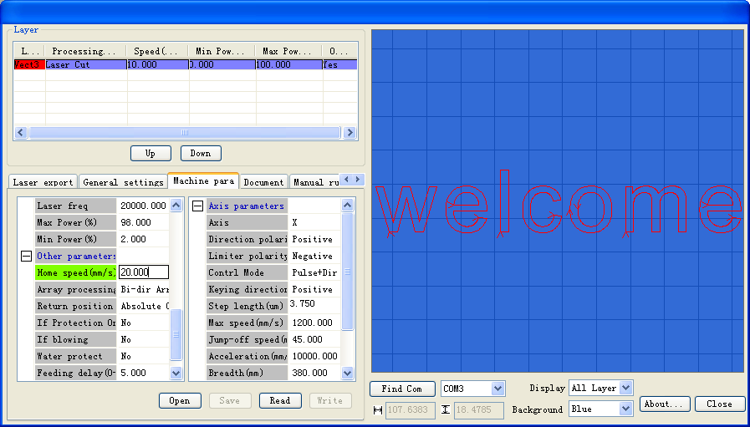

Click or double click with the right button of the mouse

Figure 1-49

As shown in Figure 1-49, click or double click on *reset speed*, you’ll see a input box here, and then just input the required value of *reset speed*.

⑶ *Open* parameter files

Procedure: as shown in Figure 1-49, click on the *Open* button; select the parameter file to be opened from the pop-up dialog box, and then click on the *Open* button in the pop-up dialog box, then the values of the parameters in the parameter files will be shown in the menu.

⑷ *Save* current machine parameter to file

The Save operations can be carried out only when the Save button is activated (it is inactivated if it’s grey; this button will only be activated when there’s machine parameter read from the machine or parameter file opened), you can click on the Save button to save machine parameters on the menu to files so as to write parameters to the machine with the saved parameter files. Procedure: as shown in Figure 1-49, click on the Save button, input the file name in the pop-up dialog box, and then click on the Save button in the pop-up dialog box. Thus, the machine parameter on the menu is saved to the file.

⑸ *Read* parameter

Procedure: as shown in Figure 1-49, select the correct USB port first, and then click on the *Read* button, after a short while, if the parameter is successfully written, the menu as shown in Figure 1-50 will appear:

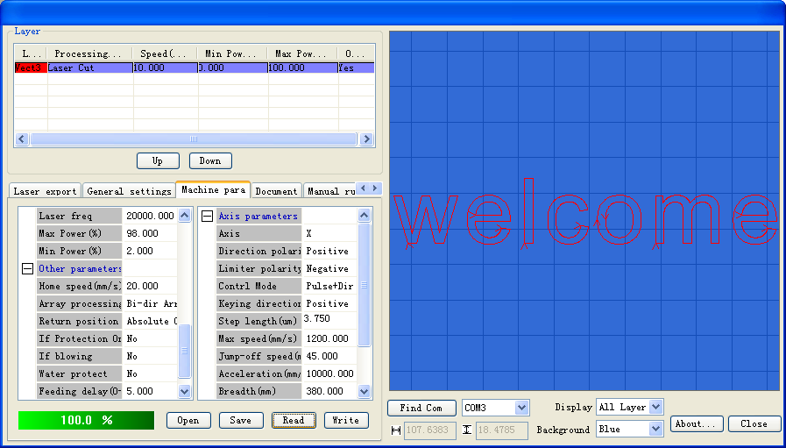

Figure 1-50

⑹ *Write* parameter

The Write parameter operations can be carried out only when the *Write* button is activated (it is inactivated if it’s grey; this button will only be activated when there’s machine parameter read from the machine or parameter file opened).

Operation procedure: as shown in Figure 1-49, select the correct USB port first, and then click on the *Write* button, after a short while, if the parameter is successfully written, the menu as shown in Figure 1-51 will appear:

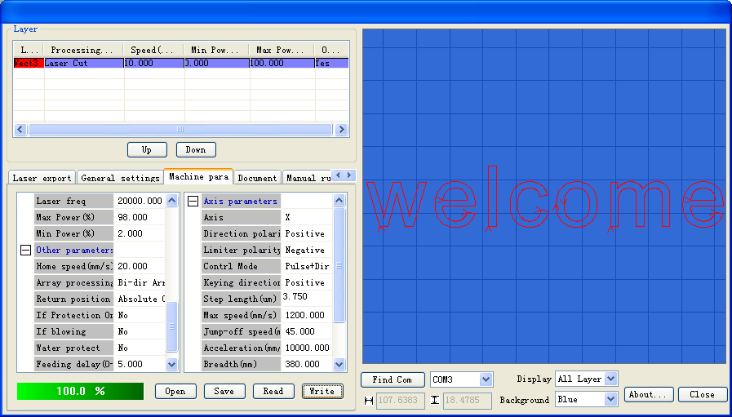

Figure 1-51

⑺ Setting of the *Step length*

In the menu shown in Figure 1-49, click or double click on *Step length*, the menu as shown in Figure1-52willappear: 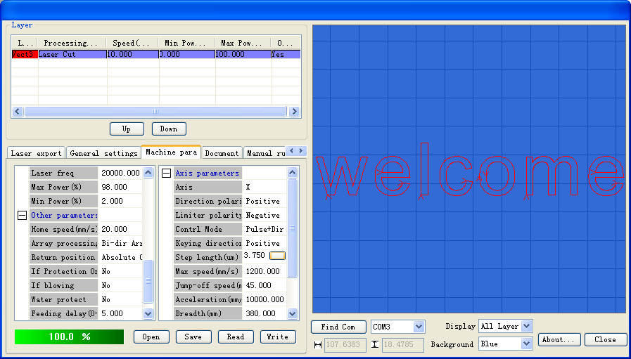

Motor pace length button

Now, the input box and a button appear after *Step length*

Figure 1-52

If you know the accurate value of *Step length*, please directly input this value in the input box of Step length. If you don’t know the accurate value of Step length, you can calculate it with the software following the steps below:

Draw a rectangle with specified dimensions of L * H (L for length, H for height) in CorelDraw (corresponding to CorelDraw_Laser) or AutoCAD (corresponding to AutoCAD_Laser). This rectangle is as shown in Figure 1-53:

Length of the rectangle: L mm

Height of the rectangle: H mm

Figure 1-53 the rectangle drawn in CorelDraw or AutoCAD

② Cut this rectangle with CorelDraw_Laser or AutoCAD_Laser and measure the length and height of the cut rectangle with measuring devices l*h (l for length, h for height), as shown in Figure 1-54:

Length of the rectangle: l mm

Height of the rectangle: h mm

Figure 1-54 Rectangle formed by cutting

③ Enter the menu as shown in Figure 1-49, click on the *Read parameter* button to correctly read the machine parameters of the current machine.

④ In the menu as shown in Figure 1-52, click on the *Step length* button, the menu as shown in Figure 1-55 will appear:

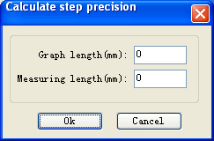

To calculate the Step length of the X-axis, input the l value;

To calculate the Step length of the Y-axis, input the h value;.

To calculate the Step length of the X-axis, input the L value;

To calculate the Step length of the Y-axis, input the H value.

Figure 1-55

As shown in Figure 1-55, input corresponding *Expected length* and *Actual length.*

⑤ Click on the *OK button* in Figure 1-55, the menu as shown in Figure 1-56 will appear:

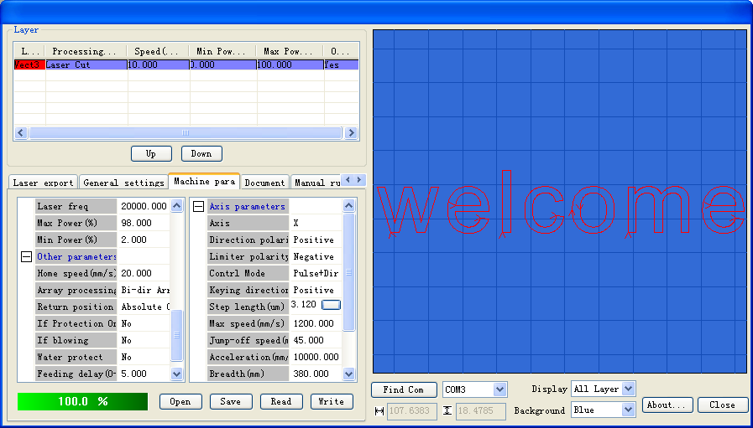

Displays the calculated value of *Step length* (3.1200 here)

Figure 1-56

#### III.1.4.3.5 *Document*

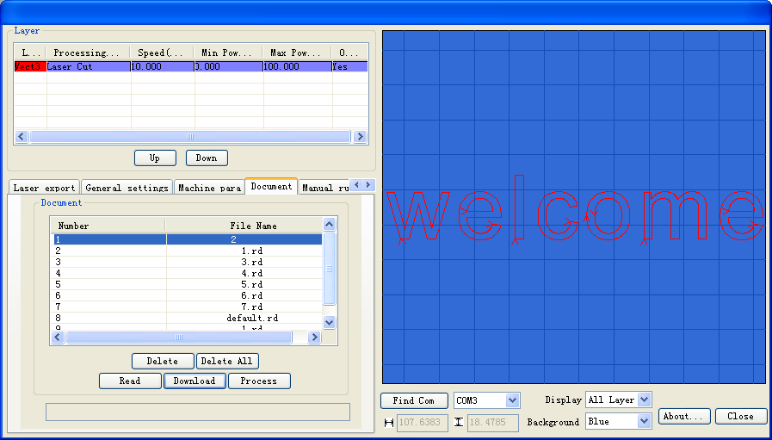

Displays the status of current operation

Click on the *Document* button to switch from any other menu to this menu

Figure 1-57

⑴ Inquiry of the Work time (h: min: s: ms).

Display format: h: min: s: ms h (hours) min (minutes) s (seconds) ms (milliseconds).

Operation procedure: as shown in Figure 1-57, select correct USB port first, and then Click on the *Work time (h: min: s: ms)* button.

⑵ *Read*

Operation procedure: as shown in Figure 1-57, select correct USB port first, and then Click on the Read button. If files have been saved in the machine, all files saved in the machine will be shown in the menu as shown in Figure 1-58:

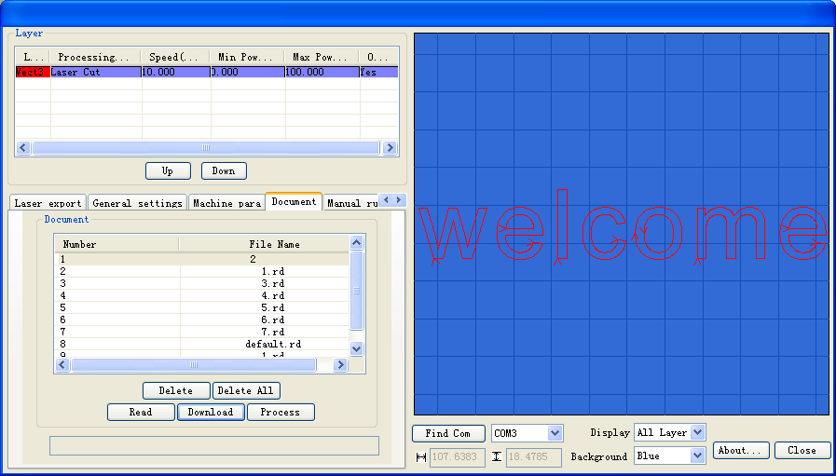

Label 1: Right click on the file to select it

After reading successfully, all files stored on the machine will be displayed in the window

Figure 1-58

⑶ Download

Operation procedure: as shown in Figure 1-57, select the correct USB port first, and then click on the download button, then select the file to be downloaded from the pop-up dialog box, and then click on the Open button in the pop-up dialog box.

⑷ Delete

Operation procedure: as shown in Figure 1-58, select the file to be processed first (see the note of label 1 in Figure 1-58), and then click on the Delete button.

⑸ Delete all

Operation procedure: as shown in Figure 1-58, directly click on the *Delete all* button.

⑹ Process

Operation procedure: as shown in Figure 1-58, select the file to be processed first (see the note of label 1 in Figure 1-58) and then click on the *Process* button

#### III.1.4.3.6 Manual

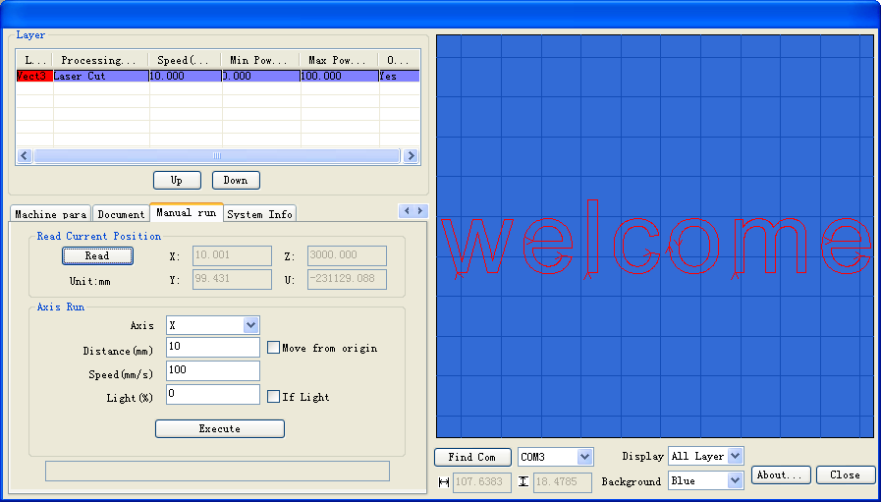

Figure 1-59

#### III.1.4.3.7 System info

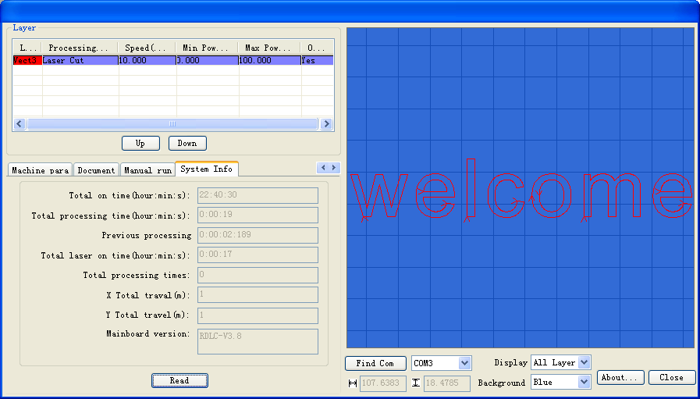

Figure 1-60

**Total on time**: The total time of motherboard working

**Total processing time**: The total time of processing, including the time of jump moving.

**Previous processing time**: The time of the last processing

**Total laser on time**: The time of the laser processing

**Total processing times**: The number of completed processing, not include the processing forcing to end.

**X total travel**: The total travel of motor X.

**Y total travel**: The total travel of motor Y.

**Motherboard version**: The version of the current controller.

## III Introduction of AutoCAD_Laser

### III.2.1 Features of AutoCAD_Laser

Mainly used in movement control, it is an important part of laser movement control and is. It realizes effective control of laser numerical control machine tool by computer and accomplishes processing tasks according to user’s different requests.

AutoCAD_Laser is a plug-in module stalled in AutoCAD, utilizing indirectly the powerful functions of plotting and edit of AutoCAD. It supports almost all the file formats supported by AutoCAD.

### III.2.2 Environmental requirements

① Above CPU586, above PIII or PV recommended CPU 586

② Memory, above 1G recommended

③ Windows2000/XP、Vista, XP recommended

④ Supports AutoCAD software above the version of AutoCAD2000 and AutoCAD2004. AutoCAD2005. AutoCAD2007.

### III.2.3 Installation and startup

III.2.3.1 Installation

1. You should have installed AutoCAD software before you install AutoCAD_Laser. If you don’t, please install AutoCAD on your computer first.

2. If AutoCAD software is opened, please close it first.

3. In order to ensure smooth installation, we suggest you to close the Anti-Virus Software first.

4. Double click on, the software installation menu will pop up as Figure 2-1:

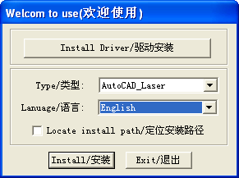

3. Click on this button to install.

2. Includes three options: Simplified Chinese, Traditional Chinese, English. Please select the software language you need.

1. Includes two options: CorelDraw_Laser and AutoCAD_Laser.. Select AutoCAD_Laser

Figure 2-1 Software installation

As shown in figure 2-1, select AutoCAD_Laser, select software language, then click on the Install button, a prompt menu as shown in figure 2-2 will pop up to show successful installation.:



Figure 2-2 Prompt of instillation completion

1. Instillation completion.

III. 2.3.2 Startup

Open AutoCAD, the main menu of AutoCAD will be shown as Figure 2-3:

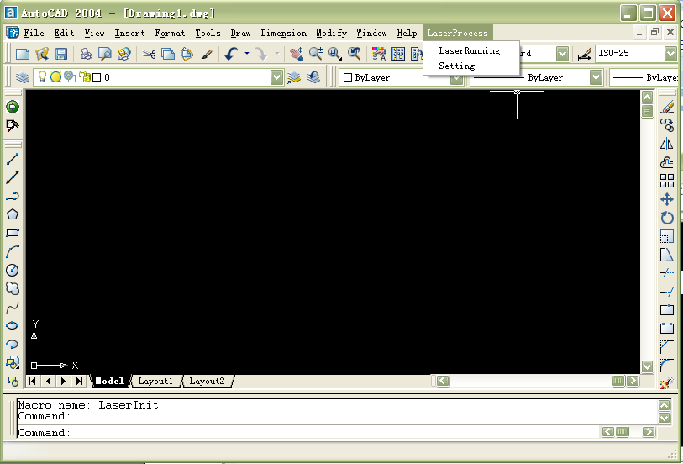

Laserprocess menu

LaserRunning button

Setting button

Figure 2-3

(1). Click on the *LaserRunning* button or the *LaserRunning* menu item, the main menu of *LaserRunning* will be shown as Figure 2-4:

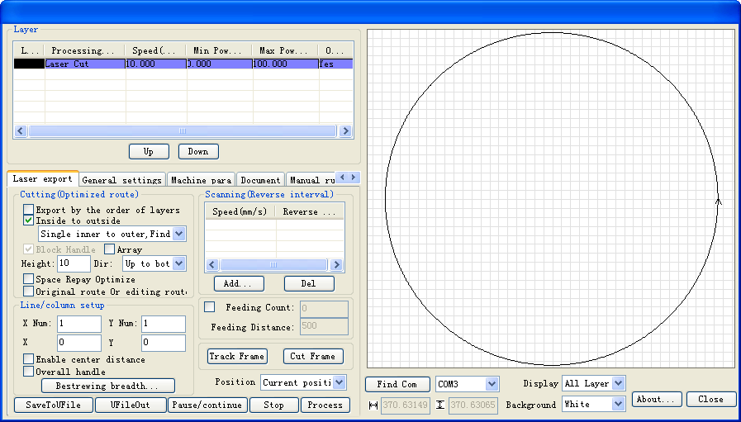

Figure 2-4

Note: this menu will not pop up when AutoCAD is not plotting at present.

(2). Click on the Setup button or the Setup menu item, the dialog box of Setup will pop up as shown in Figure 2-5:

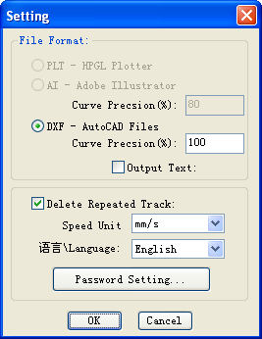

Figure 2-5

* 1. Operation instruction of AutoCAD_Laser. (Almost the same to that of CoreDraw_Laser please refer to the operation instruction of CorelDraw_Laser).

## III Attached

Bitmap Creation Flow

**Step one**: Startup Photoshop  
**Step two**: Select the menu File/Open to open a picture:   
                       
                             figure 5-1

**Step three**: Select the size and the precision of the picture  
1、Open the menu Image/Image Size, a window will pop up, as shown below:

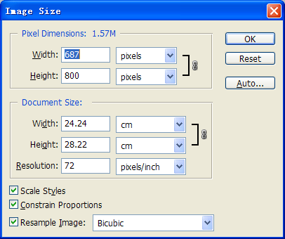

Figure 5-2

2、In the column Document Size/ Height and Width, input the value you wanted, figure 5-3 followed；   
3、In the column Document Size/ Resolution, input the converted graph precision(600~1200 pixels per inch is

recommended, the higher resolution, the clearer converted graph);  
 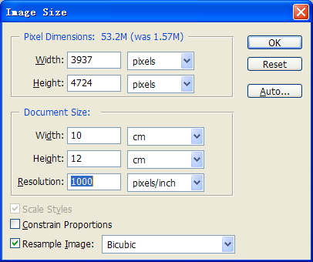

Figure 5-3

Such as figure 5-3: the converted graph size is 10cm*12cm, the resolution is 1000 pixels per inch;  
4、Push on the OK bottom.   
**Step four**: Select the menu Image/Mode/Grey Scale, take out the color information.   
**Step five**: To create net-dot bitmap, two methods are discussed below:

**Method one**:   
1、Select the menu Image/Mode/Bitmap, a window will pop up as below:  
                 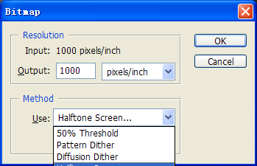

Figure 5-4  
2、Select（T）,（P）,（D）or（H）, which method is you wanted;  
3、To solid graph, Please select（T）, to create some scan graph of the character or of the logo design. To cross line graph, may select one of （P）,（D）or（H）, to create some different effect. Generally speaking, select （H）.  
4、if（H）selected, a window will pop up:

                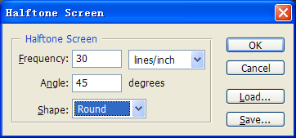  
 Figure 5-5  
 In this window, frequency （F）, that’s to say, the precision of the cross line, may be 10~60 lines per inch;   
 Angle（N）may be 45 degree;  
 In column Shape（H）, circle is selected generally.  
5、Push on the bottom OK.   
  
**Method two**:  
1、Select Filter/ Pixelate / Color Halftone , a window will pop up, such as figure 5-6.   
2、Confirm Max Radius, which is 4~127 pixels, to confirm the size of the color halftone gridding. The calculating method followed: graphics resolution*0.71/ gridding precision.  
      For example: as shown in figure 5-1, the resolution is 1000 pixels per inch, the wanted gridding precision is 60 DPI, then, the max radius is 12, the expression followed: 1000*0.7/60=12.   
3、Confirm the net angle of the graph channels.   
 Input the net angle value for some of the graph channels, the angle is -360~+360 degree, which is the angle of the net dot and the horizontal line.   
 Note：

To grey graph, only channel 1 selected;   
   To RGB graph, channels 1,2 and 3 selected, then red, green and blue channels are corresponding;   
   To CMYK graph, all four channels selected, then cyan, magenta, yellow and black channels are corresponding.  
  
 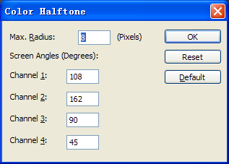

Figure 5-6  
4、Push on the OK bottom;

5、In the menu Image/Mode/Bitmap, Select 50% Threshold, to convert the graph to one-bit bitmap.

For example, after filter processing, the RGB graph, such as figure 5-7-1, will be converted to a bitmap, as shown in figure 5-7-2.  
  
 Figure 5-7-1 Figure 5-7-2   
  
(1)Select Image/Rotate Canvas/Flip Horizontal to rotate the graph;   
(2)Select the menu File/Save As to save the graph file, BMP format selected;  
(3)All things are done.  
 Some methods of drawing in Photoshop aren’t discussed in this file, if needed, please consult the Manuals of Photoshop or some related books.

# IV Specification of MC-BOARD Motion Control Mainboard Interface V3.00

## IV.1 Overview

MC-BOARD mainboard is specially used in the motion control system for laser engraving and cutting, which can support the motion control of four shafts at most, that is, the gang control of two shafts and the inching control of the other two shafts. The gang control system of 3 or 4 shafts can be developed for specific users.

MC-BOARD mainboard supports both the online control mode and the offline control mode, which, after the parameter setting, graph edition and path optimization of machines (For details, see the description of mainboard PC software) can be completed with the supporting PC software of this mainboard, can be started and processed in PC, or generated into data files (.rd) in PC and copied to the mainboard memory through U-disk so as to realize offline operation. This mainboard supports FAT32 and FAT16 file formats of U-disk in addition to copying of .rd file in the mainboard memory into U-disk.

MC-BOARD is equipped with a man-machine operating panel that is connected to RS232 interface and the mainboard.

Please pay attention to the following items when using this mainboard:

Please read this Specification prior to use of this mainboard;

Please don’t dismantle and change the chips and components on the mainboard on your own;

Please keep it far away from water and corrosive substances;

Please don’t press the chips and components with force in the process of wiring or installation.

## IV.2 Installing Dimensions

IV.2.1 Installing Dimensions of Mainboard

All the dimension units are expressed in mm to the accuracy of 0.1mm.

120.8

170.8

ф3.5

68.5

92.3

4.4

4.8

111.8

IV.2.2 Installing Dimensions of Keyboard

All the dimension units are expressed in mm to the accuracy of 0.1mm.

100.0

150.0

ф3*10

142.0

4.0

4.0

92.0

10.0

3.8

## IV.3 Physical Picture and Interfaces

IV.3.1 Physical Picture of MC-BOARD Mainboard

D16~D20

D16 means the system flashers.

Udisk

P1

IO

L-P1

L-P2

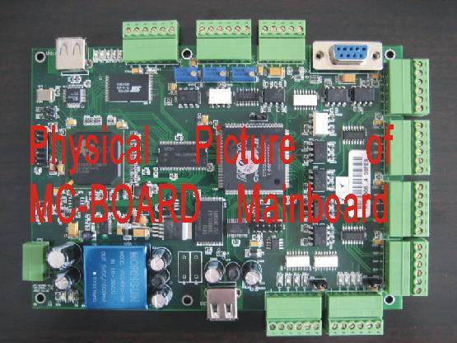

JP0

JP2

JP3

X

Y

Z

U

X/Y-Lim

PC

Z/U-Lim

D10~D7

Y/X Limit Indication

D14~D11

U/Z Limit Indication

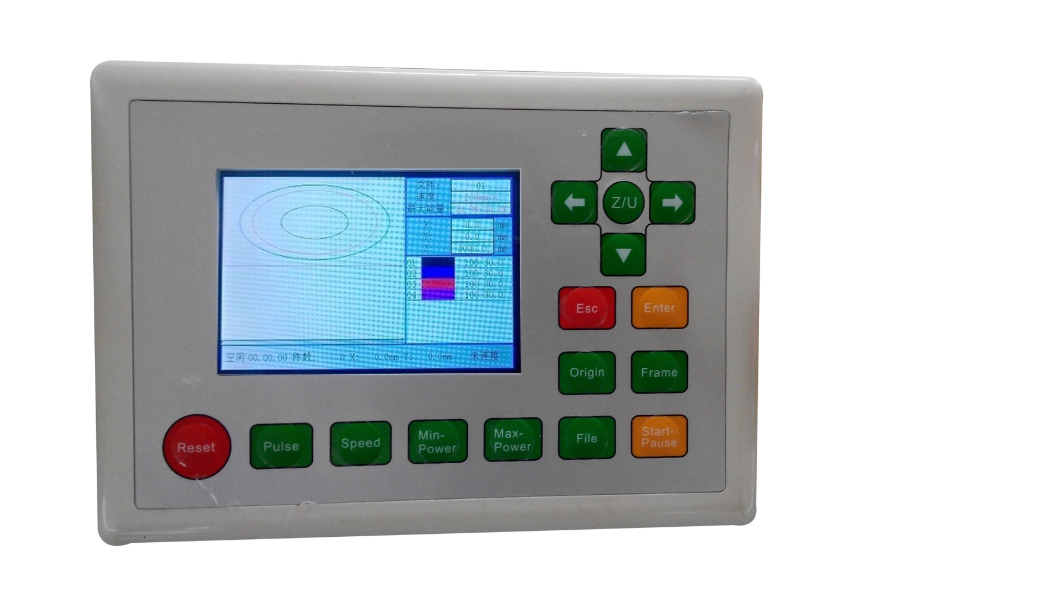

IV.3.2 Physical Picture of Main-Machine Panel

## 

## IV.4 Description of Interface Signal

IV.4.1 Power Interface JP0（4pin 3.81mm）

|  |  |
| --- | --- |
| Pins | Definitions |
| 1 | 24V GND (Input) |
| 2 | 24V VCC (Input) |
| 3 | 5V GND (Input) |
| 4 | 5V VCC (Input) |

**◆** This mainboard uses 24V and 5V power supply, of which quality should be guaranteed. Please pay attention to the sequence of all interface pins, with the serial numbers marked on the mainboard.

IV.4.2 USB Interface

There are two USB interfaces on the mainboard. One is marked as the Udisk interface used in insertion of U-disk as well as copying of U-disk files and memory files; the other is marked as PC interface used to connect PC to facilitate parameter setting and control of mainboard through PC.

IV.4. 3 4-axis Limit Interface (6pin 3.81mm)

Z/U-axis Limit Interface Z/U-Lim

|  |  |
| --- | --- |
| Pins | Definitions |
| 1 | 5V GND (Output) |
| 2 | U-，U-axis moves to the limit of 0 coordinate, and corresponds to D14 indicator. |
| 3 | U+，U-axis moves to the limit of the maximum coordinate, and corresponds to D13 indicator. |
| 4 | Z-，Z-axis moves to the limit of 0 coordinate, and corresponds to D12 indicator. |
| 5 | Z+，Z-axis moves to the limit of the maximum coordinate, and corresponds to D11 indicator. |
| 6 | 5V-1K resistor pulled up or 5V is selectable (Output); when JP3 jumps across Pin 1 and 2, Pin 6 is 5V; when JP3 jumps across Pin 2 and 3, Pin 6 is 1K resistor pulled up to 5V. |

X/Y-axis Limit Interface X/Y-Lim

|  |  |
| --- | --- |
| Pins | Definitions |
| 1 | 5V GND (Output) |
| 2 | Y-，Y-axis moves to the limit of 0 coordinate, and corresponds to D10 indicator. |
| 3 | Y+，Y-axis moves to the limit of the maximum coordinate, and corresponds to D9 indicator. |
| 4 | X-，X-axis moves to the limit of 0 coordinate, and corresponds to D8 indicator. |
| 5 | X+，X-axis moves to the limit of the maximum coordinate, and corresponds to D10 indicator. |
| 6 | 5V-1K resistor pulled up or 5V is selectable (Output); when JP2 jumps across Pin 1 and 2, Pin 6 is 5V; when JP2 jumps across Pin 2 and 3, Pin 6 is 1K resistor pulled up to 5V. |

**◆** In the PC software of this mainboard, you can select the support to the limit polarity, that is, if the axis moves to the limited position, it will trigger a low-level signal, and the LED corresponding to each limit will light up; when the axis moves far from the limited position, it will trigger the high-level signal and the limit indicator will go out. On the contrary, if the axis moves near to the limit, it will trigger the high level; if it moves far from the limit, it will trigger the low level and the limit polarity is plus.

IV.4.4 X/Y/Z/U Moving Axes Driver Interfaces（X、Y、Z、U 6pin 3.81mm）

The four moving axes have the same interfaces. X-axis interface is taken for example.

|  |  |
| --- | --- |
| Pins | Definitions |
| 1 | 5V GND (Output) |
| 2 | XDIR+  1. If the motor driver uses the pulse + direction control mode, the pin should be connected to the direction control port of motor driver;  2. If the motor driver uses the double-pulse control mode, the pin should be connected to the opposite pulse input port. |
| 3 | XDIR-，reserved |
| 4 | XPWM-，reserved |
| 5 | XPWM+  1. If the motor driver uses the pulse + direction control mode, the pin should be connected to the pulse input port of motor driver;  2. If the motor driver uses the double-pulse control mode, the pin should be connected to the positive pulse input port. |
| 6 | 5V VCC (Output) |

**◆** If the power system of the mainboard resets and either of X/Y axes moves reversely, it means the directional signal of this axis is not right in polarity. In such a case this axis should be disconnected from the motor driver (otherwise the mainboard can’t detect the limit so as to cause the collision of this axis) first, and then such a polarity be corrected on PC after D16 on the mainboard flickers (it means resetting is completed, because D16 will go out when the machine resets each time, and it can start flickering only after resetting. Please don’t read any parameters on PC before D16 doesn’t flicker). The resetting of the mainboard can be done through pressing the RESET button, the directional signal polarity of this axis having been corrected on PC.

IV.4.5 Man-machine Operating Panel Interface P1

P1 is DB9 mother socket connected to the man-machine operating panel. Both are communicated with RS232.

IV.4.6 General Purpose Input/Output (GPIO) （5pin 3.81mm）

|  |  |
| --- | --- |
| Pins | Definitions |
| 1 | 5V GND (Output) |
| 2 | GPI 2 is inputted from the protection notch. Where the machine needs protection in the specific state, the protection signal should be inputted from this pin that can be enabled and disabled. This pin being disabled, this signal will not be inquired by the mainboard; this pin being enabled, the machine will be protected when the input is at a high level, all operations be suspended and the laser closed. |
| 3 | GPI 1 is temporarily reserved for future use. |
| 4 | GPO 1, Output high level when work start and output low level when work pause or finish. This port can autocontrol some equipment such as blower, which can be opened when work start and closed when work pause or finish. |
| 5 | 5V VCC (Output) |

IV.4.7 Laser Power Supply Interface（6pin 3.81mm）

Digital Laser Power Supply Interface L-P1

|  |  |
| --- | --- |
| Pins | Definitions |
| 1 | Laser power supply 5V GND (Output) |
| 2 | LSWITCH-，Laser Enable Control Interface  1. The laser being a RF laser, this pin will not be used;  2. The laser being a glass tube, this pin will be connected to the laser power supply enable and used in ON/OFF of laser control if this laser power supply device emits light at low level. |
| 3 | LSWITCH+，Laser Enable Control Interface  1. The laser being a RF laser, this pin will not be used;  2. The laser being a glass tube, this pin will be connected to the laser power supply enable and used in ON/OFF of laser control if this laser power supply device emits light at high level. |
| 4 | LPWM+, Laser/Tube Power Control Interface  1. The laser being a RF laser, this pin will not be used;  2. The laser being a glass tube and the laser power supply PWM effective at high level, this pin will be connected to the laser power supply PWM and used in control of laser power. |
| 5 | LPWM-, Laser/Tube Power Control Interface  1. The laser being a RF laser, this pin will be used in control of laser ON/OFF and power;  2. The laser being a glass tube and the laser power supply PWM effective at low level, this pin will be connected to the laser power supply PWM and used in control of laser power. |
| 6 | Laser Power Supply 5V VCC (Output) |

Simulated Laser Power Interface L-P2

|  |  |
| --- | --- |
| Pins | Definitions |
| 1 | Laser Power Supply 5V GND (Output) |
| 2 | Simulated Voltage 1 is connected to the power control of simulated laser power supply. |
| 3 | Simulated Voltage 2 is connected to the power control of simulated laser power supply. It can at most be connected to two ways of simulated laser power supply to control two laser tubes. The power of such two laser tubes can be matched through adjustment of potentiometer VR1 and VR2. |
| 4 | The water-protecting state input has its corresponding indicator D15. Where the system configuration is the RF laser (select the digital control or digital control + pre-ignition in the options of laser type in PC software), the mainboard will not check the water protecting input. When the system configuration is the glass tube (select the analogue control in the options of laser type in PC software), the mainboard will always detect the water protecting input. If this input is of low level, it should be deemed as normal (D15 lights up); if it is of high level (D15 goes out), the mainboard will close the laser forcibly. In such a case, when the configuration is the glass tube, please connect it to the water protecting input correctly. |
| 5 | Laser Power Supply 5V VCC (Output) |
| 6 | 1K resistor is pulled up to the laser power supply 5V VCC. (Output) |

**◆** The supporting PC software of this system supports laser. Where the glass tube is provided, please select the “Analogue” in the options of laser type; where the RF tube is provided or there is pre-ignition, please select the “Digital Quantity/Pre-ignition”. Altering the options of laser type, please

# V Instruction on the Machine Parts

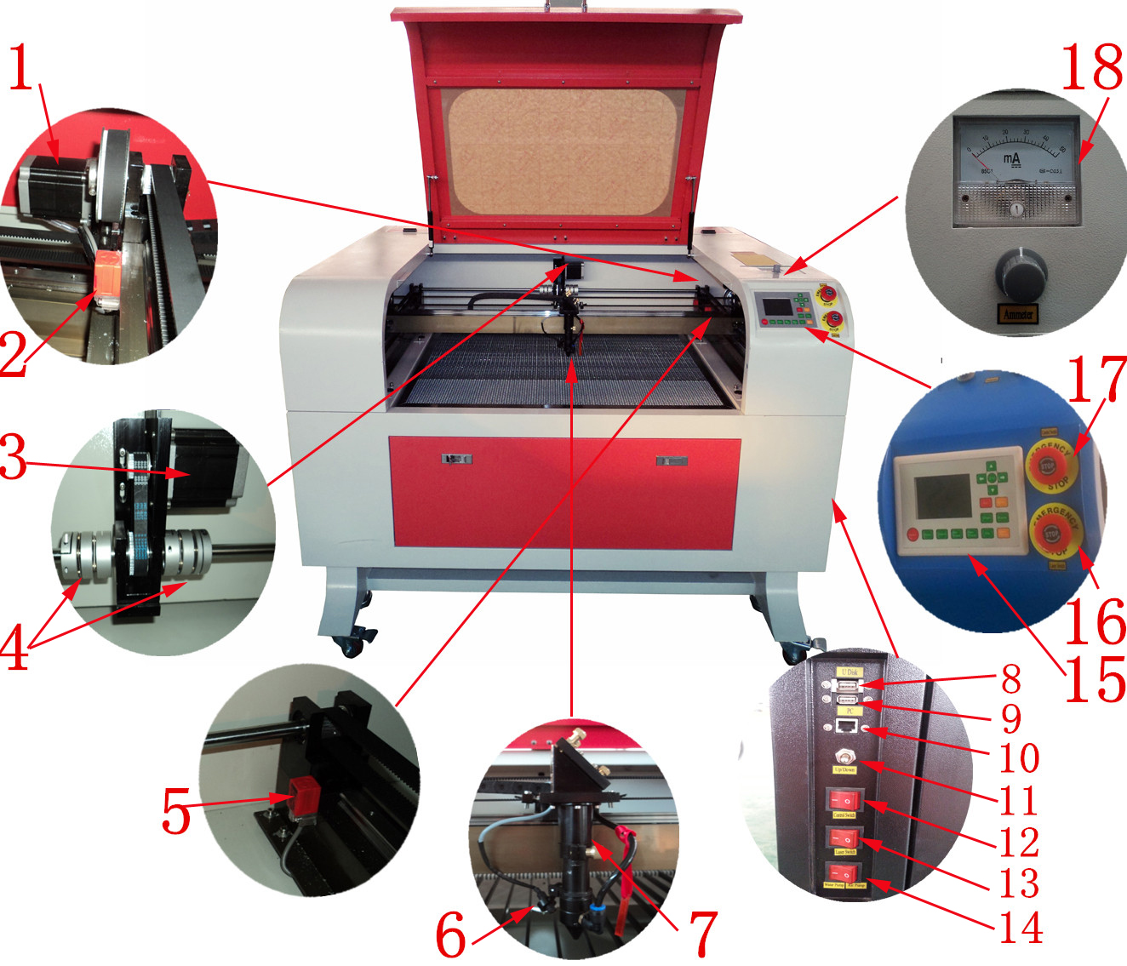

X axis motor

X axis limit switch

Y axis motor

Y axis shaft joint

Y axis limit switch

Red light indicator

Laser head

U disk

USB port

Internet port

Motorized up&down switch

Control switch

Laser switch

Air pump/water pump switch

Control Panel

Emergency stop for laser switch

Emergency stop for control switch

Current Indication

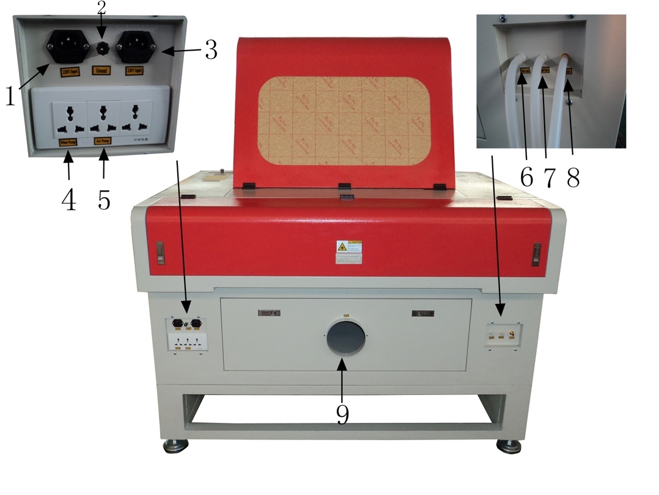

220V Input for machine

Ground wire joint

220V Input for laser

Power for Water pump

Power for Air Pump

Water Inlet

Water Outlet

Air inlet

Smoke outlet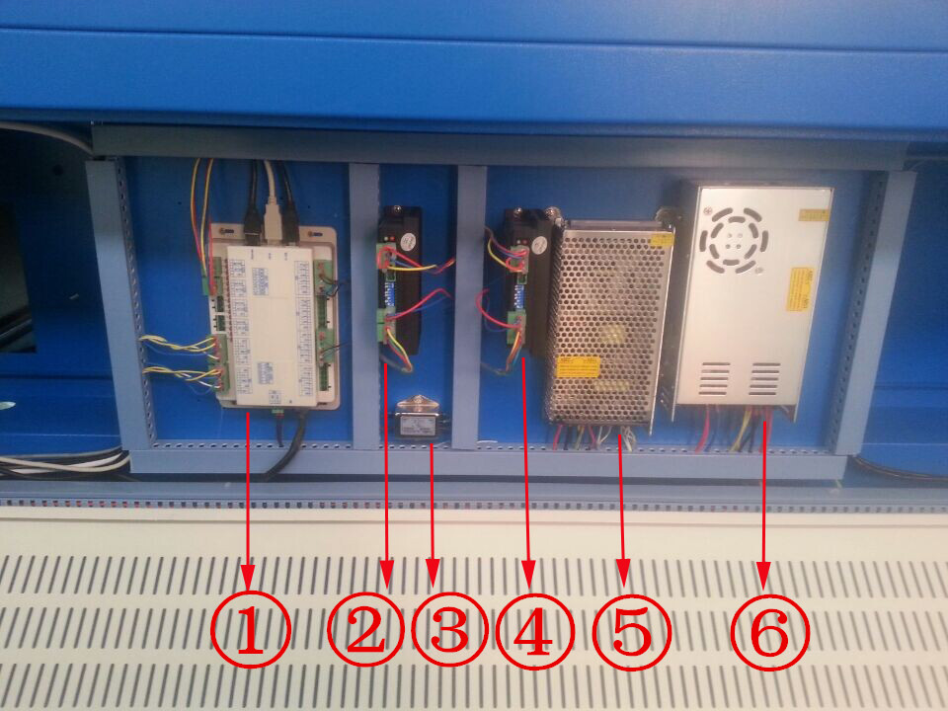

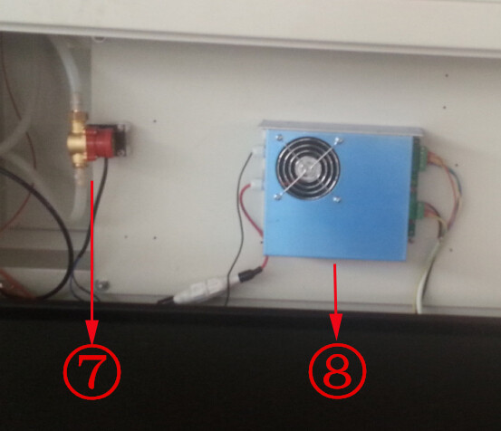

①Mainbaord

②X axis motor driver

③④Y axis motor driver

⑤24V/5V power supply for mainbaord

⑥36V power supply for motor driver

⑦Water sensor switch

⑧Laser power supply

Thank you for buying Shenhui laser machine sincerely, if you have any other problem, please contact with us without hesitate!